**Microservices**

Contents

BuildPacks 2

Google Jib 10

Approach Comparison – Dockerfile, Buildpacks and Jib 23

Pushing Local Images to Dockerhub Repository 25

Docker Compose 35

Docker Commands Deep Dive 53

Docker Extensions and Logs Explorer 57

Configuration Management in Microservices 62

How Configurations work in Spring Boot 64

Reading configurations with @Value 67

### BuildPacks

So what is a Buildpacks. Using Buildpacks, we can transform our application source code into a Docker image that can run on any cloud. There is no need of writing low level instructions with the help of Docker file. With a single maven command, we can generate a Docker image very easily. So this buildpacks is developed by Heroku. So initially they started this concept of Buildpacks. Later on both Pivotal and Heroku. They work together and they build a cloud native build packs and with these cloud native build packs, we can generate Docker images very easily because behind the scenes build a pack is going to scan all your source code, it is going to scan your dependencies and accordingly it is going to generate a Docker image.

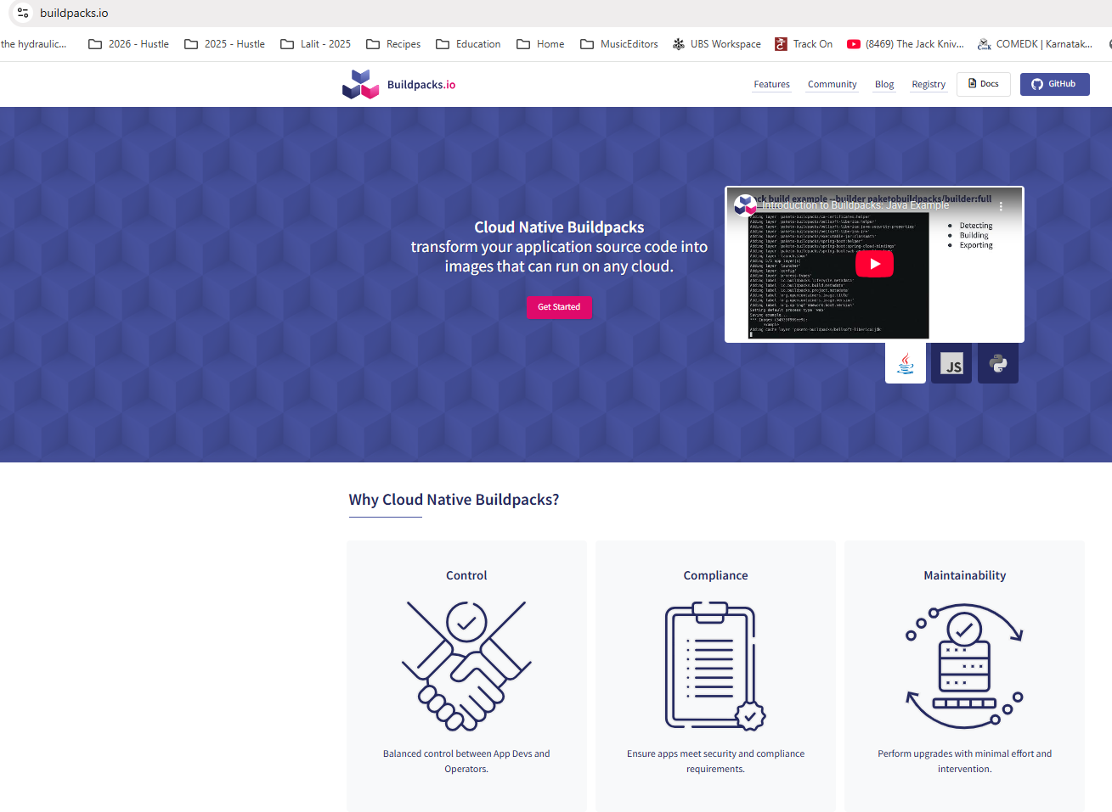

So during the generation of this Docker image, this build packs is going to follow all the standards of Docker in terms of security, in terms of compressing, in terms of caching. So regardless, whatever standard you talk about, Buildpacks is going to take care of everything. And if you want to achieve the same result with the Docker file approach, you need to be a super, super expert at Docker and understanding all the standards of Docker. Since we are the developers and don't want to learn everything about Docker, it will be a wise decision to use Buildpacks instead of Docker file. Because already these build packs is built based upon years of experience at Heroku and Pivotal and they know all the standards that we need to follow while generating a Docker image. We can use this ready to solution instead of reinventing the wheel again and again. So Buildpacks is a framework or an ecosystem or a concept. Based upon this ecosystem, we have Pacchetto Buildpacks that we can use for Java based applications.

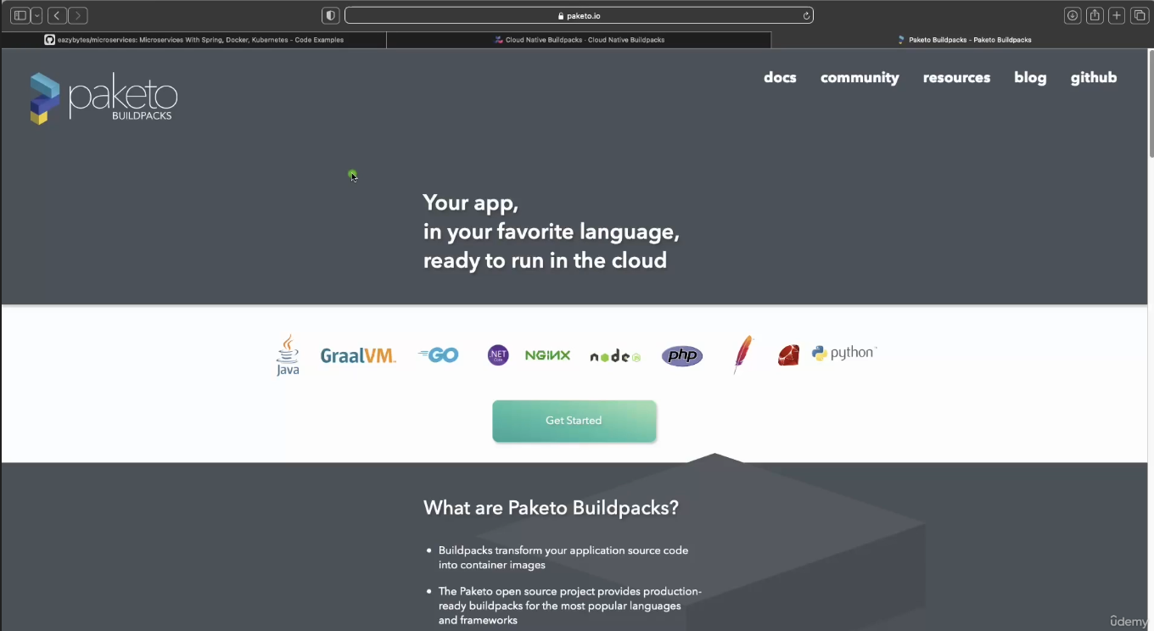

Apart from Java, it is also going to support many other languages like Go, Graalvm, Python, Ruby, PHP node. So if your microservice or if your web application is written in any of these languages, you can safely use buildpacks. And behind the scenes this buildpacks is going to use these Pacchetto build packs, which is an implementation of Buildpacks ecosystem. I hope you are clear with this quick introduction about Buildpacks. Now let's try to understand how to generate a Docker image with the help of this Buildpacks. For the same, first, let me close all these files of accounts microservice, post that I'm going to go to the loans microservice inside this pom.xml, first I need to make sure just after this version I'm mentioning the packaging as jar.

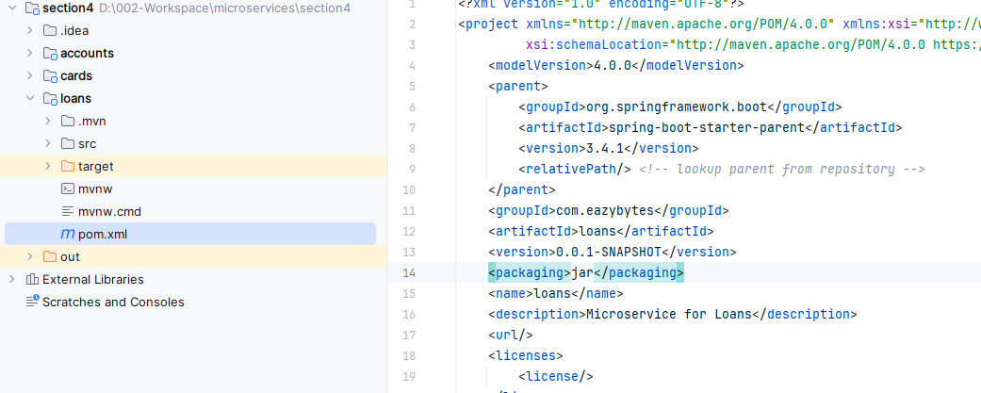

So once we mention this packaging as jar, you need to make sure you have a plugin related to the maven inside your pom.xml. Like you can see whenever we try to generate a spring boot web application from start.spring.io website. By default you will get this plugin which is like Spring boot maven plugin. With the help of this Spring boot Maven plugin.

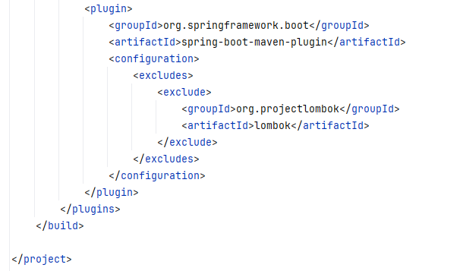

We can generate a Docker image and behind the scenes this Spring Boot Maven plugin is going to leverage Buildpacks and Paquito to generate a production ready Docker image. But in order to generate a Docker image, first we need to provide what is the name that we want to consider for that Docker image that we are going to generate. That's why inside this configurations we need to invoke a tag which is image. So inside this image tag we need to invoke one more tag, which is name. Under this name tag we need to provide what is that Docker image name. The Docker image name that we want to follow is very similar to accounts microservice First, we need to make sure that we are mentioning the Docker username that we have created inside the Docker website. So my username is eazybytes, so please make sure you are mentioning your own Docker username, post that slash followed by what is the name of your application. The name of my application is loans. Again this name can be anything but you need to make sure with the help of this Docker image name, you should be able to identify your microservice. That's why I'm giving this name as loans, which is same as my microservice name. After this, we need to mention colon. And what is the tag name or what is the version name? The tag name that we want to follow here is s4, which indicates section 4, since this image belongs to the section 4, I'm mentioning this S4 here.

<plugin>

<groupId>org.springframework.boot</groupId>

<artifactId>spring-boot-maven-plugin</artifactId>

<configuration>

<image>

<name>lalitrnagpal/loans:s4</name>

</image>

<excludes>

<exclude>

<groupId>org.projectlombok</groupId>

<artifactId>lombok</artifactId>

</exclude>

</excludes>

</configuration>

</plugin>

</plugins>

</build>

</project>

Now, if you see, instead of hard coding these loans anyway we decided to use the same as microservice name. What we can do is we can try to read this application name with the help of this dollar and curly braces.

<plugin>

<groupId>org.springframework.boot</groupId>

<artifactId>spring-boot-maven-plugin</artifactId>

<configuration>

<image>

<name>lalitrnagpal/${project.artifactId}:s4</name>

</image>

<excludes>

<exclude>

<groupId>org.projectlombok</groupId>

<artifactId>lombok</artifactId>

</exclude>

</excludes>

</configuration>

</plugin>

</plugins>

</build>

</project>

So inside this I'm going to mention project.artifactId, this project.artifactId we have defined in the top. So the artifactId name is loans. So the same name comes here. This way I'm trying to avoid hardcoding my microservice name.

<?xml version="1.0" encoding="UTF-8"?>

<project xmlns="http://maven.apache.org/POM/4.0.0" xmlns:xsi=<http://www.w3.org/2001/XMLSchema-instance> xsi:schemaLocation=

"http://maven.apache.org/POM/4.0.0 https://maven.apache.org/xsd/maven-4.0.0.xsd">

<modelVersion>4.0.0</modelVersion>

<parent>

<groupId>org.springframework.boot</groupId>

<artifactId>spring-boot-starter-parent</artifactId>

<version>3.4.1</version>

<relativePath/> <!-- lookup parent from repository -->

</parent>

<groupId>com.eazybytes</groupId>

<artifactId>loans</artifactId>

<version>0.0.1-SNAPSHOT</version>

<packaging>jar</packaging>

<name>loans</name>

<description>Microservice for Loans</description>

. . .

</project>

So with this we have mentioned that Docker image name that we want to consider whenever we are trying to generate a Docker image with the help of Buildpacks.

So let me save this changes post that I'll go to the terminal. So here, let me clean the console. Right now my terminal is at a location where my pom.xml of loans microservice is available here. I need to issue a maven command and the command is mvn spring-boot:build-image. So with this command we are telling to the maven to generate a docker image of my spring boot microservice by leveraging buildpacks. So behind the scenes it is going to leverage Buildpacks. Let me press enter here and if you are doing this very first time, it is going to take some five minutes because it has to download all the Buildpacks or package related libraries and images inside your local system. You can see right now it is downloading the base image from the paketo buildpacks using this base image only it is going to generate a Docker image. That's why very first time it is going to take some time. But once you have done this from next time onwards, it is going to be quick compared to the very first time. So let's wait for this to complete.

PS D:\002-Workspace\microservices\section4\loans> mvn spring-boot:build-image

[INFO] Scanning for projects...

[INFO]

[INFO] ------------------------< com.eazybytes:loans >-------------------------

[INFO] Building loans 0.0.1-SNAPSHOT

[INFO] from pom.xml

[INFO] --------------------------------[ jar ]---------------------------------

[INFO]

[INFO] >>> spring-boot:3.4.1:build-image (default-cli) > package @ loans >>>

[INFO]

[INFO] --- resources:3.3.1:resources (default-resources) @ loans ---

[INFO] Copying 1 resource from src\main\resources to target\classes

[INFO] Copying 1 resource from src\main\resources to target\classes

[INFO]

[INFO] --- compiler:3.13.0:compile (default-compile) @ loans ---

[INFO] Nothing to compile - all classes are up to date.

[INFO]

[INFO] --- resources:3.3.1:testResources (default-testResources) @ loans ---

[INFO] skip non existing resourceDirectory D:\002-Workspace\microservices\section4\loans\src\test\resources

[INFO]

[INFO] --- compiler:3.13.0:testCompile (default-testCompile) @ loans ---

[INFO] Nothing to compile - all classes are up to date.

[INFO]

[INFO] --- surefire:3.5.2:test (default-test) @ loans ---

[INFO] Using auto detected provider org.apache.maven.surefire.junitplatform.JunitPlatformProvider

. . .

PS D:\002-Workspace\microservices\section4\loans> mvn spring-boot:build-image

. . .

[INFO] > Pulling builder image 'docker.io/paketobuildpacks/builder-jammy-java-tiny:latest' 0%

[INFO] > Pulling builder image 'docker.io/paketobuildpacks/builder-jammy-java-tiny:latest' 5%

[INFO] > Pulling builder image 'docker.io/paketobuildpacks/builder-jammy-java-tiny:latest' 9%

[INFO] > Pulling builder image 'docker.io/paketobuildpacks/builder-jammy-java-tiny:latest' 17%

[INFO] > Pulling builder image 'docker.io/paketobuildpacks/builder-jammy-java-tiny:latest' 23%

[INFO] > Pulling builder image 'docker.io/paketobuildpacks/builder-jammy-java-tiny:latest' 29%

[INFO] > Pulling builder image 'docker.io/paketobuildpacks/builder-jammy-java-tiny:latest' 32%

[INFO] > Pulling builder image 'docker.io/paketobuildpacks/builder-jammy-java-tiny:latest' 34%

[INFO] > Pulling builder image 'docker.io/paketobuildpacks/builder-jammy-java-tiny:latest' 35%

[INFO] > Pulling builder image 'docker.io/paketobuildpacks/builder-jammy-java-tiny:latest' 36%

[INFO] > Pulling builder image 'docker.io/paketobuildpacks/builder-jammy-java-tiny:latest' 36%

[INFO] > Pulling builder image 'docker.io/paketobuildpacks/builder-jammy-java-tiny:latest' 36%

[INFO] > Pulling builder image 'docker.io/paketobuildpacks/builder-jammy-java-tiny:latest' 36%

[INFO] > Pulling builder image 'docker.io/paketobuildpacks/builder-jammy-java-tiny:latest' 36%

[INFO] > Pulling builder image 'docker.io/paketobuildpacks/builder-jammy-java-tiny:latest' 36%

[INFO] > Pulling builder image 'docker.io/paketobuildpacks/builder-jammy-java-tiny:latest' 36%

[INFO] > Pulling builder image 'docker.io/paketobuildpacks/builder-jammy-java-tiny:latest' 36%

[INFO] > Pulling builder image 'docker.io/paketobuildpacks/builder-jammy-java-tiny:latest' 100%

[INFO] > Pulled builder image 'paketobuildpacks/builder-jammy-java-tiny@sha256:da6ccadf959933cb4c2c463e9e75527174cd966fcd211335a0133efc087d90ac'

. . .

Right now it is 36% post at 41% and please make sure while running this mvn command, your Docker server should be running behind the scenes. If you don't have your Docker server is running your Buildpacks can't do anything because at the end of the day, behind the scenes it is going to give instructions to your Docker server to generate a Docker image inside your local system. So you can see it is trying to understand my Java version, which version I'm using inside my pom.xml So inside my pom.xml I have mentioned the Java version as 17. If you can go to the top of this pom.xml, here under this properties we have mentioned the Java version as 17.

So based upon all the details and dependencies that we have mentioned inside the pom.xml, it is going to scan for all the dependencies. And by considering all these behind the scenes it is going to generate a Docker image. Finally, after waiting for few more minutes, my Docker image generation of loans microservice got successful with the help of Buildpacks. You can see a Docker image is built with this image name. Now I can try to clean this console and run the docker images command. So here I'm trying to run the same and this time you can see there is also a loans image with the tag S4 and the size is 311 MB.

[INFO] [creator] Saving docker.io/lalitrnagpal/loans:s4...

[INFO] [creator] *** Images (048cf5d6b293):

[INFO] [creator] docker.io/lalitrnagpal/loans:s4

[INFO] [creator] Adding cache layer 'paketo-buildpacks/syft:syft'

[INFO] [creator] Adding cache layer 'paketo-buildpacks/spring-boot:spring-cloud-bindings'

[INFO] [creator] Adding cache layer 'buildpacksio/lifecycle:cache.sbom'

[INFO]

[INFO] Successfully built image 'docker.io/lalitrnagpal/loans:s4'

[INFO]

[INFO] ------------------------------------------------------------------------

[INFO] BUILD SUCCESS

[INFO] ------------------------------------------------------------------------

[INFO] Total time: 02:03 min

[INFO] Finished at: 2025-10-27T07:26:15+05:30

[INFO] ------------------------------------------------------------------------

PS D:\002-Workspace\microservices\section4\loans>

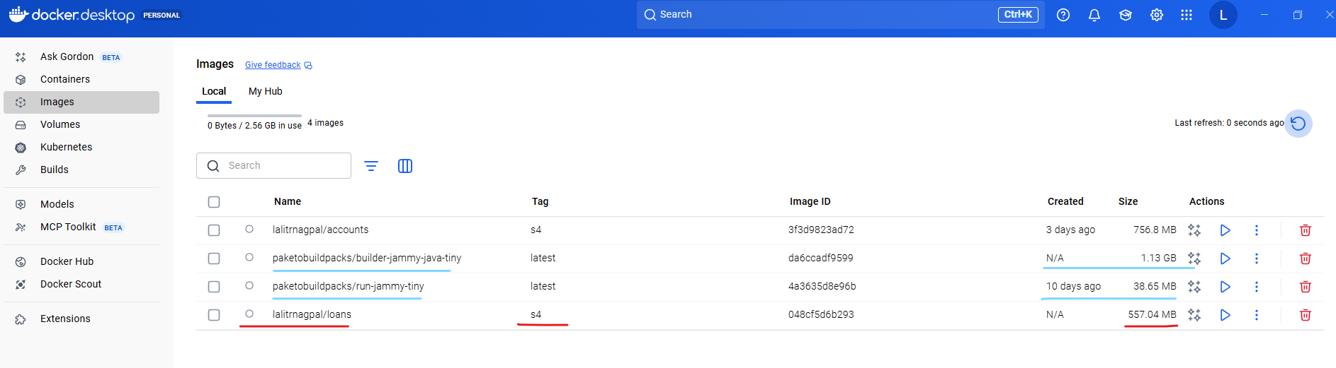

PS D:\002-Workspace\microservices\section4\loans> docker image list

REPOSITORY TAG IMAGE ID CREATED SIZE

lalitrnagpal/accounts s4 3f3d9823ad72 2 days ago 757MB

paketobuildpacks/run-jammy-tiny latest 4a3635d8e96b 9 days ago 38.7MB

lalitrnagpal/loans s4 048cf5d6b293 45 years ago 557MB

paketobuildpacks/builder-jammy-java-tiny latest da6ccadf9599 45 years ago 1.13GB

PS D:\002-Workspace\microservices\section4\loans>

If you see for accounts microservice, we have used the Docker file and the size of the accounts Docker image is 757 MB because we don't know how to follow the best standards, how to cache multiple layers, how to compress our multiple components inside Docker image. We don't know about all those standards and the Docker concept, but with the help of Buildpacks, you can see there is a lot of improvement in terms of the size of our Docker image. It reduced from 757 MB to 557 MB. So this is one of the great advantage if you use the products like Buildpacks, you can also see there is a paketo Buildpacks Docker image downloaded. So this image is going to do all the work of generating a Docker image for your spring boot microservice. And this is of 1.13 GB. So this is a very heavy image and of course you don't have to take this into your deployment. You just need only the loans Docker image. Now I can try to run my loans Docker image as a container.

PS D:\002-Workspace\. . .\loans> docker run -d -p 8081:8080 lalitrnagpal/loans:s4

6462e849d4ca6df9dc712a80942a23ac0360ad064393040dfdc88314d89f4593

PS D:\002-Workspace\microservices\section4\loans> docker ps -a

CONTAINER ID IMAGE COMMAND CREATED STATUS PORTS NAMES

6462e849d4ca lalitrnagpal/loans:s4 "/cnb/process/web" 5 seconds ago Up 4 seconds 0.0.0.0:8081->8080/tcp, [::]:8081->8080/tcp blissful_cartwright

PS D:\002-Workspace\microservices\section4\loans> docker stop 6462e849d4ca

6462e849d4ca

For the same, the command is very similar if you go to the previous commands that we have executed. So this is the one which we have executed docker run -d -p and the loans microservice is going to start at the port 8090. First, I need to make sure I'm mentioning the same and I will try to expose at the same port which is 8090 and the Docker image name of loans is eazybytes/loans and the tag name is S4 only. So we should be good with that. Now, if I try to execute this command, a Docker container will get created behind the scenes. You may see this warning, don't worry, you can simply ignore that. Now if you can go to the Docker desktop first, under the images, you should be able to see the new image that got generated, which is lalitrnagpa/loans:s4.

PS D:\...\section4\loans> docker run -d -p 8090:8090 lalitrnagpal/loans:s4

3c0666f5f0b1d833014497aa53300f019a03f02df1383fb72de0d7e063d0706d

PS D:\002-Workspace\microservices\section4\loans> docker ps -a

CONTAINER ID IMAGE COMMAND CREATED STATUS PORTS NAMES

3c0666f5f0b1 lalitrnagpal/loans:s4 "/cnb/process/web" 5 seconds ago Up 4 seconds 0.0.0.0:8090->8090/tcp, [::]:8090->8090/tcp silly_edison

6462e849d4ca lalitrnagpal/loans:s4 "/cnb/process/web" About a minute ago Exited (143) 36 seconds ago blissful_cartwright

And very similarly, if we can go to the containers, you can see there is a running container of loans. If you can click on this container name, you should be able to see all the logs and you can see your loans microservice started at the port 8090. I can also confirm the same by invoking a REST API against loans microservice with the help of postman. So here you can see, I'm trying to send a request for my create loan with the help of this mobile number. As soon as I click send, you should be able to get a response. So I'm getting a successful response here. So this confirms we have a proper running container of loans microservice that built with the help of Buildpacks concept.

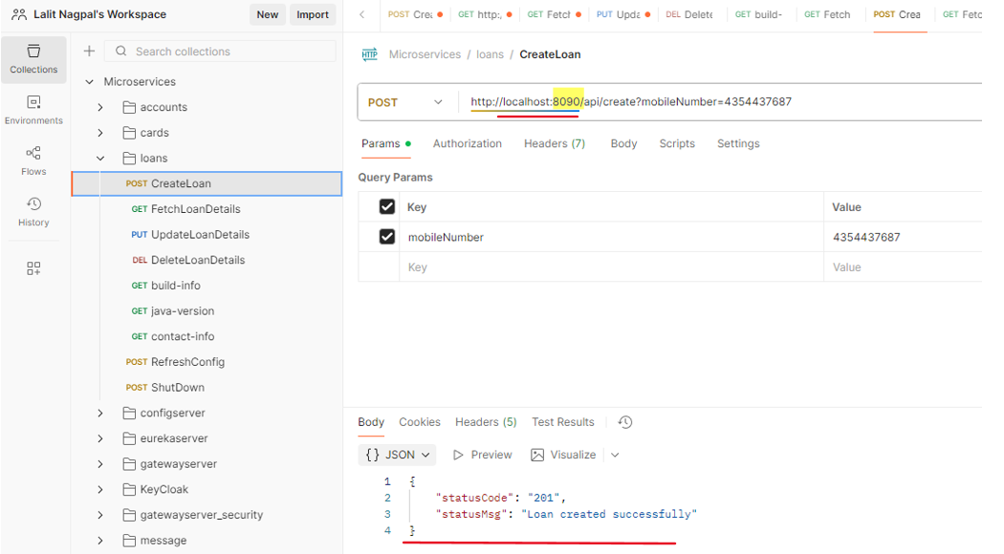

So let's try to revise the steps very quickly that we followed inside this Buildpacks approach. The very first step that we need to follow while building a Docker image with the help of Buildpacks is, we need to add the image name details inside your pom.xml like you can see on the right hand side. Along with the image name, please make sure you also have the Spring boot Maven plugin configured inside your pom.xml. This comes by default inside your spring boot web application. If you don't have, please mention that by referring to the code present inside the GitHub repo. Post that we need to run a mvn command which is mvn spring boot build image. So when you try to run this command behind the scenes, your spring boot Maven plugin is going to utilize Buildpacks to generate a Docker image without the need of Docker file.

|  |  |
| --- | --- |
|  |  |

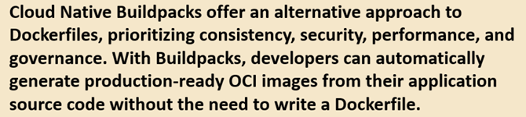

Once you generate a Docker image, you can run this Docker image as a Docker container by using the command which is Docker run along with the port mapping and your Docker image name. So these are the steps that we need to follow. So I have mentioned this inside this slide so that in future you can always refer them and you can always try to brush up the concepts that we have discussed. So on a high level, what is Buildpacks? Buildpacks offers alternative approach to Docker files. So without writing the Docker files this Buildpacks, it is going to help developers to automatically generate production ready Docker images from their application source code. And while generating these Docker images, these Buildpacks is going to follow all the production standards like security, caching, performance, compressing. So that's why this approach is better than Docker file approach. With this, I'm assuming your super clear about Buildpacks in the next lecture, let's try to explore the last approach that we have, which is Google Jib.

### Google Jib

Let's try to explore Jib from the Google to generate a Docker image for the cards microservice. So like you can see you need to go to this URL which is github.com slash Google container tool slash jib. The same URL I have mentioned inside the GitHub repository. Under the important links you can see this is the link of Google Jib website.

Docker hub website - <https://hub.docker.com>

Buildpacks website - <https://buildpacks.io>

Google Jib website - <https://github.com/GoogleContainerTools/jib>

Docker compose website - <https://docs.docker.com/compose/>

Once you are onto this GitHub repository, you can scroll down and there are instructions on how to use this jib and containerize our Java applications.

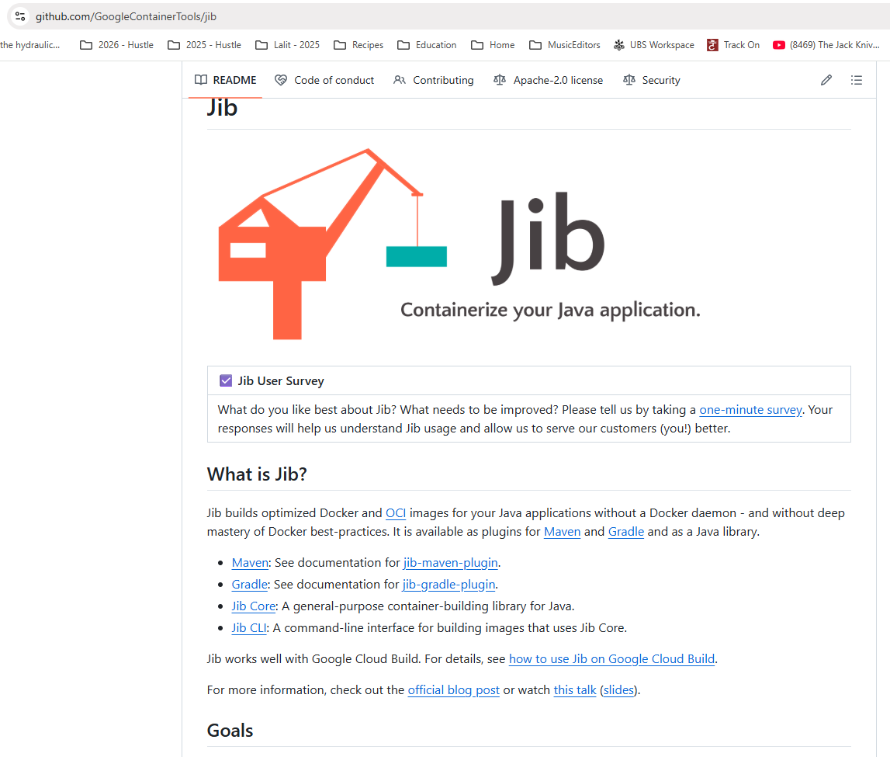

So please note that Jib is going to work only for Java applications, whereas Buildpacks is going to work for many other famous languages like Python, Ruby, Node.js. So there are many other languages that Buildpacks is going to support apart from Java, whereas Jib is strictly for Java applications. Since we are building Java based microservice, we can use this Jib without any issues. We can scroll down here. There are links to know more details about how to use this Jeep with the help of Maven and Gradle. If you are using Gradle, you can click on this Gradle link. Otherwise you can click on this Maven. Since we are using Maven, we need to click on this Maven link, which will redirect us to the GitHub repo page where this Maven plugin is available. If you can scroll down here, there are details on how to get started. The very first setup that you need to do is inside your Pom.xml. We need to make sure to copy this plugin detail which will help us to generate a Docker image. So let me copy these configurations. So here inside my cards microservice, first I'll try to delete the existing content of target folder. For that I'll go to my Pom.xml and I'll make sure to mention the packaging details after this versioning.

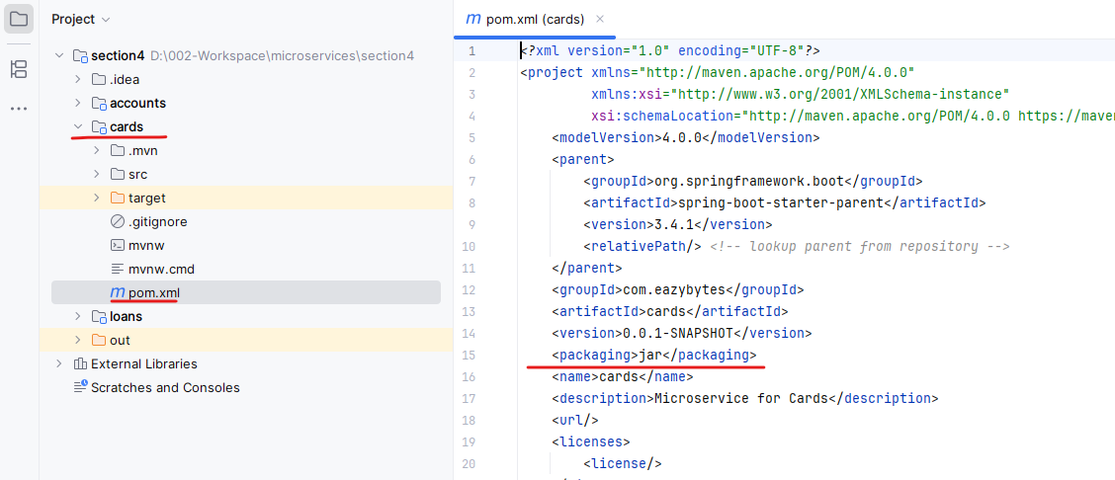

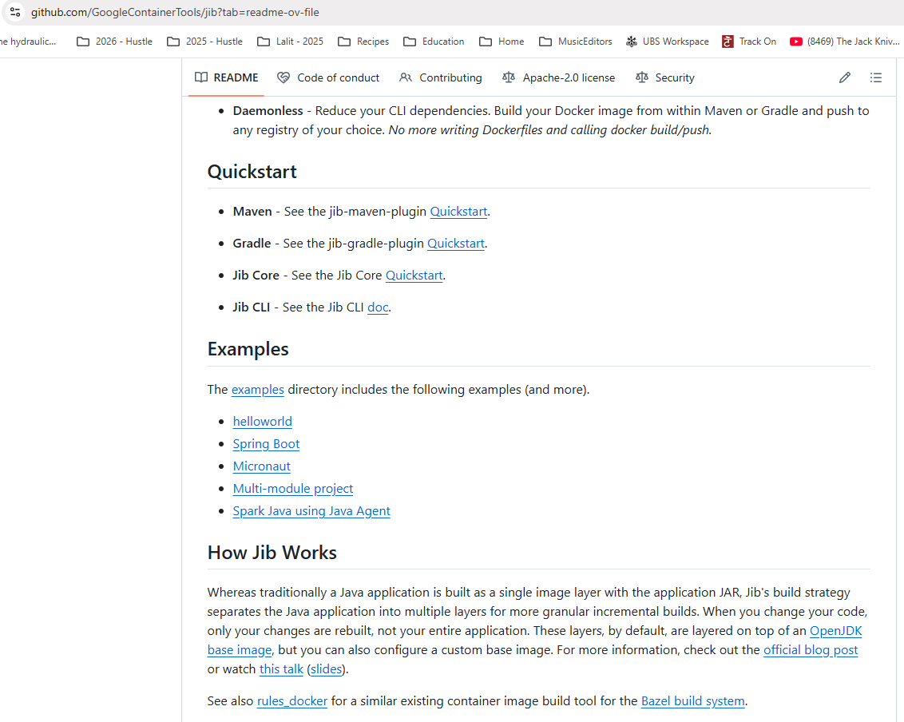

So the packaging configurations that I want to use is Jar. So let me mention the same. Now we can go to the end of this palm dot XML. We already have a Spring Boot Maven plugin here, so we can introduce one more plugin.

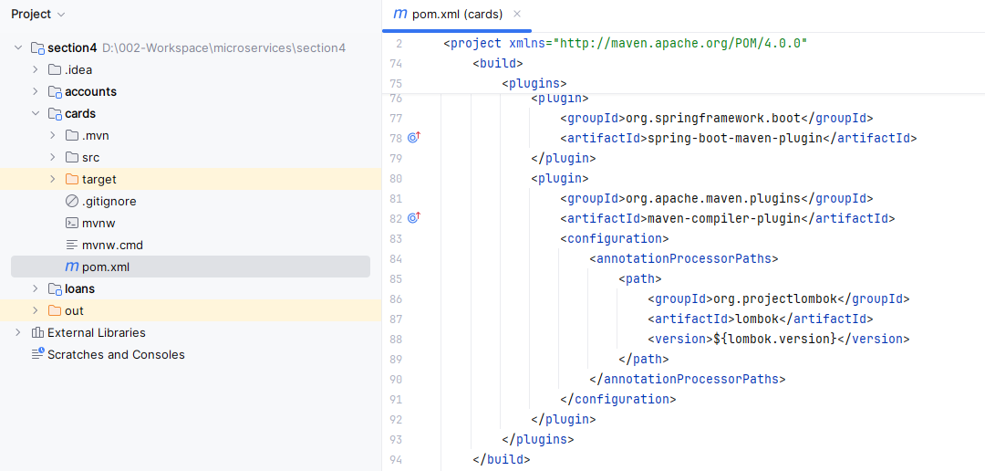

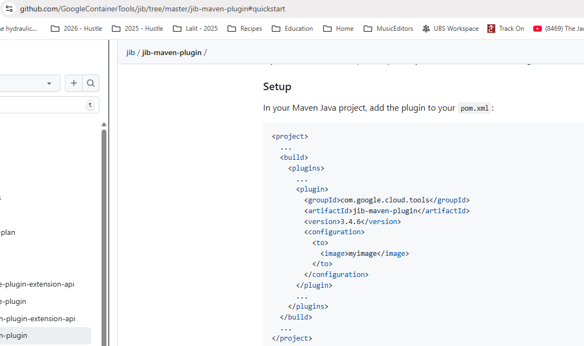

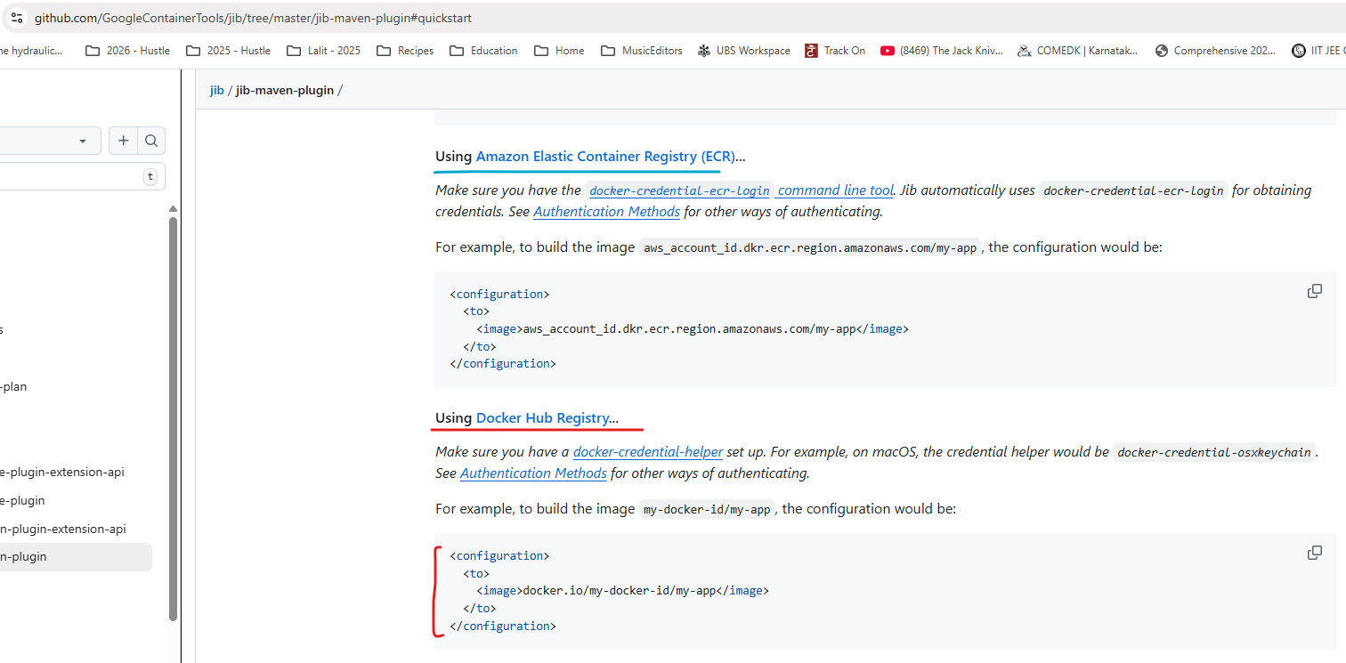

So let me copy the new plugin details. So the plugin details is it belongs to a group ID com.google.cloud.tools. And the artifact ID is Maven plugin. The version is 3.3.2. And under this configuration we need to mention a tag which is two. After this we can mention the image and what is the image name? The image name we can follow the very similar to what we have been following for the loans microservice. So let me copy the name from the loans microservice. So I'll take this value and I'll mention the same under the cards pom.XML as well.

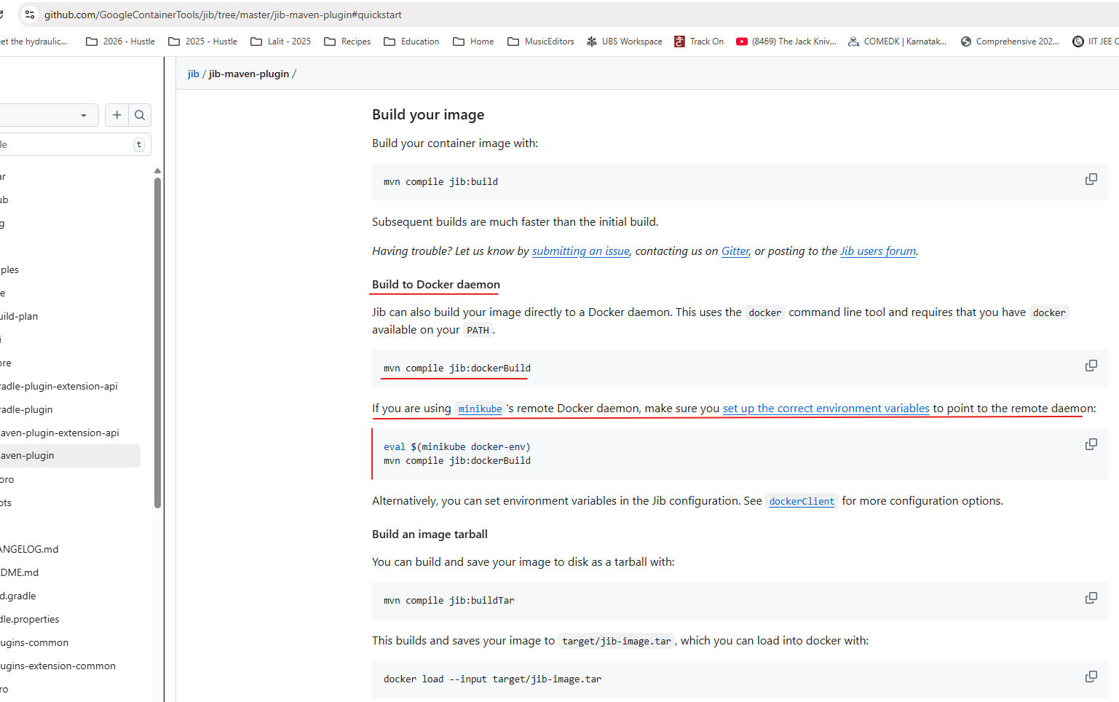

So lalitrnagpal is the Docker user name that I have created and the {project.artifactId} of this pom.xml is cards. So there is no need to worry even though we copied from the loans. Since this variable is going to get derived from the existing pom.xml we should be good post that. The tag name that I want to mention here is S4. Once we added these changes inside pom.xml, we can go to the GitHub repository here. If you can scroll down, there is a command that you can use to generate a Docker image. So the command is mvn compile jib:docker build. So this will use your local Docker server setup to generate a Docker image. So let's try to execute this command inside my terminal. So for the same first I need to go to the cards microservice location. So I'm just going there was that I'm clearing my console. After this the command that I need to run is mvn compile jib:dockerBuild with B as capital.

PS D:\002-Workspace\microservices\section4\cards> mvn compile jib:dockerBuild

[INFO] Scanning for projects...

Downloading from central: https://repo.maven.apache.org/maven2/com/google/cloud/tools/jib-maven-plugin/3.4.6/jib-maven-plugin-3.4.6.pom

Downloaded from central: https://repo.maven.apache.org/maven2/com/google/cloud/tools/jib-maven-plugin/3.4.6/jib-maven-plugin-3.4.6.pom (4.9 kB at 13 kB/s)

Downloading from central: https://repo.maven.apache.org/maven2/com/google/cloud/tools/jib-maven-plugin/3.4.6/jib-maven-plugin-3.4.6.jar

Downloaded from central: https://repo.maven.apache.org/maven2/com/google/cloud/tools/jib-maven-plugin/3.4.6/jib-maven-plugin-3.4.6.jar (567 kB at 4.7 MB/s)

[INFO]

[INFO] ------------------------< com.eazybytes:cards >-------------------------

[INFO] Building cards 0.0.1-SNAPSHOT

[INFO] from pom.xml

[INFO] --------------------------------[ jar ]---------------------------------

[INFO]

[INFO] --- resources:3.3.1:resources (default-resources) @ cards ---

[INFO] Copying 1 resource from src\main\resources to target\classes

[INFO] Copying 1 resource from src\main\resources to target\classes

[INFO]

[INFO] --- compiler:3.13.0:compile (default-compile) @ cards ---

[INFO] Nothing to compile - all classes are up to date.

[INFO]

[INFO] --- jib:3.4.6:dockerBuild (default-cli) @ cards ---

. . .

[WARNING] The credential helper (docker-credential-desktop) has nothing for server URL: registry.hub.docker.com

[WARNING]

Got output:

credentials not found in native keychain

[INFO] Using credentials from Docker config (**C:\Users\Lalit\.docker\config.json**) for eclipse-temurin:17-jre

[INFO] Using base image with digest: sha256:696817d4fb79b9c442e84e18483d8345dd2d0b6710546344e5eb182bd3153333

[INFO]

[INFO] Container entrypoint set to [java, -cp, @/app/jib-classpath-file, com.eazybytes.cards.CardsApplication]

[INFO]

[INFO] Built image to Docker daemon as lalitrnagpal/cards:s4

[INFO] Executing tasks:

[INFO] [==============================] 100.0% complete

[INFO]

[INFO] ------------------------------------------------------------------------

[INFO] BUILD SUCCESS

[INFO] ------------------------------------------------------------------------

[INFO] Total time: 44.231 s

[INFO] Finished at: 2025-10-29T08:16:48+05:30

[INFO] ------------------------------------------------------------------------

PS D:\002-Workspace\microservices\section4\cards>

PS D:\002-Workspace\microservices\section4\cards> docker images

REPOSITORY TAG IMAGE ID CREATED SIZE

lalitrnagpal/accounts s4 3f3d9823ad72 4 days ago 757MB

paketobuildpacks/run-jammy-tiny latest 4a3635d8e96b 11 days ago 38.7MB

lalitrnagpal/loans s4 048cf5d6b293 45 years ago 557MB

paketobuildpacks/builder-jammy-java-tiny latest da6ccadf9599 45 years ago 1.13GB

lalitrnagpal/cards s4 36eb5ff7f0d3 55 years ago 493MB

PS D:\002-Workspace\microservices\section4\cards>

Dropping -d parameter to see how it runs our image

PS D:\002-Workspace\microservices\section4\cards> docker run -p 9000:9000 lalitrnagpal/cards:s4

. ____ _ __ _ _

/\\ / ___'_ __ _ _(_)_ __ __ _ \ \ \ \

( ( )\___ | '_ | '_| | '_ \/ _` | \ \ \ \

\\/ ___)| |_)| | | | | || (_| | ) ) ) )

' |____| .__|_| |_|_| |_\__, | / / / /

=========|_|==============|___/=/_/_/_/

:: Spring Boot :: (v3.4.1)

2025-10-29T02:51:49.613Z INFO 1 --- [ main] com.eazybytes.cards.CardsApplication : Starting CardsApplication using Java 17.0.16 with PID 1 (/app/classes started by root in /)

2025-10-29T02:51:49.617Z INFO 1 --- [ main] com.eazybytes.cards.CardsApplication : No active profile set, falling back to 1 default profile: "default"

2025-10-29T02:51:50.716Z INFO 1 --- [ main] .s.d.r.c.RepositoryConfigurationDelegate : Bootstrapping Spring Data JPA repositories in DEFAULT mode.

2025-10-29T02:51:50.775Z INFO 1 --- [ main] .s.d.r.c.RepositoryConfigurationDelegate : Finished Spring Data repository scanning in 49 ms. Found 1 JPA repository interface.

2025-10-29T02:51:51.517Z INFO 1 --- [ main] o.s.b.w.embedded.tomcat.TomcatWebServer : Tomcat initialized with port 9000 (http)

2025-10-29T02:51:51.528Z INFO 1 --- [ main] o.apache.catalina.core.StandardService : Starting service [Tomcat]

2025-10-29T02:51:51.529Z INFO 1 --- [ main] o.apache.catalina.core.StandardEngine : Starting Servlet engine: [Apache Tomcat/10.1.34]

2025-10-29T02:51:51.599Z INFO 1 --- [ main] o.a.c.c.C.[Tomcat].[localhost].[/] : Initializing Spring embedded WebApplicationContext

2025-10-29T02:51:51.600Z INFO 1 --- [ main] w.s.c.ServletWebServerApplicationContext : Root WebApplicationContext: initialization completed in 1916 ms

2025-10-29T02:51:51.872Z INFO 1 --- [ main] com.zaxxer.hikari.HikariDataSource : HikariPool-1 - Starting...

2025-10-29T02:51:52.039Z INFO 1 --- [ main] com.zaxxer.hikari.pool.HikariPool : HikariPool-1 - Added connection conn0: url=jdbc:h2:mem:testdb user=SA

2025-10-29T02:51:52.041Z INFO 1 --- [ main] com.zaxxer.hikari.HikariDataSource : HikariPool-1 - Start completed.

2025-10-29T02:51:52.138Z INFO 1 --- [ main] o.hibernate.jpa.internal.util.LogHelper : HHH000204: Processing PersistenceUnitInfo [name: default]

2025-10-29T02:51:52.198Z INFO 1 --- [ main] org.hibernate.Version : HHH000412: Hibernate ORM core version 6.6.4.Final

2025-10-29T02:51:52.228Z INFO 1 --- [ main] o.h.c.internal.RegionFactoryInitiator : HHH000026: Second-level cache disabled

2025-10-29T02:51:52.464Z INFO 1 --- [ main] o.s.o.j.p.SpringPersistenceUnitInfo : No LoadTimeWeaver setup: ignoring JPA class transformer

2025-10-29T02:51:52.508Z WARN 1 --- [ main] org.hibernate.orm.deprecation : HHH90000025: H2Dialect does not need to be specified explicitly using 'hibernate.dialect' (remove the property setting and it will be selected by default)

2025-10-29T02:51:52.527Z INFO 1 --- [ main] org.hibernate.orm.connections.pooling : HHH10001005: Database info:

Database JDBC URL [Connecting through datasource 'HikariDataSource (HikariPool-1)']

Database driver: undefined/unknown

Database version: 2.3.232

Autocommit mode: undefined/unknown

Isolation level: undefined/unknown

Minimum pool size: undefined/unknown

Maximum pool size: undefined/unknown

2025-10-29T02:51:53.240Z INFO 1 --- [ main] o.h.e.t.j.p.i.JtaPlatformInitiator : HHH000489: No JTA platform available (set 'hibernate.transaction.jta.platform' to enable JTA platform integration)

Hibernate: alter table if exists cards alter column card_id set data type bigint

Hibernate: alter table if exists cards alter column created_at set data type timestamp(6)

Hibernate: alter table if exists cards alter column created_by set data type varchar(255)

Hibernate: alter table if exists cards alter column updated_at set data type timestamp(6)

Hibernate: alter table if exists cards alter column updated_by set data type varchar(255)

Hibernate: alter table if exists cards alter column card_number set data type varchar(255)

Hibernate: alter table if exists cards alter column card_type set data type varchar(255)

Hibernate: alter table if exists cards alter column mobile_number set data type varchar(255)

2025-10-29T02:51:53.307Z INFO 1 --- [ main] j.LocalContainerEntityManagerFactoryBean : Initialized JPA EntityManagerFactory for persistence unit 'default'

2025-10-29T02:51:53.857Z WARN 1 --- [ main] JpaBaseConfiguration$JpaWebConfiguration : spring.jpa.open-in-view is enabled by default. Therefore, database queries may be performed during view rendering. Explicitly configure spring.jpa.open-in-view to disable this warning

2025-10-29T02:51:54.594Z INFO 1 --- [ main] o.s.b.a.h2.H2ConsoleAutoConfiguration : H2 console available at '/h2-console'. Database available at 'jdbc:h2:mem:testdb'

2025-10-29T02:51:54.638Z INFO 1 --- [ main] o.s.b.a.e.web.EndpointLinksResolver : Exposing 1 endpoint beneath base path '/actuator'

2025-10-29T02:51:54.748Z INFO 1 --- [ main] o.s.b.w.embedded.tomcat.TomcatWebServer : Tomcat started on port 9000 (http) with context path '/'

2025-10-29T02:51:54.770Z INFO 1 --- [ main] com.eazybytes.cards.CardsApplication : Started CardsApplication in 5.544 seconds (process running for 5.949)

So if I try to execute this command, it will scan all the details inside my pom.xml and it is going to generate a docker image for my cards microservice. And this jib is going to be faster than build packs. You can see I'm able to get my Docker image within 11 seconds, whereas builder packs is going to take a lot of time. So now let me clear the console and try to run the Docker images. So if you can see here we got a new Docker image with the name cards. And this also is having a size of 322 MB, which is very similar to build a pack, but far better than the image size that we have for the accounts microservice. This confirms that Jib also is doing very good job in following all the standards and providing a production ready Docker image. Of course, this tool is from Google.

We can confidently use this tool because they might be using this from many years and optimized it to a great extent. That's why we can always leverage these kind of open source tools like jib and build packs. Now here you may have question like for the images that got generated with the help of build packs and zip. There is a created value which is like 43 years ago or 53 years ago. Is this a bug inside this build? Packs and zip. No, this is not a bug. This is a feature provided by them. The reason on why they are using such old dates is they will have a starting date, which is somewhere in 1970 or 1960, which they are going to use whenever you try to generate a Docker image. And if you try to generate a Docker image again without making any changes, intentionally or unintentionally, this new Docker image is also going to have the same created it, and since it is going to have the same content inside it, the regeneration process of the same Docker image is going to be the same.

PS D:\002-Workspace\microservices\section4\cards> docker images

REPOSITORY TAG IMAGE ID CREATED SIZE

lalitrnagpal/accounts s4 3f3d9823ad72 4 days ago 757MB

paketobuildpacks/run-jammy-tiny latest 4a3635d8e96b 11 days ago 38.7MB

lalitrnagpal/loans s4 048cf5d6b293 45 years ago 557MB

paketobuildpacks/builder-jammy-java-tiny latest da6ccadf9599 45 years ago 1.13GB

lalitrnagpal/cards s4 36eb5ff7f0d3 55 years ago 493MB

But instead of this old created date, if they use a normal current created date, then the same is not going to work because they cannot really compare two images to identify if the same or not, because the created date is going to differ due to that reason, they are using older dates. You can also look about this these inside the web. Lot. Many people thought this is a bug inside the build packs and zip and why they are showing it as part three years or 53 years. But this is not a bug. This is a feature to optimize the generation of the Docker images again and again. So now my Docker image is available. As a next step we can run docker run command which is docker run, followed by hyphen d, followed by hyphen p. And the port mapping that I want to follow for the cards is 9000 9000. Since our cards microservice is going to start at 9000, I have mentioned this port mapping and the image name is easy byte slash cards and the tag name is S4. So now I'm trying to execute this command. You can see the new container started. I can go to the Docker desktop under the containers. Right now you can see there is a cards related container also running right now. I can also confirm by looking at the logs, you can see it is still starting and the logs are being updated behind the scenes. So now my cards application container is started. I can also validate if it is working properly or not. With the help of postman inside the postman, I'm trying to send a request to the create API available inside the card. So let me click on this send button.

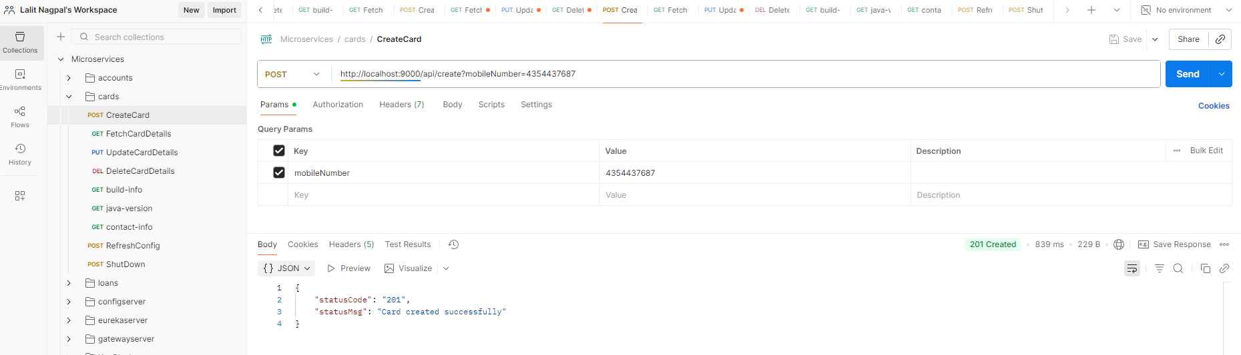

After clicking on the send button, you can see I'm getting a successful response, which means our cards microservice is also working fine. After converting as a Docker container, you can also try to run the Docker PS command which will show all the existing running containers. So these cards and loans containers are running and accounts microservice container is not running because I have stopped it long back.

Lets see some more details about Google Jib. There is a one more great advantage of Google Jib compared to Buildpacks. Whenever we are using Jib, we can generate a Docker image. Even if you don't have Docker installed inside your system. That's the beauty of jib. So if you don't want to install Docker inside your local system, but at the same time you want to convert your application to a Docker image, then you can use a command which is mvn compile jib build.

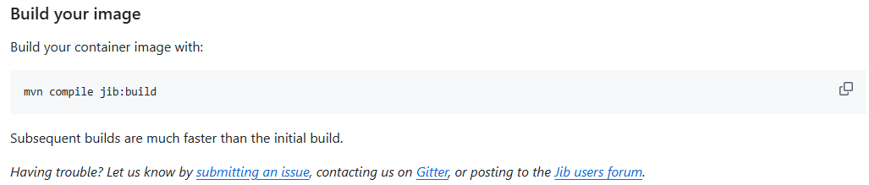

So when you try to use this build command, it is going to generate a Docker image from your application. And the same will be pushed into the remote repository. Because if you're not running a Docker inside a local system, that means there is no place for your jib to generate the Docker image.

PS D:\002-Workspace\microservices\section4\cards> mvn compile jib:build

[INFO] Scanning for projects...

[INFO]

[INFO] ------------------------< com.eazybytes:cards >-------------------------

[INFO] Building cards 0.0.1-SNAPSHOT

[INFO] from pom.xml

[INFO] --------------------------------[ jar ]---------------------------------

[INFO]

[INFO] --- resources:3.3.1:resources (default-resources) @ cards ---

[INFO] Copying 1 resource from src\main\resources to target\classes

[INFO] Copying 1 resource from src\main\resources to target\classes

. . .

credentials not found in native keychain

[INFO] Using credentials from Docker config (C:\Users\Lalit\.docker\config.json) for eclipse-temurin:17-jre

[INFO] Using base image with digest: sha256:696817d4fb79b9c442e84e18483d8345dd2d0b6710546344e5eb182bd3153333

[INFO]

[INFO] Container entrypoint set to [java, -cp, @/app/jib-classpath-file, com.eazybytes.cards.CardsApplication]

[INFO]

[INFO] Built and pushed image as lalitrnagpal/cards:s4

[INFO] Executing tasks:

[INFO] [==============================] 100.0% complete

[INFO]

[INFO] ------------------------------------------------------------------------

[INFO] BUILD SUCCESS

[INFO] ------------------------------------------------------------------------

[INFO] Total time: 01:48 min

[INFO] Finished at: 2025-10-29T09:29:39+05:30

[INFO] ------------------------------------------------------------------------

That's why it will look for the remote repository details where it has to store. If you can see here there are many other remote repository details that you can configure. If you are using GCR to store your Docker image, you can mention this image name as gcr.io. And what is your GCP project name followed by what is your app name?

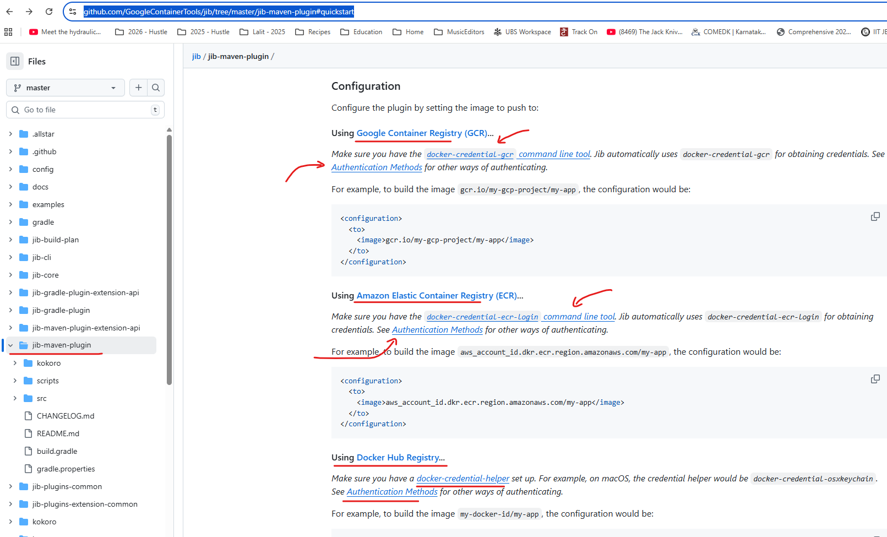

And very similarly for ECR. Also we can configure image name by following these standards. Whereas for Docker Hub you can mention docker.io. What is your docker username and post that? What is your app name followed by tag name? Tag name is always optional. So whenever it is trying to push your Docker image into the remote repository, it may need some credentials like your Docker credentials or your Amazon credentials, or your GCP credentials. So to provide those details you can always look these documentation on how to provide.

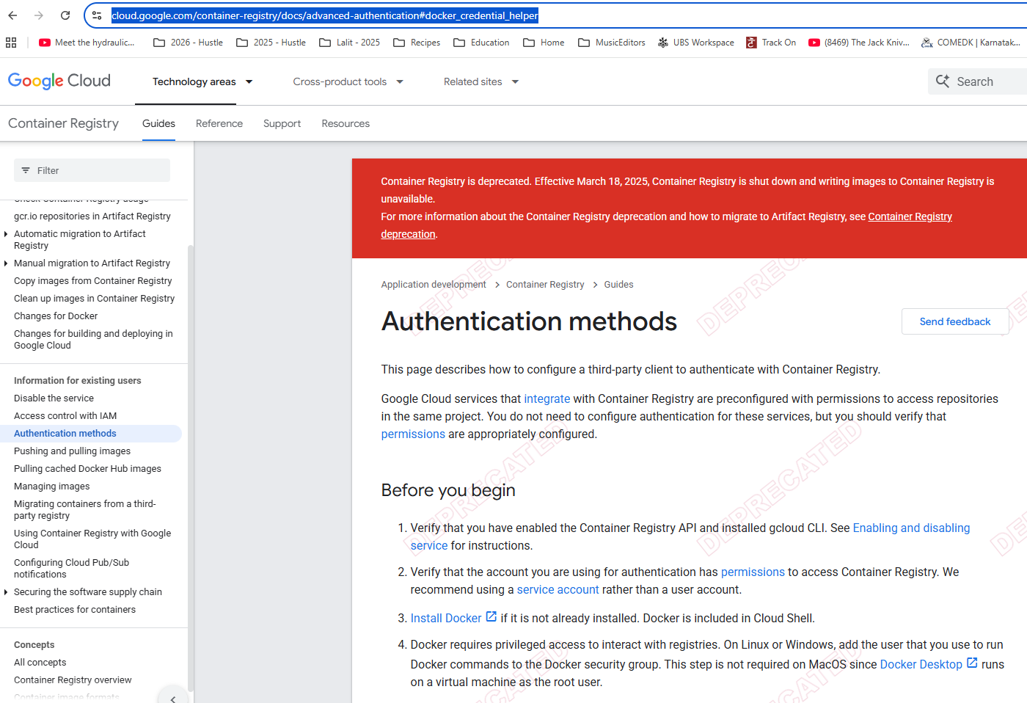

But in this course we are not going to use any of these approaches. Because first we want to store inside our local system. We want to test it. Once we satisfied then only we want to manually push into the remote repository. But this approach is going to be super, super helpful for the projects where the developers are not responsible to generate a Docker images, they are simply responsible to push the code into the GitHub repository inside the GitHub repository using CI, CD tools like Jenkins or GitHub actions or any other tool. You can write scripts to generate the Docker image from your application and inside your CI CD server you don't have to install this heavy software, which is Docker. In such scenarios, this is going to be super, super helpful. But like I said, inside this course we are going to use docker build command. Throughout the course. But I just wanted to highlight these advantages that we have with Jib. And this is the true differentiator for many projects where they are trying to prefer Jib compared to Buildpacks. Now let me show you the steps that we have followed to generate a container with the help of Google Jib.

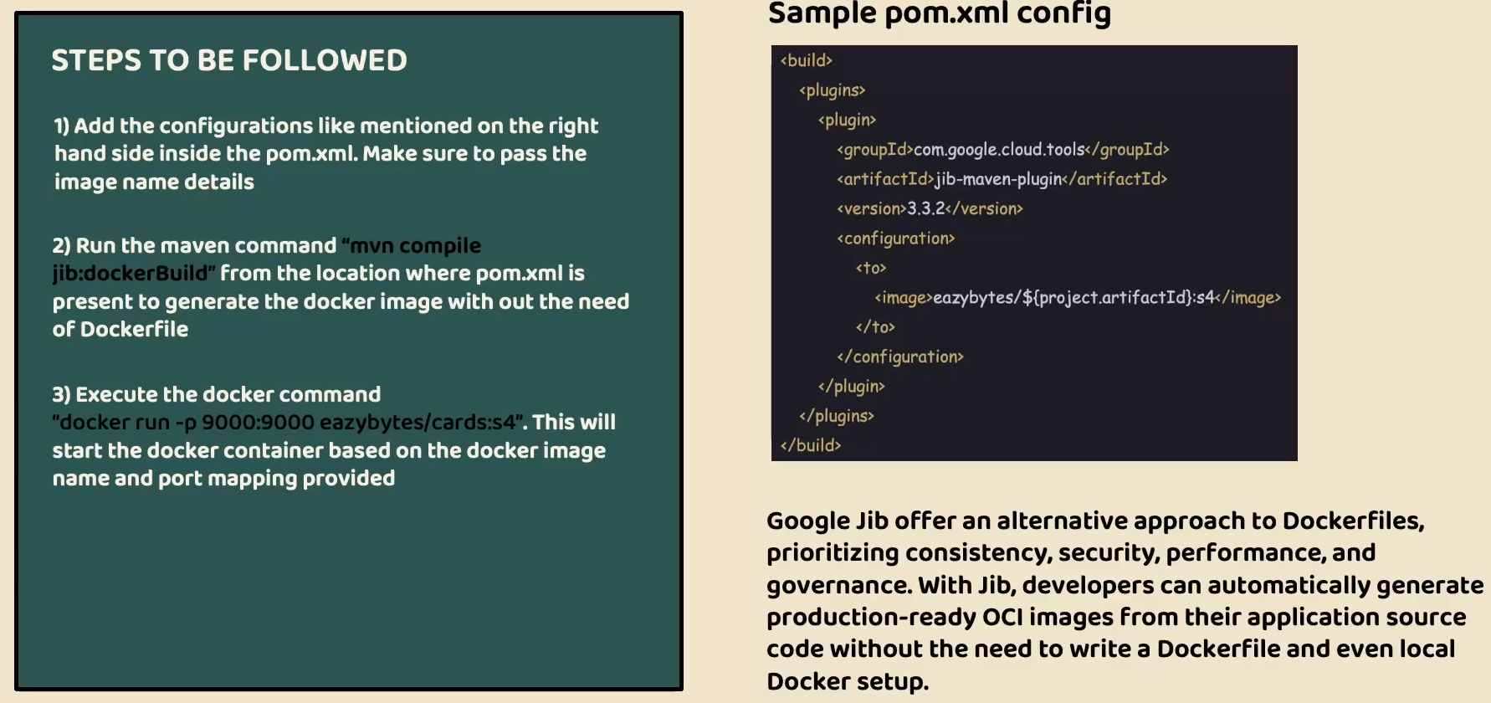

In the very first step, we need to configure the plugin details of Jib Maven plugin inside our Pom.xml. Like you can see on the right hand side and inside this plugin details. We should also configure what is the image name with the help of these two tag available under the configuration tag. Once we configure these details, we can run a command which is Maven compile jib docker build. And when we run this command, a Docker image will be generated inside your local system with the help of Docker server Were installed. And here we're not writing any Docker file. And the last step is once we have the Docker image available, you can run your Docker image as a container with the help of docker run command. And with that, your application is ready to accept requests in the form of Docker container.

And a high level Google chip help us to generate production ready Docker images by following all the production standards like performance, security, caching, compressing and developers are not forced to write any Docker files, they can simply generate production ready images for their application source code without the need of writing any low level Docker file and if needed. Jib also is capable of generating a Docker image without even local docker setup. I hope you are clear with all the details that we discussed about Google Jib in the next lecture, let's try to compare three different approaches that we have, and try to select one of them for the rest of the course.

### Approach Comparison – Dockerfile, Buildpacks and Jib

We looked at three most commonly used approaches to generate a Docker image of our microservices. And now you may have a question like which approach is better, Which one I can use? Frankly speaking, there is no better approach. Every approach has its own advantages and disadvantages. So based upon your scenario, you need to select one of them. You see, for the Docker file, it has disadvantages. Like you need to be an expert to write a Docker file. You need to follow all the production standards and best practices by yourself. And at the same time, the Docker file has to be maintained for all your microservices, but it also has an advantage. This Docker file will give a lot of flexibility to you. If you have any custom requirements while you are generating a Docker image, you can achieve all of them with the help of Docker file approach. Whereas with the buildpacks and jib, you just need to accept what you have received or what they are supporting. That's why if you have any such custom requirements, you can always follow these Docker file approach. But we're not going to use this Docker file approach throughout this course because we as a developers, we don't have to learn all the concepts of Docker file and follow all the best practices manually. We don't want to take that burden. Instead, we can rely on these open source platforms like Buildpacks and Google jib inside these two approaches, which one to choose. Again here, a confusion. Let's try to understand the advantages and disadvantages of them.

So inside the Buildpacks website, if you click on this features tab and scroll down, there is a comparison table provided by the Buildpacks team among the various approaches that you can use to generate a Docker image. The very first approach is of course the Buildpacks approach. The second approach is Docker file and similarly we have jib approach.

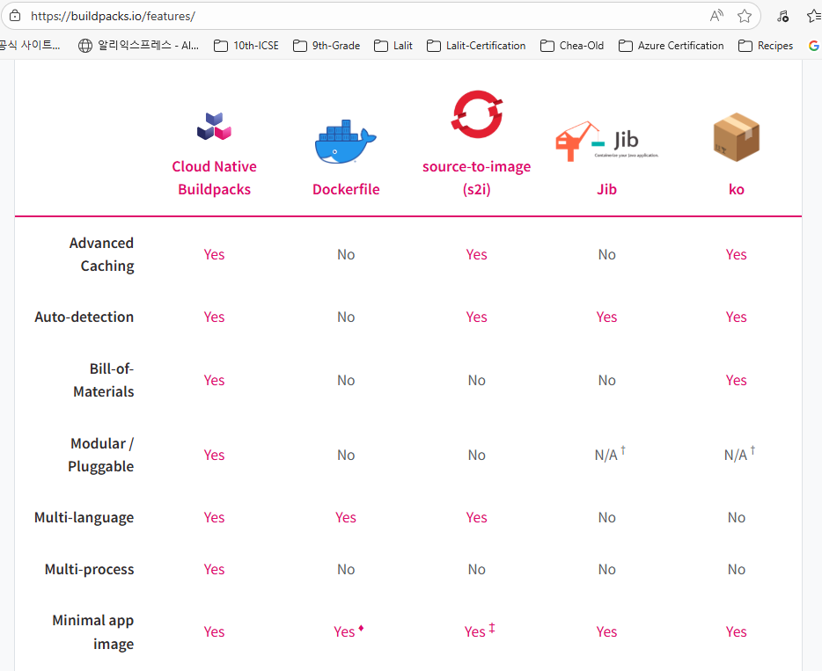

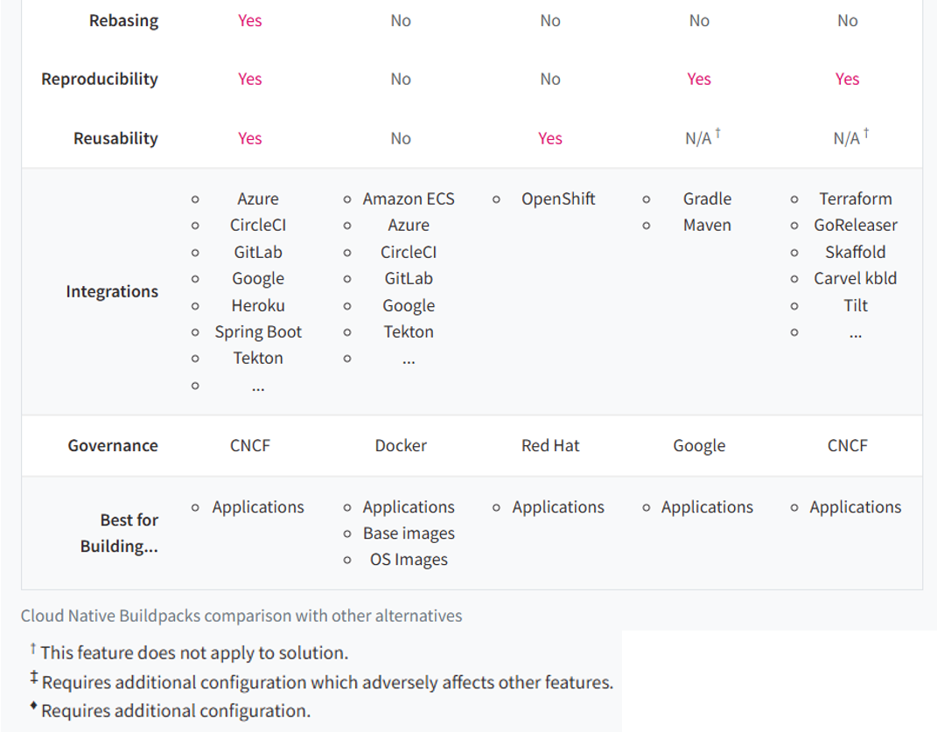

And apart from that, we also have other approaches like source to image and ko. Inside this ko I showed you three different approaches like Buildpacks, Dockerfile and Jib. That's why let's focus on them only and ignore the other approaches because those are not commonly used. You see here, Buildpacks is a winner in most of the scenarios like caching. Buildpacks is providing and the jib it is not providing this bill of materials Buildpacks is providing, Jib is not providing and similarly modular and pluggable Buildpacks is providing and multi-language support this is very, very important because Buildpack supports various languages and even the Docker file, whereas Jib is going to support only Java and same Multi-process Buildpacks is a winner.

Minimal app image both a buildpacks and jib by default provide, whereas dockerfile with some conditions. This way there are many other advantages and you can see Buildpacks is a clear winner. That's why you'll be seeing many people using Buildpacks. And this also give them flexibility. If they have different microservices based upon different languages, they can always use a buildpacks. But whereas if they go with jib, then only for Java based microservice, they can use jib and for the other microservice where they are using Python or any other language. In such scenarios they have to use buildpacks. So instead of using two different approaches they will go with the Buildpacks. They have microservices focusing on various languages. But the question right now is which one we are going to use inside this course. The approach that I'm going to use inside this course is jib. You may get surprise here, why I'm using Jib.

There are three different reasons why I'm going to use Jib inside this course.

1. The very first one is Jib is going to take very less time to generate a Docker image. It is going to super quick compared to Buildpacks. That's the very first reason and it is also going to take less memory inside my system. So inside local system, since I want to save some storage and ram memory, I'm going with this jib option. Even many of my students, they may have some laptops with eight GB Ram only or 16 GB Ram only. And since we are going to build lot many other microservice components in the coming sections, the following buildpacks inside local system, I won't recommend because it is going to need a lot of storage and ram capacity and many times it is going to be super slow.
2. The second reason why I'm preferring Jib or Buildpacks is right now our microservice is only Java based microservice. I don't have any intentions to develop microservice based upon other languages. That's why I'm not going to choose Buildpacks. I'll simply follow the jib. But in real projects where you have multi language microservice, please follow the buildpacks.
3. The last reason why I'm using jib is, Buildpacks has some issues inside the Mac operating systems. There are some official defects are also logged inside Buildpacks and the Buildpacks team is trying to fix them in the coming months or may take years also to stabilize these buildpacks inside the Mac operating system. Since I'm using Mac operating system and many of my students are also going to use Mac operating system. I don't want to follow an approach which is going to give some issues in a particular operating system, whereas I validated it is working perfectly fine in Windows Mac and at the same time it is also working perfectly Linux operating system. Buildpacks also working fine in Mac operating system like we saw in the loans demo, but it is going to work very slowly inside the Mac operating system. And few students may even have some challenges to generate a Docker image with the Buildpacks.

With all these reasons I am going with the jib approach inside this course. But like I said, in real projects where we use heavy servers to generate a Docker images, you can go with the Buildpacks because inside local system many of the softwares running and you may not have 32 GB Ram laptop or any other higher configurations. With all these reasons we are going with jib but not the Buildpacks, but in production applications I recommend Buildpacks. Off course, Jib also works for production applications. This buildpacks has more advantages like we saw like it supports advanced caching, it supports multiple languages. So there are many, many other advantages which you can identify by looking at this comparison table. I hope you are clear on why we are using Jib as a approach that we are going to continue to use throughout this course. So there is no bad and good approach. All of them are very good. They all have their own strengths and disadvantages. Please choose whatever works based upon your project and scenario.

### Pushing Local Images to Dockerhub Repository

As of now, we have the Docker images generated and they are available inside our local system. If you keep them inside your local system, then obviously it's not going to make sense. Because the images has to be eventually deployed into your production server or inside a dev server or QA server. To achieve this deployment in higher environment, just like how we push our code into the GitHub. Very similarly, we need to push our Docker images into a remote repository provided by the Docker hub or any other private registries available inside AWS, GCP Azure. So there are many private registries available even from GitHub also there is a private registry, but inside the course, like we discussed, we are going to store all our Docker images inside the remote repository provided by the Docker hub. For the same, we need to push our Docker images from local system into the remote Docker hub repository. The command that we need to run to push our Docker images into the Docker hub repository is docker space image space push. After this push you need to give the space and followed by docker.io. Since we decided to push our Docker images into the Docker hub, we need to provide this docker.io followed by what is your complete image name? So your image name should also have your Docker username, which is eazybytes in my case post that accounts. And what is the tag name? The tag name of my accounts microservice is S4. So this is a complete command that I need to use to push the image from my local system to the remote repository.

PS D:\...\accounts> docker images

REPOSITORY TAG IMAGE ID CREATED SIZE

lalitrnagpal/accounts s4 3f3d9823ad72 5 days ago 757MB

paketobuildpacks/run-jammy-tiny latest 4a3635d8e96b 12 days ago 38.7MB

lalitrnagpal/loans s4 048cf5d6b293 45 years ago 557MB

paketobuildpacks/builder-jammy-java-tiny latest da6ccadf9599 45 years ago 1.13GB

lalitrnagpal/cards s4 36eb5ff7f0d3 55 years ago 493MB

PS D:\...\accounts> docker image push docker.io/lalitrnagpal/accounts:s4

The push refers to repository [docker.io/lalitrnagpal/accounts]

1fe172e4850f: Pushed

44d3aa8d0766: Pushed

6ce99fdf16e8: Pushing [====================> ] 77.59MB/187.9MB

389234bc1800: Pushed

d8ee7a091f5f: Pushed

I have mentioned all the Docker commands that I have used inside the GitHub repository, so please refer them if you have any questions. Now let me try to execute this command. You see, my image is getting pushed into the remote repository provided by the Docker hub. Here you may have a question like I didn't give my credentials to push into the Docker hub. So there is a password for my account inside the Docker hub, but I have not provided that password or username anywhere inside my command. So here what my CLI will do is behind the scenes since I already logged in into my Docker desktop with the same username, it is going to fetch my username and password details from the Docker desktop. So the CLI and Docker desktop, they are going to work together and based upon the credentials that I have used to log in into my Docker desktop, the same is going to be utilized while we are trying to push our image into a remote repository.

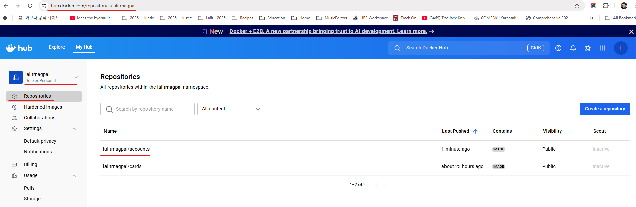

If you have not logged in into your Docker desktop or if there are no login details configured inside the local system, then obviously you will get an error saying that login failed or access denied. And here also make sure that you are mentioning your own Docker username. Don't mention myeazybytes username inside your docker push command because you will not have my credentials. That's why this is very very important to use your own username. And the same username also should be used inside your pom.xml or while generating a docker image. So your image name should have your username followed by your application name. And this is the tag name. Now I'm going to push my loans microservice image as well. The command is going to be the same instead of accounts, we are going to mention loans and I'm pushing the loans microservice right now. So you can see here this is being pushed from my local system into the remote repository.

After I logout from both the browser and docker desktop, I get the below behavior

PS D:\...\section4> docker image push docker.io/lalitrnagpal/loans:s4

The push refers to repository [docker.io/lalitrnagpal/loans]

0cebb6f35598: Waiting

bea0a3dc2651: Waiting

ac1aec1fa948: Waiting

a907216185f3: Waiting

40168ffbc66f: Waiting

78f775610b35: Waiting

5f70bf18a086: Waiting

979b659da65a: Waiting

1dc94a70dbaa: Waiting

18d9bfb23721: Waiting

366ce7d1a7f9: Waiting

460771a03062: Waiting

89732bc75041: Waiting

5f5c595091e4: Waiting

4585c2473079: Waiting

4d13fcd94d75: Waiting

3b28a7ec9e02: Waiting

6c77e73b74bc: Waiting

f0e9078fd509: Waiting

417e5bfc3c82: Waiting

push access denied, repository does not exist or may require authorization: server message: insufficient_scope: authorization failed

PS D:\002-Workspace\microservices\section4> docker login

USING WEB-BASED LOGIN

i Info → To sign in with credentials on the command line, use 'docker login -u <username>'

Your one-time device confirmation code is: JJLW-VPGN

Press ENTER to open your browser or submit your device code here: https://login.docker.com/activate

Waiting for authentication in the browser…

login canceled

PS D:\002-Workspace\microservices\section4> docker login -u lalitrnagpal

i Info → A Personal Access Token (PAT) can be used instead.

To create a PAT, visit https://app.docker.com/settings

Password:

Login Succeeded

After few seconds, my loans Docker image is also successfully pushed into the remote repository. As a next step, I can try to push my cards microservice. The command is going to be the same instead of loans, I'm going to mention the name cards. So you can see the command is Docker image push docker.io/eazybytes/cards and what is the tag name which is S4 here. So let me execute this command.

PS D:\...\section4> docker image push docker.io/lalitrnagpal/loans:s4

The push refers to repository [docker.io/lalitrnagpal/loans]

3b28a7ec9e02: Pushed

5f5c595091e4: Pushed

366ce7d1a7f9: Pushed

18d9bfb23721: Pushed

5f70bf18a086: Pushed

979b659da65a: Mounted from paketobuildpacks/run-jammy-tiny

4585c2473079: Pushed

bea0a3dc2651: Pushed

4d13fcd94d75: Pushed

78f775610b35: Pushed

a907216185f3: Pushed

f0e9078fd509: Pushed

0cebb6f35598: Mounted from paketobuildpacks/run-jammy-tiny

6c77e73b74bc: Pushed

417e5bfc3c82: Pushed

89732bc75041: Mounted from paketobuildpacks/builder-jammy-java-tiny

460771a03062: Pushed

1dc94a70dbaa: Pushed

ac1aec1fa948: Mounted from paketobuildpacks/run-jammy-tiny

40168ffbc66f: Pushed

s4: digest: sha256:048cf5d6b293388ae104ddb302ea6b0b7784471174a38056939e15c5f87661b0 size: 3432

This will also push my cards Docker image into my remote repository. So this is going to take few seconds, so let's wait for this to get completed. Now my Cards Docker image is also pushed into the remote repository. To validate if these images are really pushed into the remote repository or not. First, we can go to the Docker desktop. Here under these images you can see these are all the images available inside our local system. Very similarly, if you can click on this hub, this will show you all the images available inside your remote repository with the Docker account name eazybytes. So you can see there are three different Docker images with three different names along with the tag names. And when they are pushed, what is the size of them? All these details are available here.

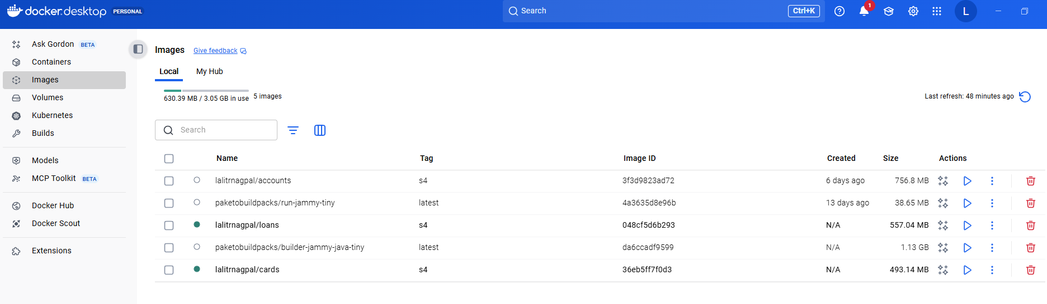

You can also validate these details by going into the Docker Hub website. So here I logged in into the Docker Hub website. And this is my username, which is eazybytes. You can see there are three different images pushed like this accounts is pushed nine minutes back and similarly loans pushed five minutes back and cards pushed two minutes back.

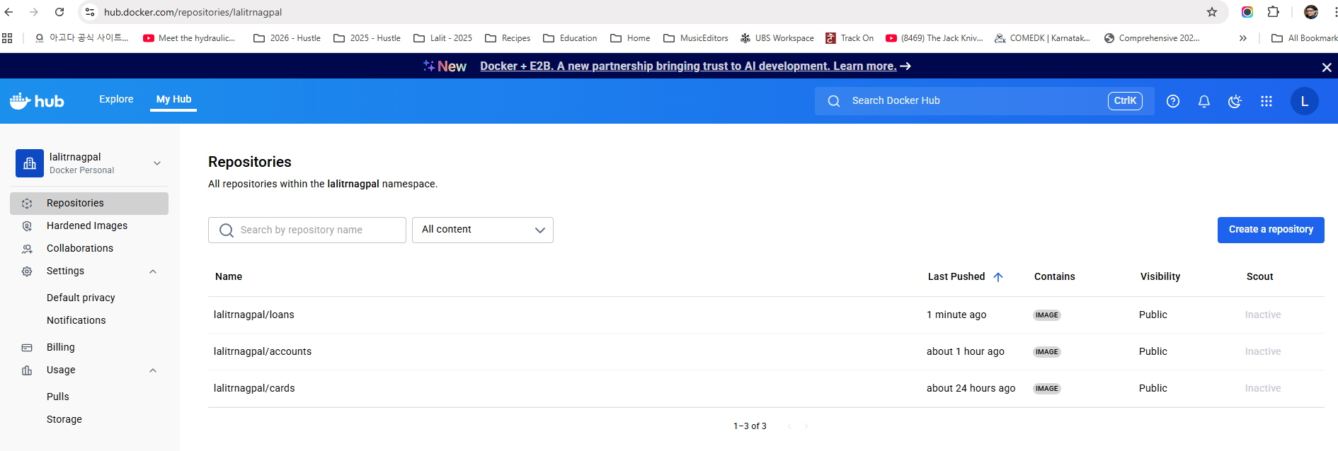

If you can click any of these image, you will have all the details. Like this image has a tag with the name S4. You can also see this image can be viewed by anyone. Since this public view is available. This means I can push into my Docker hub repository and anyone can pull my Docker images into their local system and they can start using them without any credentials. That's the meaning of this public view here. This is very similar to GitHub private repository and public repository, so this works very similarly. If you want to change this Docker image from public view to private view, then you need to go to the settings. Here under the visibility settings, you can make this as private, but like I said, with a basic personal plan, we can only have one image as a private repository. But I'm not going to make this as a private because I want my Docker images to be visible for everyone. So this is the default behavior of my Docker images that I have pushed.

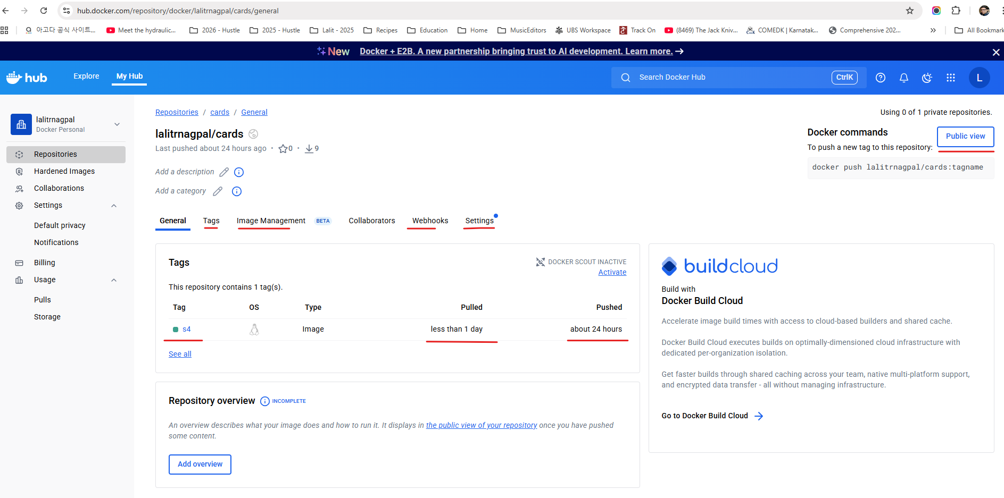

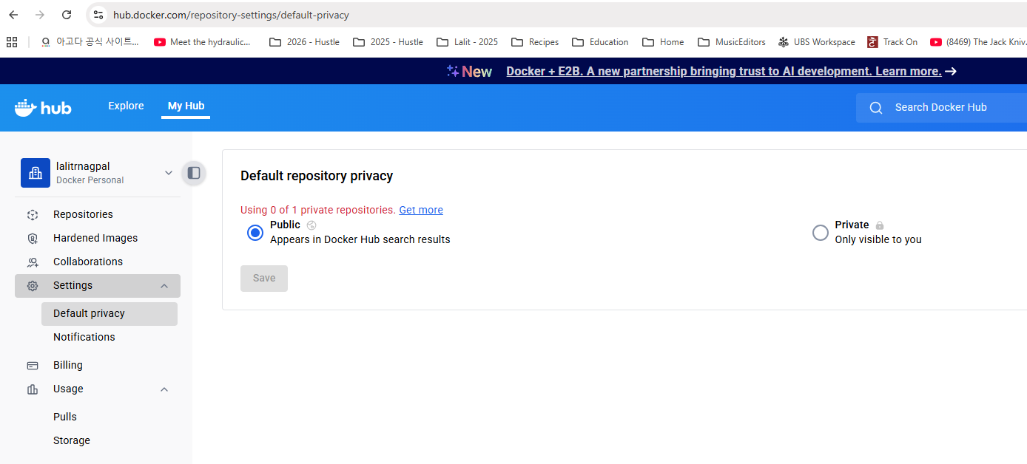

And if you want to understand more details about the tags available inside my Docker image, you can see as of now I have only one tag, which is S4. If anyone want to use this Docker image with this tag, they can simply execute this command docker pull eazybytes/cards:S4.

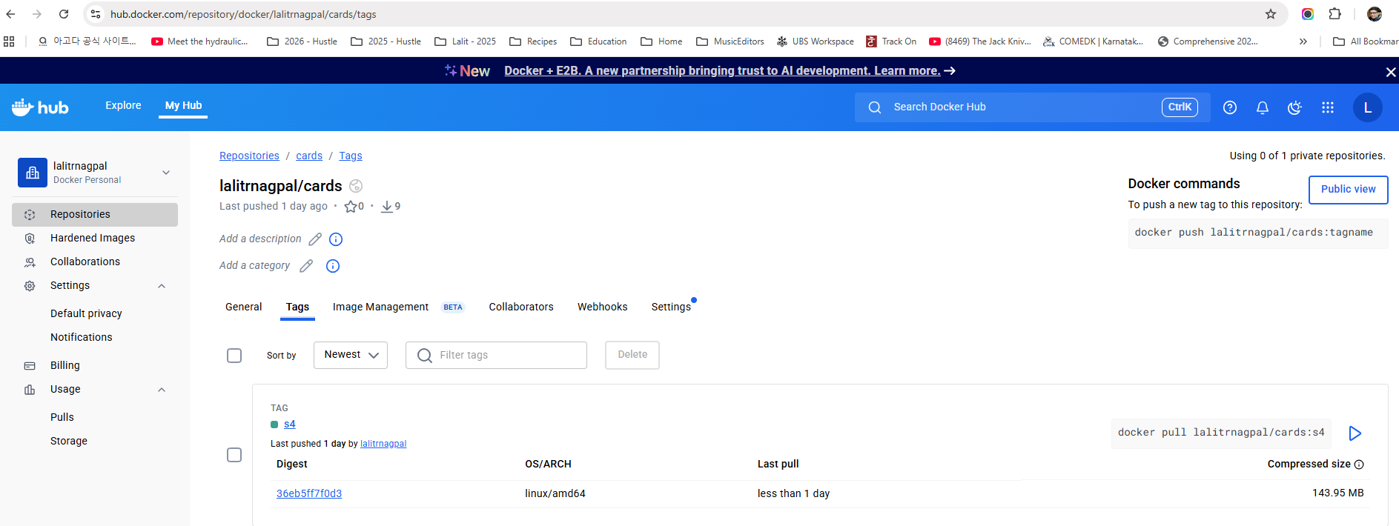

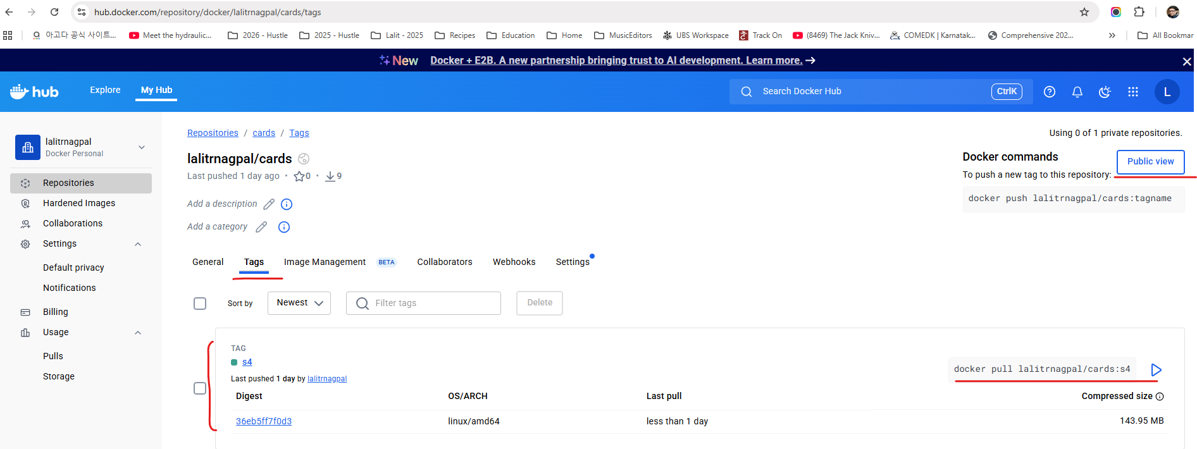

We can also try to validate the same. So let me copy this. I'll go to my Docker desktop. First I'll try to delete the cards Docker image from my mission. So I'm just selecting this cards. I'm clicking on this delete button. So let me click on this Delete forever. I'm not able to delete it because there is a container with this docker image created.

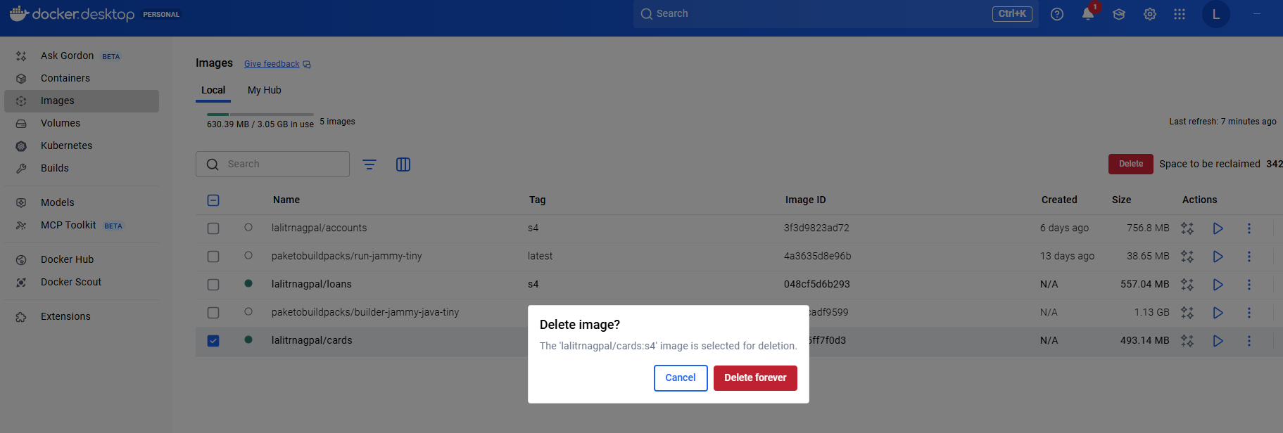

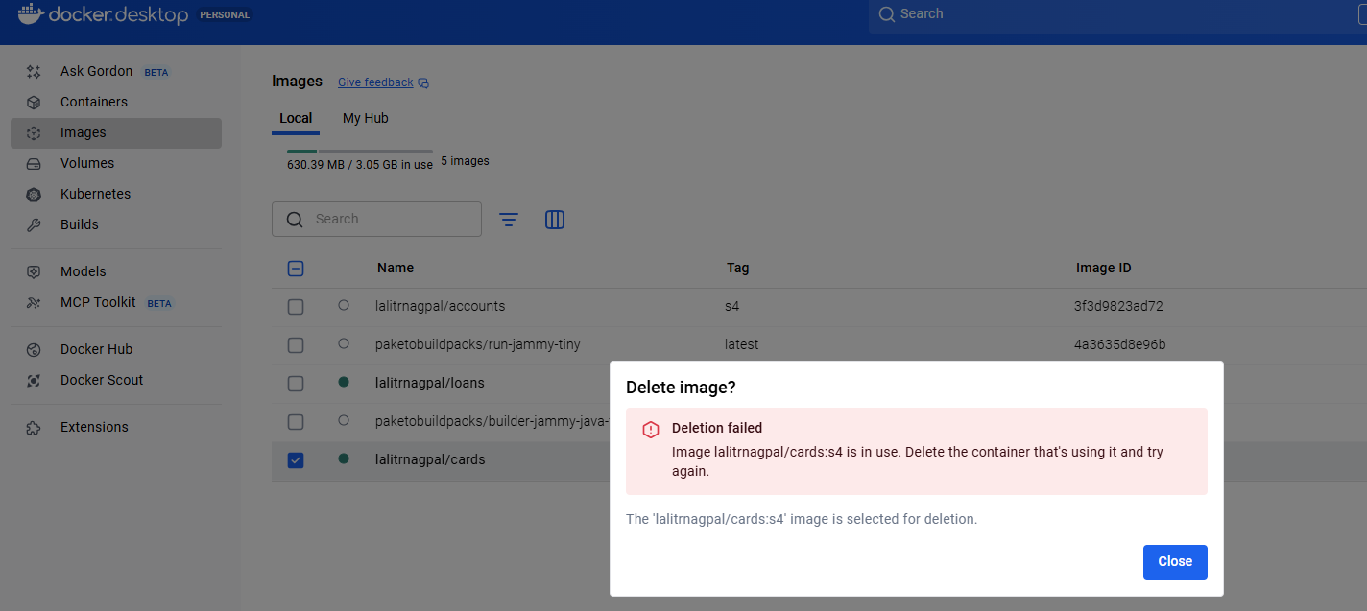

So first we need to delete the cards related container. So let me delete that post that I'll go to images and delete these cards Image.

Containers show the image they are using, but you can see further details using the inspect option

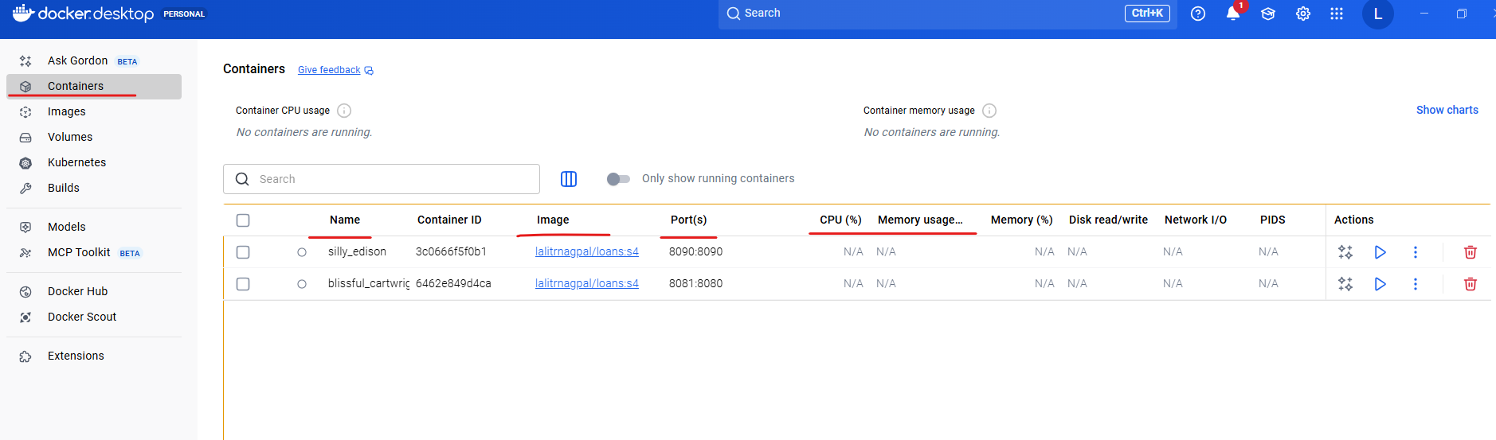

To see which container is using which image, click on the container and see under inspect

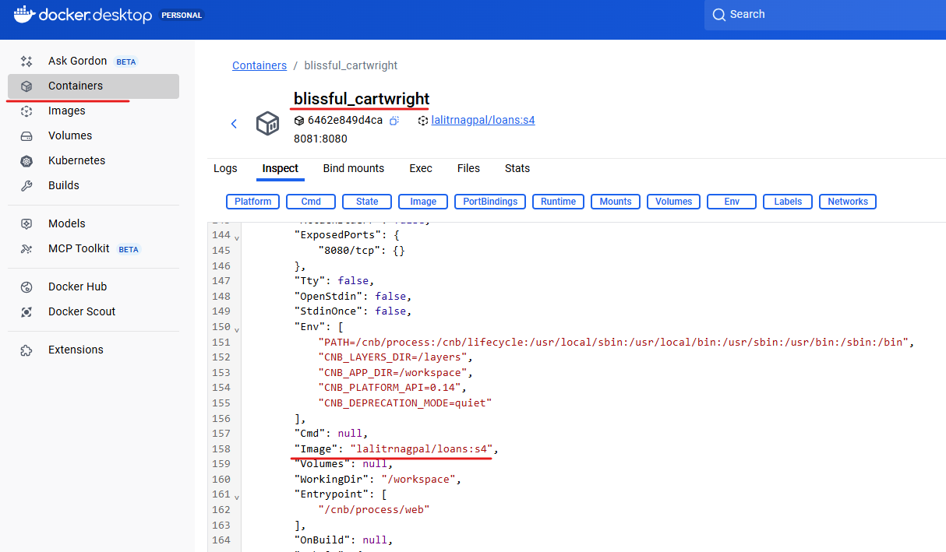

Below is the one for Cards

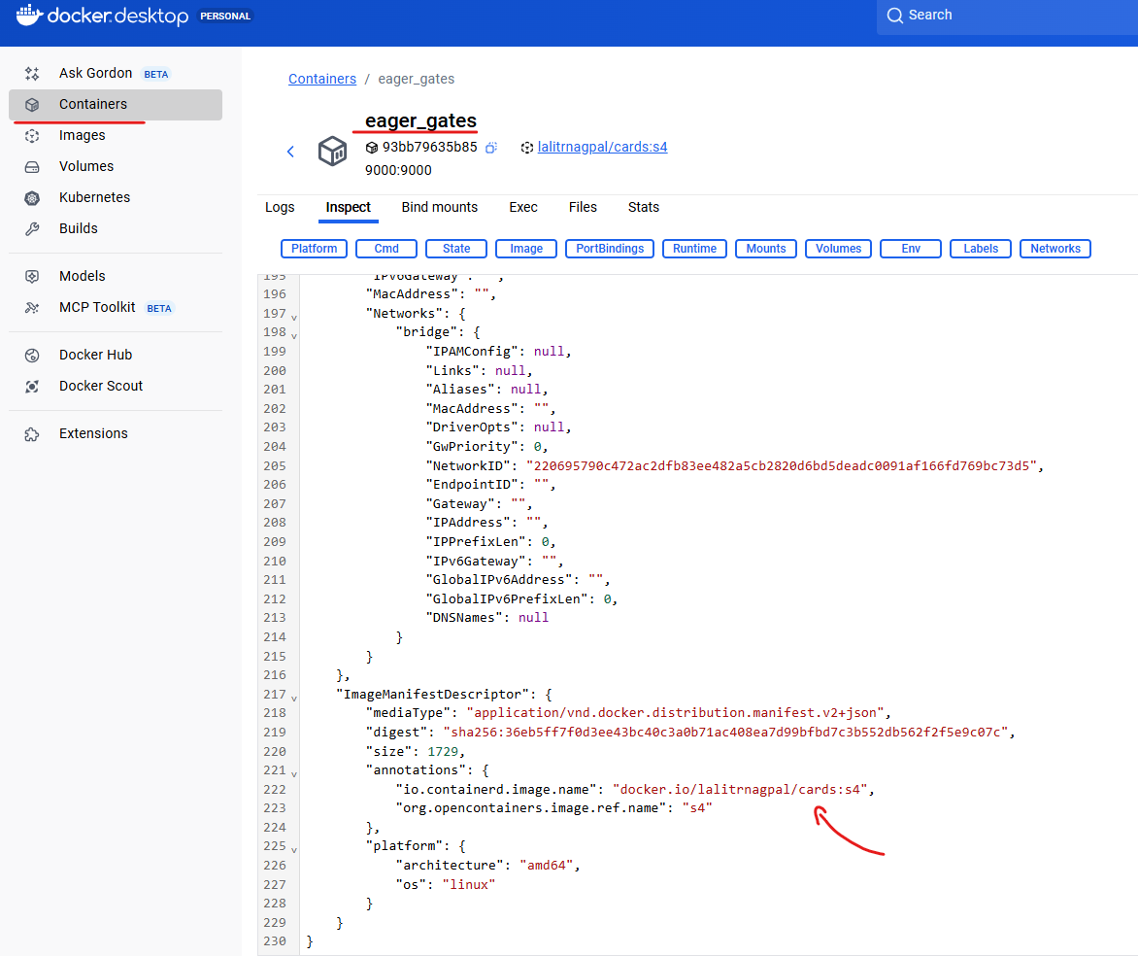

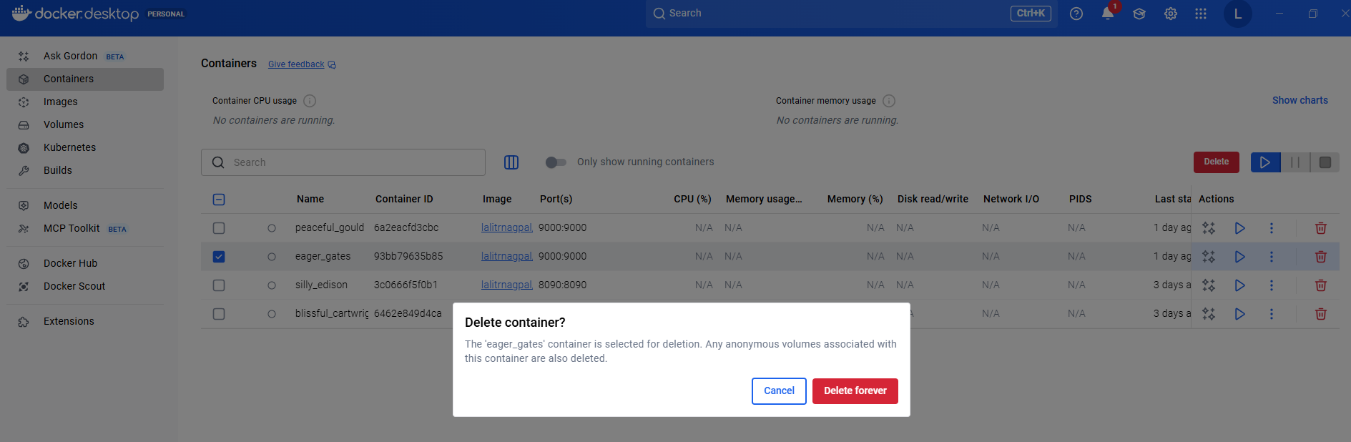

So now there is no Docker image of cards inside my local system, so I can also confirm the same by running Docker images.

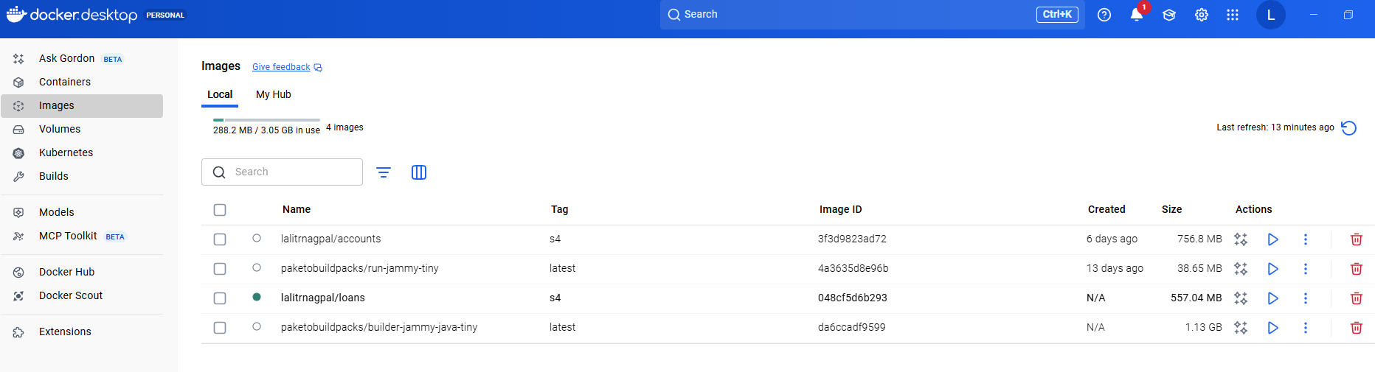

So you can see there is no cards related Docker image inside my system. So we can run the command which is Docker pull easybytes/cards:S4.

So this will download that image from the remote repository into my local system. I hope it is making sense to you. Docker Pull will do the exact opposite action of Docker push Docker push will take your Docker images from local system to the remote repository. Whereas if you want to fetch the images from remote repository into your local system, you need to use this docker pull command.

PS D:\002-Workspace\microservices\section4> docker pull lalitrnagpal/cards:s4

s4: Pulling from lalitrnagpal/cards

4b3ffd8ccb52: Pull complete

073011d3ceea: Pull complete

fd4969aa9957: Pull complete

075338da2d04: Pull complete

b315b75540ca: Pull complete

9712caec413d: Pull complete

c36a596532b6: Pull complete

f35cff1a101a: Pull complete

6d2c50dbf000: Pull complete

Digest: sha256:36eb5ff7f0d3ee43bc40c3a0b71ac408ea7d99bfbd7c3b552db562f2f5e9c07c

Status: Downloaded newer image for lalitrnagpal/cards:s4

docker.io/lalitrnagpal/cards:s4

PS D:\002-Workspace\microservices\section4>

So you can see it is being downloaded. Now the download is completed. If I try to run the Docker images again this time you should be able to see the cards inside my local system.

PS D:\002-Workspace\microservices\section4> docker images

REPOSITORY TAG IMAGE ID CREATED SIZE

lalitrnagpal/accounts s4 3f3d9823ad72 5 days ago 757MB

paketobuildpacks/run-jammy-tiny latest 4a3635d8e96b 13 days ago 38.7MB

lalitrnagpal/loans s4 048cf5d6b293 45 years ago 557MB

paketobuildpacks/builder-jammy-java-tiny latest da6ccadf9599 45 years ago 1.13GB

lalitrnagpal/cards s4 36eb5ff7f0d3 55 years ago 493MB

This way we can push our store any number of Docker images inside the remote repository provided by the Docker hub. From this Docker hub.

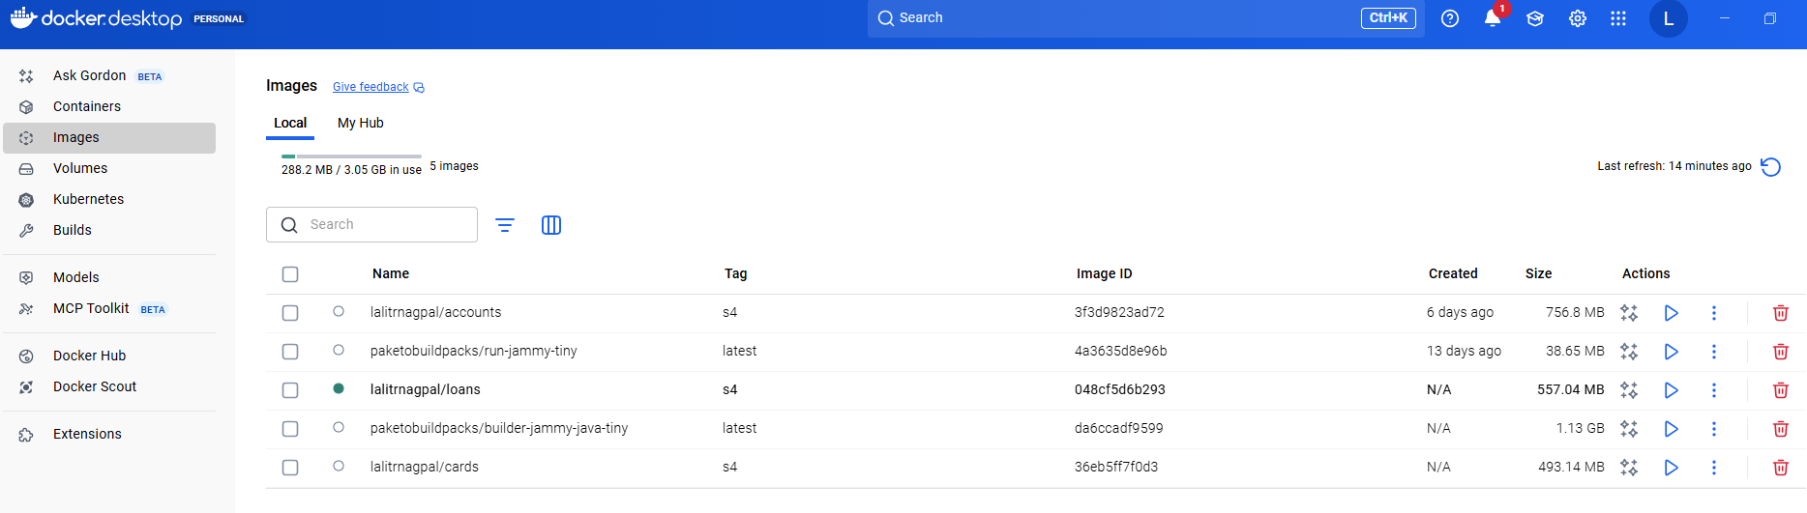

My teammates, they can pull the Docker images, they can use them, or we can have some CI/CD pipelines or tools to fetch the Docker images from my Docker hub and using the same Docker images, they are going to deploy my accounts microservice loans and cards, microservice in any of the cloud server or inside the virtual machines. I hope you are clear on how to push the images and pull the images.

### Docker Compose

We will see a problem that we face with the current setup that we have, and post that I'll also show you a solution for the problem. As of now, you can see we have three different images like cards, loans and accounts. These are the Docker images of three microservices that we have built so far to run our microservices we need to convert these Docker images into containers with the help of docker run command. So if I want to start my three microservice, I need to issue docker run command three different times along with the image name and the port mapping. What if I want to start multiple instances of my microservices in such scenarios, giving this docker run command manually for each microservice and for each instance of it is super, super cumbersome process and it is time consuming process. If I have 100 microservice, I need to issue these Docker run command 100 different times, which is not quite viable option for any human.

To overcome this challenge, we have another component inside Docker ecosystem with the name Docker Compose. Let me try to introduce this Docker Compose. So this is a location where you can read more details about the Docker compose.

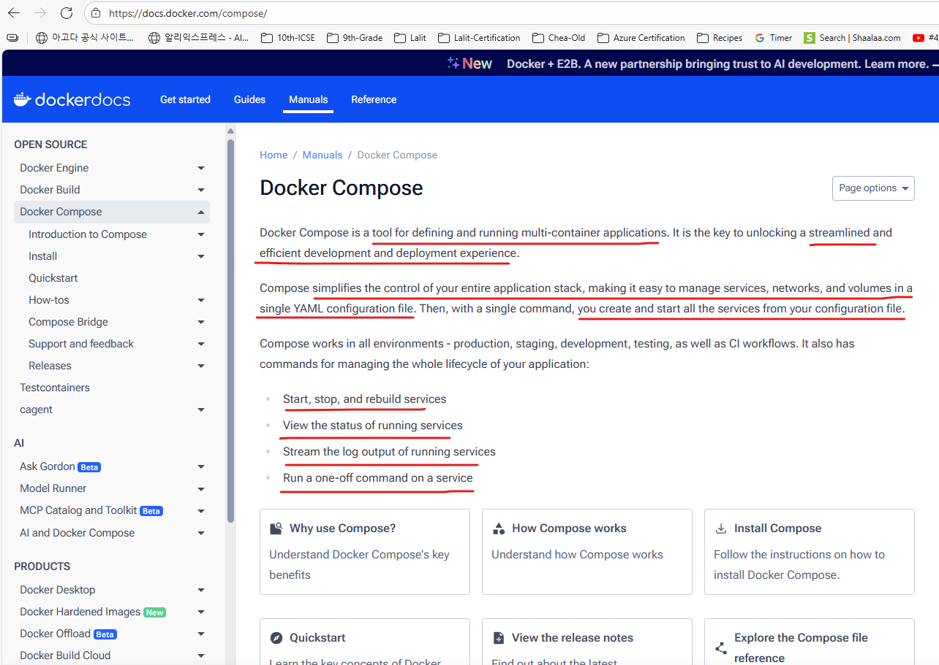

You can see Docker Compose is a tool for defining and running multiple container docker applications. So with the help of with Compose, we can use a Yaml file to configure all our application service. Then with a single command we can create or start all our services. So instead of running multiple Docker run commands, I can define all my Docker image details and how I want to start them inside a single Yaml file. Once I define all these details inside a single Yaml file, I can issue a single command and with a single command all of my microservice containers are going to start and this docker compose. We can make it work inside any environment like production, staging, development testing as well as continuous integration workflows. So that's why it is highly recommended to use Docker Compose. If you have multiple microservices inside your system and these Docker compose will help you to start, stop and rebuild services. View the status of running services. Stream the log output. Run a one off command. This way it has many other advantages. So whenever you install Docker desktop inside your system by default, Docker compose related components also will be installed. We can also validate the same by running a command which is Docker space compose version. This will print the what is the Docker compose version right now you have inside your system. So this is the version of Docker Compose right now that I have inside my system.

PS D:\002-Workspace\microservices\section4> docker compose version

Docker Compose version v2.40.2-desktop.1

PS D:\002-Workspace\microservices\section4>

And this also confirms that Docker Compose is installed inside my machine. For some reason, if you don't have this docker compose installed inside your system, don't worry, you can simply come to this page and here there is an link which will help you to install Docker compose inside your system. So please follow the steps based upon your operating system and you should be able to install the Docker compose successfully.

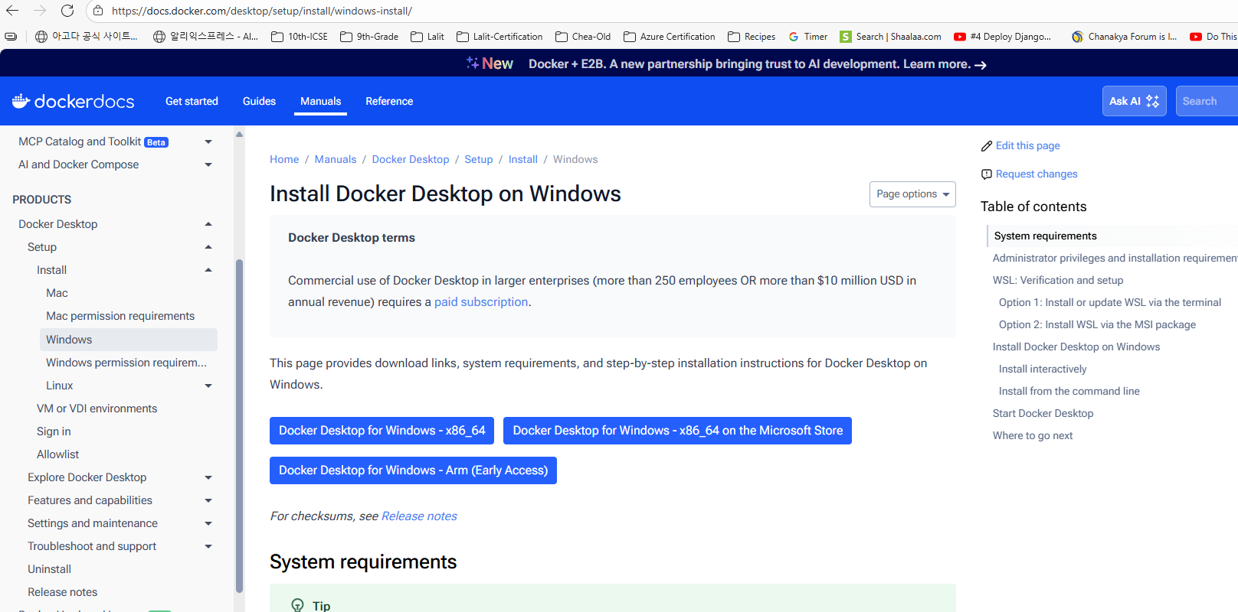

Now to get started with the Docker compose. Like I said, we need to write a configuration file and inside this configuration file we need to define all the details about our Docker images and how we want to start them. For the same, first, I need to create a configuration file and I'm going to create that under this accounts microservice. There is no specific reason on why I'm creating a configuration file under accounts. Since this is applicable for all microservices, you can create this configuration file any place. But since I want to check in this file into the GitHub repository I'm trying to create inside this accounts microservice maven project. So here I'm going to create a new file and the file name has to be docker-compose and the format are the extension of this Docker compose file should be yml. Because we are going to provide all our configuration details to the Docker server using Yaml format. So let me create this file. Post this you can see this is an Yaml file. It is automatically detected now here, since we want to define about all our service details, the very first syntax that we need to mention here is, services followed by colon – services:, and at these services we can define any number of service details. That's why we need to press enter and make sure there is a Tab space. If you don't have tab space then Yaml configuration is not going to work. You can see there is a tab space that I have created. After you have given tab space you can give, what is your service name? The service name that I want to give for accounts microservice is, accounts itself and under these accounts service I can provide the details like what is the image name that this service is going to use, For the same let me press enter as soon as I press enter since I'm using .yaml extension and there is a yaml plugin installed inside my intelliJ IDE.

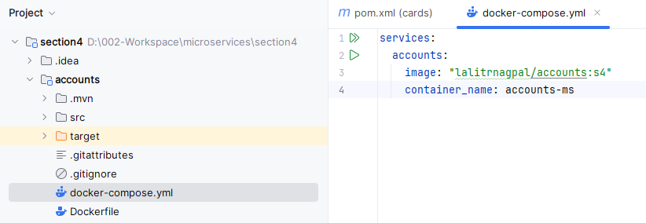

It is automatically giving a tab space. Right you can see I'm not exactly under the accounts so there is a tab space came into picture. Here since we want to provide the image details, I need to select the image and post that give colon followed by space. After that you can mention what is that accounts microservice image name. So the image name is eazybytes/accounts. And tag name is S4. If needed, you can also give this image name inside the double quotes so that will make your image name crystal clear to your docker compose file, post that we can give a container name. So with the help of this container_name, we can give a container name for our accounts microservice whenever it is trying to generate a new container from the Docker image that we have provided. So the container name that I'm going to give here is accounts-ms. MS indicates microservice. If you don't give this container, what will happen is whenever you are trying to create a container from your Docker image, a random name will be given to your container by the Docker server. You can also see under the containers right now there is a container of loans previously which we have created, so it has a random name which is angry Cannon.

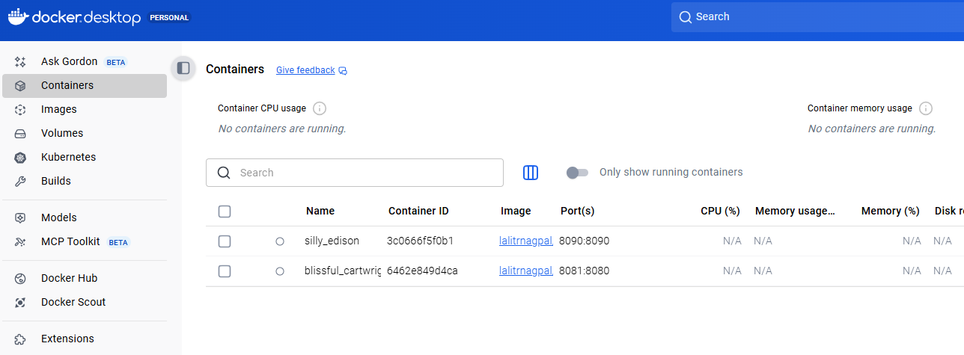

So with this I cannot really identify to which microservice this container belongs. So to identify that, I need to check the image details to avoid such inconvenience, we can define a name to our container. So this container is in running status. Let me stop this. So please make sure you have deleted all the containers inside your system so that you will get some space and memory inside your Docker desktop. Once we mention these container name, press enter and configure the ports mapping with the help of ports. So under the ports we can define multiple ports mapping. That's why inside the Yaml, whenever you are trying to provide multiple elements, we should follow this hyphen. So this hyphen indicates this is a single element inside an array like, you know, our accounts microservice is going to start at the port 8080 and at the same port I'm trying to expose to the external network. And if needed, if you want more number of port mapping, you can define multiple port mapping by pressing enter and following the syntax with the help of Hyphen.

**docker-compose.yml**

services:

accounts:

image: "lalitrnagpal/accounts:s4"

container_name: accounts-ms

ports:

- "8080:8080"

- "9090:9091"

But right now I don't have any requirements to create multiple port mappings, so that's why I'm deleting this and going to the same position where my ports is present. Now whenever my container is being created, I want to make sure that it has a maximum memory allocation. Beyond that, I don't want to assign that because inside my local system I have only 16 GB Ram. Since we are going to create multiple containers inside our course, we should make sure we are restricting our containers to a maximum memory. For the same, I need to mention a keyword which is deploy and this deploy you need to invoke resources. Post that under these resources, please invoke limits after the limits you can mention memory and under the memory mention 700 M with this I'm telling to this accounts microservice at a max I want to provide 700 M memory. Beyond that my Docker server is not going to assign.

services:

accounts:

image: "lalitrnagpal/accounts:s4"

container_name: accounts-ms

ports:

- "8080:8080"

deploy:

resources:

limits:

memory: 700m

So if you see there is a hierarchy that we have followed inside Yaml services is the parent and under the services there is a child with the name accounts under accounts we have details like image, container name, ports mapping and what are the deployment instructions. So under the deploy we have resources and a resources we have limits under the limits, we have memory. Now we can copy the same configuration and copy it at the same location where the accounts microservice details are mentioned. So please make sure this newly copied values are also present inside the same line where my accounts is present. Like you can see it is present in the same line portion. Now I can change this accounts to the loans because we want to mention the loans related configurations. Also, the image name is going to be changed to loans and the container name is going to be changed to the loans-ms. And the port mapping is going to be 8090 and the both sides and the deployment instructions are going to be the same. After loans, I'm going to copy the same again. And this time I'm going to rename all these loans details to cards. So let me do the same for image name as well. And the container name I'm going to change to cards-ms. And the port mapping is 9000:9000 the same I'm trying to mention here. And there is no change inside the deployment resource limits memory restrictions. Now if I try to start my services with this Docker compose file, all these services are going to start with a single command.

**docker-compose.yml**

services:

accounts:

image: "lalitrnagpal/accounts:s4"

container_name: accounts-ms

ports:

- "8080:8080"

deploy:

resources:

limits:

memory: 700m

loans:

image: "lalitrnagpal/loans:s4"

container_name: loans-ms

ports:

- "8090:8090"

deploy:

resources:

limits:

memory: 700m

cards:

image: "lalitrnagpal/cards:s4"

container_name: cards-ms

ports:

- "9000:9000"

deploy:

resources:

limits:

memory: 700m

As of now, there is no dependency between these microservices. They are all going to start in different, different isolated networks. What if I have a dependency between these microservices or what if in future, if I have a scenario where these microservices need to talk with each other? In that scenario, it is not going to work by default because all these services are going to get created inside their own network. So to make sure that the Intercommunication is working, we need to tag all these microservices under a same network by the same. What you have to do is just after these deploy instructions, mention networks, after these networks, we can define any number of networks. The network name that I want to mention here is EazyBank and this can be any name. So the same network information I'm going to mention for loans as well just after the deploy, I'll just make sure it is present exactly in the same portion of deploy. So let me do the same for cards as well. Now I have tagged a network to all my microservices with the name easybank to create a network with the name easybank. You can come to the place where the services is mentioned so you can see there is no space. I'm at the very first position of my line. Here I need to invoke a root element inside my docker compose and the root element is networks, just like how we have services at the root level. Similarly, we can also define networks. The network name that I want to create is the same name that we have configured inside our services. So this is the network that I want to create. So I'm just mentioning the easybank under my networks post that I'm just mentioning : followed by Driver under the driver, I'm going to mention bridge.

services:

accounts:

image: "lalitrnagpal/accounts:s4"

container_name: accounts-ms

ports:

- "8081:8081"

deploy:

resources:

limits:

memory: 700m

networks:

- lalitrnapgal-nw

loans:

image: "lalitrnagpal/loans:s4"

container_name: loans-ms

ports:

- "8090:8090"

deploy:

resources:

limits:

memory: 700m

networks:

- lalitrnapgal-nw

cards:

image: "lalitrnagpal/cards:s4"

container_name: cards-ms

ports:

- "9000:9000"

deploy:

resources:

limits:

memory: 700m

networks:

- lalitrnapgal-nw

networks:

lalitrnagpal:

driver: "bridge"

So with this I'm telling to my Docker server, please create a network with the name easybank with the driver bridge. Since I'm using the same network inside my accounts, microservice, loans microservice and the cards microservice. My Docker server is going to establish a bridge using which all my micro services they can communicate with each other. So this way we have defined all our instructions inside this docker compose Yaml file. Right now our docker compose file is ready. Inside the next lecture I'll show you how to start all our microservices with a single command. With the help of this Docker compose file.

#### Running using docker-compose

Let's see how to start all our microservices with the docker compose command. As of now, you can see I am into my cards microservice. So this is my present working directory. And inside this folder there is no docker-compose.yml file. If I try to give a command which is docker compose up, which is up with this docker compose up, we should be able to start all our microservices that we have defined inside our docker-compose.ymlfile. But the problem right now we may face is inside folder. We don't have this yml file. Let's see what error it is going to throw. So if I try to execute here you can see no configuration file provided, not found. That's why please make sure you are running this docker compose up command from the location where you are docker-compose.yml file is present.

PS D:\002-Workspace\microservices\section4> docker compose up

no configuration file provided: not found

So let me go back to the accounts folder and inside this folder we know that docker-compose.yml file is available. I can also confirm the same by running the command list. You can see there is an docker-compose.yml file. Now I'm going to run the docker compose up command.

PS D:\002-Workspace\microservices\section4\accounts> docker compose up

[+] Running 4/4

✔ Network accounts_lalitrnagpal_nw Created 0.1s

✔ Container loans-ms Created 0.2s

✔ Container accounts-ms Created 0.2s

✔ Container cards-ms Created 0.2s

Attaching to accounts-ms, cards-ms, loans-ms

loans-ms | Calculated JVM Memory Configuration: -XX:MaxDirectMemorySize=10M -Xmx82321K -XX:MaxMetaspaceSize=122478K -XX:ReservedCodeCacheSize=240M -Xss1M (Total Memory: 700M, Thread Count: 250, Loaded Class Count: 19210, Headroom: 0%)

loans-ms | Enabling Java Native Memory Tracking

loans-ms | Adding 146 container CA certificates to JVM truststore

loans-ms | Spring Cloud Bindings Enabled

loans-ms | Picked up JAVA_TOOL_OPTIONS: -Djava.security.properties=/layers/paketo-buildpacks_bellsoft-liberica/java-security-properties/java-security.properties -XX:+ExitOnOutOfMemoryError -XX:MaxDirectMemorySize=10M -Xmx82321K -XX:MaxMetaspaceSize=122478K -XX:ReservedCodeCacheSize=240M -Xss1M -XX:+UnlockDiagnosticVMOptions -XX:NativeMemoryTracking=summary -XX:+PrintNMTStatistics -Dorg.springframework.cloud.bindings.boot.enable=true

cards-ms |

cards-ms | . ____ _ __ _ _

cards-ms | /\\ / ___'_ __ _ _(_)_ __ __ _ \ \ \ \

cards-ms | ( ( )\___ | '_ | '_| | '_ \/ _` | \ \ \ \

cards-ms | \\/ ___)| |_)| | | | | || (_| | ) ) ) )

cards-ms | ' |____| .__|_| |_|_| |_\__, | / / / /

cards-ms | =========|_|==============|___/=/_/_/_/

cards-ms |

cards-ms | :: Spring Boot :: (v3.4.1)

cards-ms |

cards-ms | 2025-10-30T06:09:18.404Z INFO 1 --- [ main] com.eazybytes.cards.CardsApplication : Starting CardsApplication using Java 17.0.16 with PID 1 (/app/classes started by root in /)

cards-ms | 2025-10-30T06:09:18.409Z INFO 1 --- [ main] com.eazybytes.cards.CardsApplication : No active profile set, falling back to 1 default profile: "default"

loans-ms |

loans-ms | . ____ _ __ _ _

loans-ms | /\\ / ___'_ __ _ _(_)_ __ __ _ \ \ \ \

loans-ms | ( ( )\___ | '_ | '_| | '_ \/ _` | \ \ \ \

loans-ms | \\/ ___)| |_)| | | | | || (_| | ) ) ) )

loans-ms | ' |____| .__|_| |_|_| |_\__, | / / / /

loans-ms | =========|_|==============|___/=/_/_/_/

loans-ms |

loans-ms | :: Spring Boot :: (v3.4.1)

loans-ms |

loans-ms | 2025-10-30T06:09:19.211Z INFO 1 --- [loans] [ main] com.eazybytes.loans.LoansApplication : Starting LoansApplication v0.0.1-SNAPSHOT using Java 17.0.17 with PID 1 (/workspace/BOOT-INF/classes started by cnb in /workspace)

loans-ms | 2025-10-30T06:09:19.217Z DEBUG 1 --- [loans] [ main] com.eazybytes.loans.LoansApplication : Running with Spring Boot v3.4.1, Spring v6.2.1

loans-ms | 2025-10-30T06:09:19.219Z INFO 1 --- [loans] [ main] com.eazybytes.loans.LoansApplication : The following 1 profile is active: "prod"

cards-ms | 2025-10-30T06:09:20.737Z INFO 1 --- [ main] .s.d.r.c.RepositoryConfigurationDelegate : Bootstrapping Spring Data JPA repositories in DEFAULT mode.

cards-ms | 2025-10-30T06:09:20.860Z INFO 1 --- [ main] .s.d.r.c.RepositoryConfigurationDelegate : Finished Spring Data repository scanning in 101 ms. Found 1 JPA repository interface.

loans-ms | 2025-10-30T06:09:21.713Z INFO 1 --- [loans] [ main] .s.d.r.c.RepositoryConfigurationDelegate : Bootstrapping Spring Data JPA repositories in DEFAULT mode.

loans-ms | 2025-10-30T06:09:21.841Z INFO 1 --- [loans] [ main] .s.d.r.c.RepositoryConfigurationDelegate : Finished Spring Data repository scanning in 104 ms. Found 1 JPA repository interface.

cards-ms | 2025-10-30T06:09:22.249Z INFO 1 --- [ main] o.s.b.w.embedded.tomcat.TomcatWebServer : Tomcat initialized with port 9000 (http)

cards-ms | 2025-10-30T06:09:22.274Z INFO 1 --- [ main] o.apache.catalina.core.StandardService : Starting service [Tomcat]

cards-ms | 2025-10-30T06:09:22.275Z INFO 1 --- [ main] o.apache.catalina.core.StandardEngine : Starting Servlet engine: [Apache Tomcat/10.1.34]

cards-ms | 2025-10-30T06:09:22.464Z INFO 1 --- [ main] o.a.c.c.C.[Tomcat].[localhost].[/] : Initializing Spring embedded WebApplicationContext

cards-ms | 2025-10-30T06:09:22.468Z INFO 1 --- [ main] w.s.c.ServletWebServerApplicationContext : Root WebApplicationContext: initialization completed in 3904 ms

cards-ms | 2025-10-30T06:09:22.979Z INFO 1 --- [ main] com.zaxxer.hikari.HikariDataSource : HikariPool-1 - Starting...

cards-ms | 2025-10-30T06:09:23.345Z INFO 1 --- [ main] com.zaxxer.hikari.pool.HikariPool : HikariPool-1 - Added connection conn0: url=jdbc:h2:mem:testdb user=SA

cards-ms | 2025-10-30T06:09:23.349Z INFO 1 --- [ main] com.zaxxer.hikari.HikariDataSource : HikariPool-1 - Start completed.

loans-ms | 2025-10-30T06:09:23.540Z INFO 1 --- [loans] [ main] o.s.b.w.embedded.tomcat.TomcatWebServer : Tomcat initialized with port 8090 (http)

cards-ms | 2025-10-30T06:09:23.563Z INFO 1 --- [ main] o.hibernate.jpa.internal.util.LogHelper : HHH000204: Processing PersistenceUnitInfo [name: default]

loans-ms | 2025-10-30T06:09:23.574Z INFO 1 --- [loans] [ main] o.apache.catalina.core.StandardService : Starting service [Tomcat]

loans-ms | 2025-10-30T06:09:23.575Z INFO 1 --- [loans] [ main] o.apache.catalina.core.StandardEngine : Starting Servlet engine: [Apache Tomcat/10.1.34]

loans-ms | 2025-10-30T06:09:23.687Z INFO 1 --- [loans] [ main] o.a.c.c.C.[Tomcat].[localhost].[/] : Initializing Spring embedded WebApplicationContext

loans-ms | 2025-10-30T06:09:23.690Z INFO 1 --- [loans] [ main] w.s.c.ServletWebServerApplicationContext : Root WebApplicationContext: initialization completed in 4308 ms

cards-ms | 2025-10-30T06:09:23.720Z INFO 1 --- [ main] org.hibernate.Version : HHH000412: Hibernate ORM core version 6.6.4.Final

cards-ms | 2025-10-30T06:09:23.819Z INFO 1 --- [ main] o.h.c.internal.RegionFactoryInitiator : HHH000026: Second-level cache disabled

loans-ms | 2025-10-30T06:09:24.245Z INFO 1 --- [loans] [ main] com.zaxxer.hikari.HikariDataSource : HikariPool-1 - Starting...

cards-ms | 2025-10-30T06:09:24.381Z INFO 1 --- [ main] o.s.o.j.p.SpringPersistenceUnitInfo : No LoadTimeWeaver setup: ignoring JPA class transformer

cards-ms | 2025-10-30T06:09:24.482Z WARN 1 --- [ main] org.hibernate.orm.deprecation : HHH90000025: H2Dialect does not need to be specified explicitly using 'hibernate.dialect' (remove the property setting and it will be selected by default)

cards-ms | 2025-10-30T06:09:24.518Z INFO 1 --- [ main] org.hibernate.orm.connections.pooling : HHH10001005: Database info:

cards-ms | Database JDBC URL [Connecting through datasource 'HikariDataSource (HikariPool-1)']

cards-ms | Database driver: undefined/unknown

cards-ms | Database version: 2.3.232

cards-ms | Autocommit mode: undefined/unknown

cards-ms | Isolation level: undefined/unknown

cards-ms | Minimum pool size: undefined/unknown

cards-ms | Maximum pool size: undefined/unknown

loans-ms | 2025-10-30T06:09:24.696Z INFO 1 --- [loans] [ main] com.zaxxer.hikari.pool.HikariPool : HikariPool-1 - Added connection conn0: url=jdbc:h2:mem:testdb user=SA

loans-ms | 2025-10-30T06:09:24.701Z INFO 1 --- [loans] [ main] com.zaxxer.hikari.HikariDataSource : HikariPool-1 - Start completed.

loans-ms | 2025-10-30T06:09:24.955Z INFO 1 --- [loans] [ main] o.hibernate.jpa.internal.util.LogHelper : HHH000204: Processing PersistenceUnitInfo [name: default]

loans-ms | 2025-10-30T06:09:25.106Z INFO 1 --- [loans] [ main] org.hibernate.Version : HHH000412: Hibernate ORM core version 6.6.4.Final

loans-ms | 2025-10-30T06:09:25.191Z INFO 1 --- [loans] [ main] o.h.c.internal.RegionFactoryInitiator : HHH000026: Second-level cache disabled

loans-ms | 2025-10-30T06:09:25.803Z INFO 1 --- [loans] [ main] o.s.o.j.p.SpringPersistenceUnitInfo : No LoadTimeWeaver setup: ignoring JPA class transformer

loans-ms | 2025-10-30T06:09:25.920Z WARN 1 --- [loans] [ main] org.hibernate.orm.deprecation : HHH90000025: H2Dialect does not need to be specified explicitly using 'hibernate.dialect' (remove the property setting and it will be selected by default)

loans-ms | 2025-10-30T06:09:25.962Z INFO 1 --- [loans] [ main] org.hibernate.orm.connections.pooling : HHH10001005: Database info:

loans-ms | Database JDBC URL [Connecting through datasource 'HikariDataSource (HikariPool-1)']

loans-ms | Database driver: undefined/unknown

loans-ms | Database version: 2.3.232

loans-ms | Autocommit mode: undefined/unknown

loans-ms | Isolation level: undefined/unknown

loans-ms | Minimum pool size: undefined/unknown

loans-ms | Maximum pool size: undefined/unknown

cards-ms | 2025-10-30T06:09:26.246Z INFO 1 --- [ main] o.h.e.t.j.p.i.JtaPlatformInitiator : HHH000489: No JTA platform available (set 'hibernate.transaction.jta.platform' to enable JTA platform integration)

cards-ms | Hibernate: alter table if exists cards alter column card_id set data type bigint

cards-ms | Hibernate: alter table if exists cards alter column created_at set data type timestamp(6)

cards-ms | Hibernate: alter table if exists cards alter column created_by set data type varchar(255)

cards-ms | Hibernate: alter table if exists cards alter column updated_at set data type timestamp(6)

cards-ms | Hibernate: alter table if exists cards alter column updated_by set data type varchar(255)

cards-ms | Hibernate: alter table if exists cards alter column card_number set data type varchar(255)

cards-ms | Hibernate: alter table if exists cards alter column card_type set data type varchar(255)

cards-ms | Hibernate: alter table if exists cards alter column mobile_number set data type varchar(255)

cards-ms | 2025-10-30T06:09:28.475Z INFO 1 --- [ main] j.LocalContainerEntityManagerFactoryBean : Initialized JPA EntityManagerFactory for persistence unit 'default'

cards-ms | 2025-10-30T06:09:29.655Z WARN 1 --- [ main] JpaBaseConfiguration$JpaWebConfiguration : spring.jpa.open-in-view is enabled by default. Therefore, database queries may be performed during view rendering. Explicitly configure spring.jpa.open-in-view to disable this warning

loans-ms | 2025-10-30T06:09:30.066Z INFO 1 --- [loans] [ main] o.h.e.t.j.p.i.JtaPlatformInitiator : HHH000489: No JTA platform available (set 'hibernate.transaction.jta.platform' to enable JTA platform integration)

loans-ms | Hibernate: alter table if exists loans alter column loan_id set data type bigint

loans-ms | Hibernate: alter table if exists loans alter column created_at set data type timestamp(6)

loans-ms | Hibernate: alter table if exists loans alter column created_by set data type varchar(255)

loans-ms | Hibernate: alter table if exists loans alter column updated_at set data type timestamp(6)

loans-ms | Hibernate: alter table if exists loans alter column updated_by set data type varchar(255)

loans-ms | Hibernate: alter table if exists loans alter column loan_number set data type varchar(255)

loans-ms | Hibernate: alter table if exists loans alter column loan_type set data type varchar(255)

loans-ms | Hibernate: alter table if exists loans alter column mobile_number set data type varchar(255)

loans-ms | 2025-10-30T06:09:30.226Z INFO 1 --- [loans] [ main] j.LocalContainerEntityManagerFactoryBean : Initialized JPA EntityManagerFactory for persistence unit 'default'

cards-ms | 2025-10-30T06:09:31.103Z INFO 1 --- [ main] o.s.b.a.h2.H2ConsoleAutoConfiguration : H2 console available at '/h2-console'. Database available at 'jdbc:h2:mem:testdb'

cards-ms | 2025-10-30T06:09:31.195Z INFO 1 --- [ main] o.s.b.a.e.web.EndpointLinksResolver : Exposing 1 endpoint beneath base path '/actuator'

loans-ms | 2025-10-30T06:09:31.385Z WARN 1 --- [loans] [ main] JpaBaseConfiguration$JpaWebConfiguration : spring.jpa.open-in-view is enabled by default. Therefore, database queries may be performed during view rendering. Explicitly configure spring.jpa.open-in-view to disable this warning

cards-ms | 2025-10-30T06:09:31.385Z INFO 1 --- [ main] o.s.b.w.embedded.tomcat.TomcatWebServer : Tomcat started on port 9000 (http) with context path '/'

cards-ms | 2025-10-30T06:09:31.427Z INFO 1 --- [ main] com.eazybytes.cards.CardsApplication : Started CardsApplication in 13.755 seconds (process running for 14.589)

loans-ms | 2025-10-30T06:09:33.068Z INFO 1 --- [loans] [ main] o.s.b.a.h2.H2ConsoleAutoConfiguration : H2 console available at '/h2-console'. Database available at 'jdbc:h2:mem:testdb'

loans-ms | 2025-10-30T06:09:33.137Z INFO 1 --- [loans] [ main] o.s.b.a.e.web.EndpointLinksResolver : Exposing 15 endpoints beneath base path '/actuator'

loans-ms | 2025-10-30T06:09:33.299Z INFO 1 --- [loans] [ main] o.s.b.w.embedded.tomcat.TomcatWebServer : Tomcat started on port 8090 (http) with context path '/'

loans-ms | 2025-10-30T06:09:33.328Z INFO 1 --- [loans] [ main] com.eazybytes.loans.LoansApplication : Started LoansApplication in 15.235 seconds (process running for 16.091)

The app on port 8080 did not get created as port was already busy, so lets free that port

PS D:\002-Workspace\microservices\section4\accounts> netstat -ano | findstr :8080

TCP 0.0.0.0:8080 0.0.0.0:0 LISTENING 5860

TCP [::]:8080 [::]:0 LISTENING 5860

PS D:\002-Workspace\microservices\section4\accounts> tasklist /fi "PID eq 5860"

Image Name PID Session Name Session# Mem Usage

========================= ======== ================ =========== ============

AgentService.exe 5860 Services 0 2,340 K

**docker-compose.yml**

services:

accounts:

image: "lalitrnagpal/accounts:s4"

container_name: accounts-ms

ports:

- "8081:8081"

deploy:

resources:

limits:

memory: 700m

networks:

- lalitrnapgal-nw

loans:

image: "lalitrnagpal/loans:s4"

container_name: loans-ms

ports:

- "8090:8090"

deploy:

resources:

limits:

memory: 700m

networks:

- lalitrnapgal-nw

cards:

image: "lalitrnagpal/cards:s4"

container_name: cards-ms

ports:

- "9000:9000"

deploy:

resources:

limits:

memory: 700m

networks:

- lalitrnapgal-nw

networks:

lalitrnagpal:

driver: "bridge"

PS D:\002-Workspace\microservices\section4\accounts> docker compose up

[+] Running 3/3

✔ Container loans-ms Running 0.0s

✔ Container cards-ms Running 0.0s

✔ Container accounts-ms Recreated 0.2s

Attaching to accounts-ms, cards-ms, loans-ms

accounts-ms |

accounts-ms | . ____ _ __ _ _

accounts-ms | /\\ / ___'_ __ _ _(_)_ __ __ _ \ \ \ \

accounts-ms | ( ( )\___ | '_ | '_| | '_ \/ _` | \ \ \ \

accounts-ms | \\/ ___)| |_)| | | | | || (_| | ) ) ) )

accounts-ms | ' |____| .__|_| |_|_| |_\__, | / / / /

accounts-ms | =========|_|==============|___/=/_/_/_/

accounts-ms |

accounts-ms | :: Spring Boot :: (v3.5.6)

accounts-ms |

accounts-ms | 2025-10-30T06:20:45.691Z INFO 1 --- [ main] c.e.accounts.AccountsApplication : Starting AccountsApplication v0.0.1-SNAPSHOT using Java 17.0.2 with PID 1 (/accounts-0.0.1-SNAPSHOT.jar started by root in /)

accounts-ms | 2025-10-30T06:20:45.696Z INFO 1 --- [ main] c.e.accounts.AccountsApplication : No active profile set, falling back to 1 default profile: "default"

accounts-ms | 2025-10-30T06:20:47.331Z INFO 1 --- [ main] .s.d.r.c.RepositoryConfigurationDelegate : Bootstrapping Spring Data JPA repositories in DEFAULT mode.

accounts-ms | 2025-10-30T06:20:47.455Z INFO 1 --- [ main] .s.d.r.c.RepositoryConfigurationDelegate : Finished Spring Data repository scanning in 99 ms. Found 2 JPA repository interfaces.

accounts-ms | 2025-10-30T06:20:48.564Z INFO 1 --- [ main] o.s.b.w.embedded.tomcat.TomcatWebServer : Tomcat initialized with port 8080 (http)

accounts-ms | 2025-10-30T06:20:48.591Z INFO 1 --- [ main] o.apache.catalina.core.StandardService : Starting service [Tomcat]

accounts-ms | 2025-10-30T06:20:48.592Z INFO 1 --- [ main] o.apache.catalina.core.StandardEngine : Starting Servlet engine: [Apache Tomcat/10.1.46]

accounts-ms | 2025-10-30T06:20:48.665Z INFO 1 --- [ main] o.a.c.c.C.[Tomcat].[localhost].[/] : Initializing Spring embedded WebApplicationContext

accounts-ms | 2025-10-30T06:20:48.668Z INFO 1 --- [ main] w.s.c.ServletWebServerApplicationContext : Root WebApplicationContext: initialization completed in 2852 ms

accounts-ms | 2025-10-30T06:20:48.855Z INFO 1 --- [ main] com.zaxxer.hikari.HikariDataSource : HikariPool-1 - Starting...

accounts-ms | 2025-10-30T06:20:49.195Z INFO 1 --- [ main] com.zaxxer.hikari.pool.HikariPool : HikariPool-1 - Added connection conn0: url=jdbc:h2:mem:testdb user=SA

accounts-ms | 2025-10-30T06:20:49.197Z INFO 1 --- [ main] com.zaxxer.hikari.HikariDataSource : HikariPool-1 - Start completed.

accounts-ms | 2025-10-30T06:20:49.380Z INFO 1 --- [ main] o.hibernate.jpa.internal.util.LogHelper : HHH000204: Processing PersistenceUnitInfo [name: default]

accounts-ms | 2025-10-30T06:20:49.515Z INFO 1 --- [ main] org.hibernate.Version : HHH000412: Hibernate ORM core version 6.6.29.Final

accounts-ms | 2025-10-30T06:20:49.594Z INFO 1 --- [ main] o.h.c.internal.RegionFactoryInitiator : HHH000026: Second-level cache disabled

accounts-ms | 2025-10-30T06:20:50.054Z INFO 1 --- [ main] o.s.o.j.p.SpringPersistenceUnitInfo : No LoadTimeWeaver setup: ignoring JPA class transformer

accounts-ms | 2025-10-30T06:20:50.175Z INFO 1 --- [ main] org.hibernate.orm.connections.pooling : HHH10001005: Database info:

accounts-ms | Database JDBC URL [Connecting through datasource 'HikariDataSource (HikariPool-1)']

accounts-ms | Database driver: undefined/unknown

accounts-ms | Database version: 2.3.232

accounts-ms | Autocommit mode: undefined/unknown

accounts-ms | Isolation level: undefined/unknown

accounts-ms | Minimum pool size: undefined/unknown

accounts-ms | Maximum pool size: undefined/unknown

accounts-ms | 2025-10-30T06:20:51.288Z INFO 1 --- [ main] o.h.e.t.j.p.i.JtaPlatformInitiator : HHH000489: No JTA platform available (set 'hibernate.transaction.jta.platform' to enable JTA platform integration)

accounts-ms | 2025-10-30T06:20:51.320Z INFO 1 --- [ main] j.LocalContainerEntityManagerFactoryBean : Initialized JPA EntityManagerFactory for persistence unit 'default'

accounts-ms | 2025-10-30T06:20:52.007Z WARN 1 --- [ main] JpaBaseConfiguration$JpaWebConfiguration : spring.jpa.open-in-view is enabled by default. Therefore, database queries may be performed during view rendering. Explicitly configure spring.jpa.open-in-view to disable this warning

accounts-ms | 2025-10-30T06:20:52.663Z INFO 1 --- [ main] o.s.b.w.embedded.tomcat.TomcatWebServer : Tomcat started on port 8080 (http) with context path '/'

accounts-ms | 2025-10-30T06:20:52.699Z INFO 1 --- [ main] c.e.accounts.AccountsApplication : Started AccountsApplication in 8.06 seconds (process running for 9.317)

You can see behind the scenes it is trying to start my containers and right now my terminal is also free. So let me clear the console and try to run the command, which is docker ps. So with the single command, I'm able to start three different microservice that are running at the port 8080:8090, 9000. These are the container names that we have created. We can also confirm the same inside the Docker desktop. So under the containers you can see since I'm trying to run my docker compose command from the accounts folder, the parent folder will come here. So under this accounts folder we have three different microservices are running.

PS D:\002-Workspace\microservices\section4\accounts> docker ps -a

CONTAINER ID IMAGE COMMAND CREATED STATUS PORTS NAMES

977db9df1f6f lalitrnagpal/accounts:s4 "java -jar accounts-…" 2 minutes ago Up 2 minutes 0.0.0.0:8081->8081/tcp, [::]:8081->8081/tcp accounts-ms

7622cd88d1d0 lalitrnagpal/loans:s4 "/cnb/process/web" 13 minutes ago Up 13 minutes 0.0.0.0:8090->8090/tcp, [::]:8090->8090/tcp loans-ms

90e0049ab2c0 lalitrnagpal/cards:s4 "java -cp @/app/jib-…" 13 minutes ago Up 13 minutes 0.0.0.0:9000->9000/tcp, [::]:9000->9000/tcp cards-ms

3c0666f5f0b1 lalitrnagpal/loans:s4 "/cnb/process/web" 3 days ago Exited (137) 28 hours ago silly_edison

6462e849d4ca lalitrnagpal/loans:s4 "/cnb/process/web" 3 days ago Exited (143) 3 days ago blissful_cartwright

If I try to run this command, all my containers are going to start and the same log is going to be displayed inside my terminal. I don't want to keep my terminal busy, so that's why I'm going to start this in a detached mode. -d will start all your containers behind the scenes, so let me try to execute this command.

PS D:\002-Workspace\microservices\section4\accounts> docker compose up -d

[+] Running 3/3

✔ Container loans-ms Started 0.6s

✔ Container accounts-ms Started 0.6s

✔ Container cards-ms Started 0.7s

PS D:\002-Workspace\microservices\section4\accounts>

Otherwise when you press ctrl + c – all the containers stop

Gracefully Stopping... press Ctrl+C again to force

Container cards-ms Stopping

Container accounts-ms Stopping

Container accounts-ms Stopped

Container cards-ms Stopped

Container loans-ms Stopped

PS D:\002-Workspace\microservices\section4\accounts> docker ps -a

CONTAINER ID IMAGE COMMAND CREATED STATUS PORTS NAMES

977db9df1f6f lalitrnagpal/accounts:s4 "java -jar accounts-…" 4 hours ago Exited (143) About a minute ago accounts-ms

7622cd88d1d0 lalitrnagpal/loans:s4 "/cnb/process/web" 4 hours ago Exited (143) About a minute ago loans-ms

90e0049ab2c0 lalitrnagpal/cards:s4 "java -cp @/app/jib-…" 4 hours ago Exited (143) About a minute ago cards-ms

3c0666f5f0b1 lalitrnagpal/loans:s4 "/cnb/process/web" 3 days ago Exited (137) 31 hours ago silly_edison

6462e849d4ca lalitrnagpal/loans:s4 "/cnb/process/web" 3 days ago Exited (143) 3 days ago blissful_cartwright

One is loans microservice, and the third one is cards microservice for accounts microservice you may have question like why it is showing only ms but not accounts-ms. The accounts is already present here. That's why it is not showing accounts-ms again here. I think it's a kind of bug inside the Docker desktop, but that's fine.

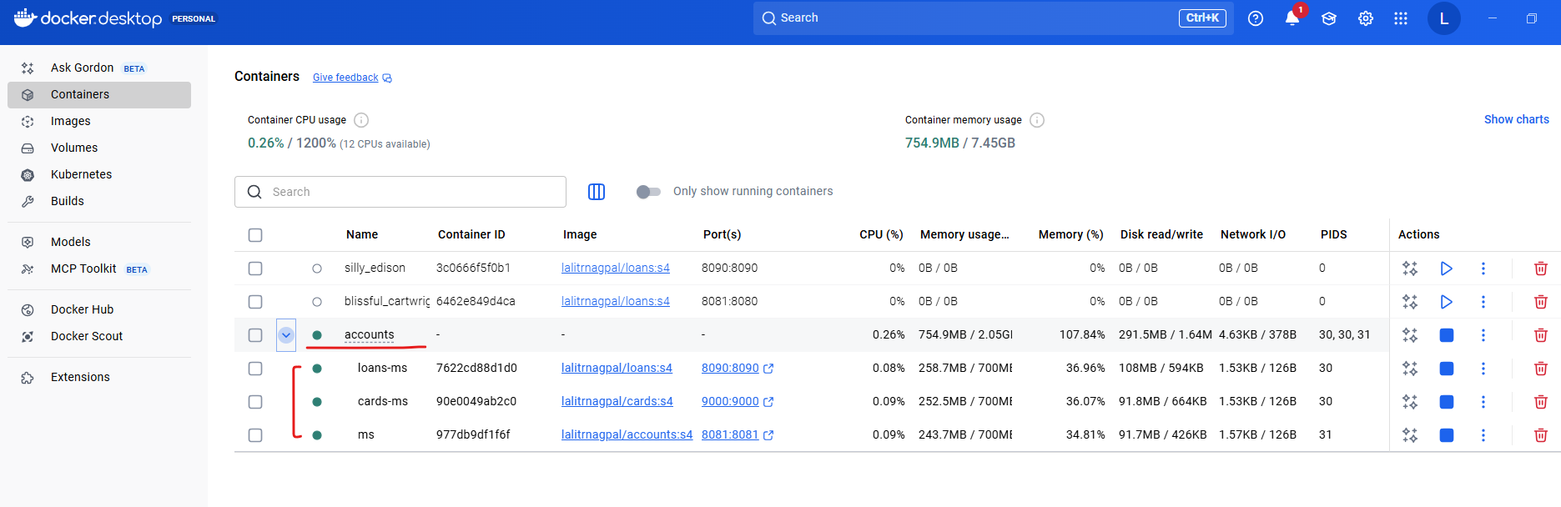

Inside our CLI, we are able to see the container name properly.

PS D:\002-Workspace\microservices\section4\accounts> docker ps -a

CONTAINER ID IMAGE COMMAND CREATED STATUS PORTS NAMES

977db9df1f6f lalitrnagpal/accounts:s4 "java -jar accounts-…" 4 hours ago Up About a minute 0.0.0.0:8081->8081/tcp, [::]:8081->8081/tcp accounts-ms

7622cd88d1d0 lalitrnagpal/loans:s4 "/cnb/process/web" 4 hours ago Up About a minute 0.0.0.0:8090->8090/tcp, [::]:8090->8090/tcp loans-ms

90e0049ab2c0 lalitrnagpal/cards:s4 "java -cp @/app/jib-…" 4 hours ago Up About a minute 0.0.0.0:9000->9000/tcp, [::]:9000->9000/tcp cards-ms

3c0666f5f0b1 lalitrnagpal/loans:s4 "/cnb/process/web" 3 days ago Exited (137) 32 hours ago silly_edison

6462e849d4ca lalitrnagpal/loans:s4 "/cnb/process/web" 3 days ago Exited (143) 3 days ago blissful_cartwright

You can see all these three containers are running properly. Now I can try to test them. Frist I'm trying to create an account, but please make sure the port number is 8080 because we configured the port mapping as 8080.

Port was occupied so I killed the task that was occupying the port

PS D:\002-Workspace\microservices\section4\accounts> netstat -ano | findstr :8080

TCP 0.0.0.0:8080 0.0.0.0:0 LISTENING 5860

TCP [::]:8080 [::]:0 LISTENING 5860

TCP [::1]:64507 [::1]:8080 TIME_WAIT 0

TCP [::1]:64508 [::1]:8080 TIME_WAIT 0

PS D:\002-Workspace\microservices\section4\accounts> tasklist /fi "PID eq 5860"

Image Name PID Session Name Session# Mem Usage

========================= ======== ================ =========== ============

AgentService.exe 5860 Services 0 6,700 K

PS D:\002-Workspace\microservices\section4\accounts> taskkill /F /PID 5860

ERROR: The process with PID 5860 could not be terminated.

Reason: Access is denied.

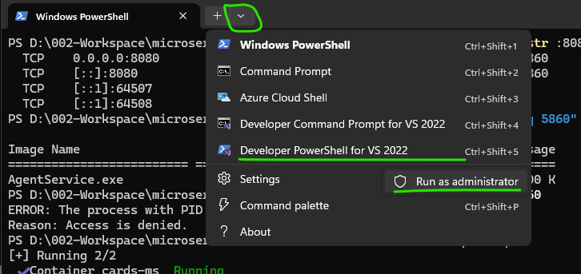

**Kill the task**

PS C:\Program Files (x86)\Microsoft Visual Studio\2022\BuildTools> taskkill /F /PID 5860

SUCCESS: The process with PID 5860 has been terminated.

PS C:\Program Files (x86)\Microsoft Visual Studio\2022\BuildTools>

So let me click on the send button and you can see I'm getting a successful response. Now I'll go to the create loan. I will click on the send button and you will get a successful response. Let me do the same for Create Card. And here also I'm getting a successful response. So this confirms all our containers are started successfully with a single command. How about stopping all of them with a single command again. For the same, it's going to be super, super easy. Just like how we have docker compose up. You can also use docker compose down. So let me run this command docker compose down -d. I think for docker compose down, we can't use this -d. So let me try to execute docker compose down alone and that will stop all my containers.

PS D:\002-Workspace\microservices\section4\accounts> docker compose down

[+] Running 4/4

✔ Container accounts-ms Removed 1.5s

✔ Container loans-ms Removed 1.2s

✔ Container cards-ms Removed 1.0s

✔ Network accounts_lalitrnagpal_nw Removed 0.5s

PS D:\002-Workspace\microservices\section4\accounts>

You can see those are getting removed. Now I'll go to my Docker desktop. You can see now my containers are no more there and all the containers are deleted. If you don't want them to be deleted, you can run a command which is docker compose stop. But since it is always advisable to delete the containers whenever you are trying to stop them, please use the docker compose down command. So we have used two commands docker compose up which will start all your containers with a single command. And similarly we also use docker compose down which will stop and remove all your containers from your Docker desktop. I hope this is clear. I didn't show you the demo of network that we have created. Like there is a network easybank that we have created as of now in the upcoming sections. When we try to have such scenario, I'll be showing you the demo and how the intercommunication between the containers are working with the help of this driver bridge network that we have created. This way you can create any number of services inside your Docker compose file and you can start them and you can stop them. You can restart them, you can achieve everything with a single command. Please make sure you are learning the structure and syntax of this docker-compose.yml file. This is super super easy. You can also find this inside the GitHub repo. Please make sure you are following this indentation of this yaml file properly. Otherwise things won't work like you expected. Every space is important inside the yaml file.

#### Docker Compose Commands Demo

In the previous lecture, we explored the commands of docker Compose, which is docker compose up, and similarly docker compose down. We saw that with the help of docker compose up, we will be able to create the containers. So whenever we use this docker compose up command, it is going to create your containers from scratch. If you see here right now there are three containers created from scratch because I have used docker compose up command. Now using docker compose down command, I can stop and I can also remove the containers. Think like there is a scenario where I don't want to remove my containers, but simply I want to stop them. In such scenario you can use docker compose stop. This will stop all the running containers that you have started with the help of docker compose command. You can also see right now the containers are simply stopped. If I want to start them again, the command that I need to use is docker compose start. So there is a clear difference between start and up Command. Start Command **will look for the existing containers** and it will try to start them again. So that is what happening here. Like you can see right now, they are in the running status. Now, this time I'm going to use docker compose down, which will stop and remove my containers. So now you can see all of my containers are removed. We confirm the same inside my Docker desktop. Now if I try to execute a command which is docker compose start since there are no containers, it will simply fail with a reason.

PS D:\002-Workspace\microservices\section4\accounts> docker compose down

[+] Running 4/4

✔ Container accounts-ms Removed 0.1s

✔ Container loans-ms Removed 0.1s

✔ Container cards-ms Removed 0.1s

✔ Network accounts_lalitrnagpal_nw Removed 0.4s

PS D:\002-Workspace\microservices\section4\accounts> docker compose start

service "cards" has no container to start

There is no service with the name cards are similarly, there is no service with the name, loans and accounts. And even if you try to run a command stop without any running containers, there will be no effect due to this command. Now let me try to run the command docker compose up again with a -d. So this will create the containers from scratch and start the same. After starting I'm going to simply stop them with the command docker compose stop and this will stop all the running containers like you can see. My containers are not deleted. They are only being stopped.

PS D:\002-Workspace\microservices\section4\accounts> docker compose up -d

[+] Running 3/3

✔ Container cards-ms Started 0.5s

✔ Container loans-ms Started 0.5s

✔ Container accounts-ms Started 0.4s

PS D:\002-Workspace\microservices\section4\accounts> docker ps -a

CONTAINER ID IMAGE COMMAND CREATED STATUS PORTS NAMES

1a330a20dea5 lalitrnagpal/accounts:s4 "java -jar accounts-…" About a minute ago Up 38 seconds 0.0.0.0:8080->8080/tcp, [::]:8080->8080/tcp accounts-ms

d4707eb0659f lalitrnagpal/cards:s4 "java -cp @/app/jib-…" About a minute ago Up 37 seconds 0.0.0.0:9000->9000/tcp, [::]:9000->9000/tcp cards-ms

ab08828c8972 lalitrnagpal/loans:s4 "/cnb/process/web" About a minute ago Up 38 seconds 0.0.0.0:8090->8090/tcp, [::]:8090->8090/tcp loans-ms

3c0666f5f0b1 lalitrnagpal/loans:s4 "/cnb/process/web" 3 days ago Exited (137) 34 hours ago silly_edison

6462e849d4ca lalitrnagpal/loans:s4 "/cnb/process/web" 3 days ago Exited (143) 3 days ago blissful_cartwright

PS D:\002-Workspace\microservices\section4\accounts> docker compose stop

[+] Stopping 3/3

✔ Container cards-ms Stopped 0.5s

✔ Container loans-ms Stopped 0.6s

✔ Container accounts-ms Stopped 0.8s

PS D:\002-Workspace\microservices\section4\accounts> docker ps -a

CONTAINER ID IMAGE COMMAND CREATED STATUS PORTS NAMES

1a330a20dea5 lalitrnagpal/accounts:s4 "java -jar accounts-…" 2 minutes ago Exited (143) 8 seconds ago accounts-ms

d4707eb0659f lalitrnagpal/cards:s4 "java -cp @/app/jib-…" 2 minutes ago Exited (143) 8 seconds ago cards-ms

ab08828c8972 lalitrnagpal/loans:s4 "/cnb/process/web" 2 minutes ago Exited (143) 8 seconds ago loans-ms

3c0666f5f0b1 lalitrnagpal/loans:s4 "/cnb/process/web" 3 days ago Exited (137) 34 hours ago silly_edison

6462e849d4ca lalitrnagpal/loans:s4 "/cnb/process/web" 3 days ago Exited (143) 3 days ago blissful_cartwright

PS D:\002-Workspace\microservices\section4\accounts> docker compose start

[+] Running 3/3

✔ Container accounts-ms Started 0.4s

✔ Container loans-ms Started 0.3s

✔ Container cards-ms Started 0.4s

In this scenario, if I try to run the command which is docker compose up, it is not going to create the containers from scratch. Instead, it is going to leverage the existing containers already with the same names like cards-ms and accounts microservice and loans microservice. So that is what's happening here. I hope you are getting a complete picture of docker compose up, docker compose down, docker compose start and docker compose stop. So there is a clear difference between these commands, so please make sure you are clear and use them accordingly on your day to day basis. Most of the times I'm going to use docker compose up and docker compose down because **I always make sure I'm deleting my containers when I don't need them**. That will give me some space inside my local system.

PS D:\002-Workspace\microservices\section4\accounts> docker compose down

[+] Running 4/4

✔ Container accounts-ms Removed 0.4s

✔ Container cards-ms Removed 0.7s

✔ Container loans-ms Removed 0.6s

✔ Network accounts_lalitrnagpal_nw Removed 0.4s

### Docker Commands Deep Dive

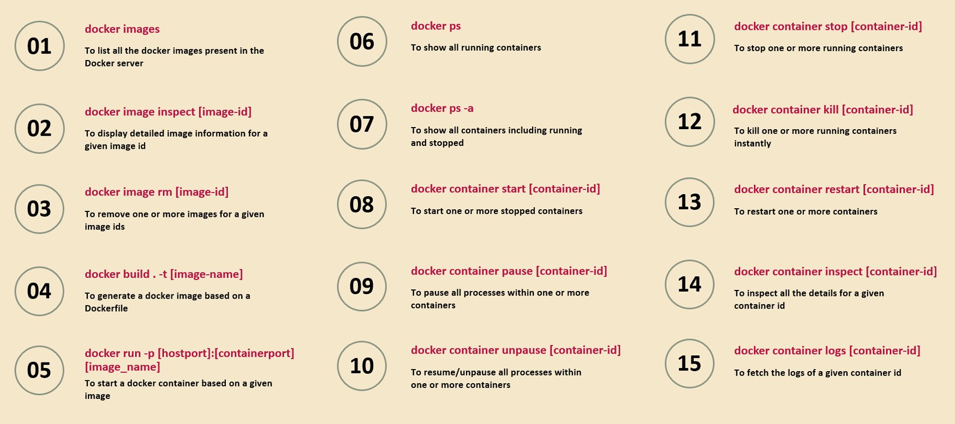

The very first Docker command that we have here is docker images. We are already using these Docker images command. A lot of times to see the list of Docker images present inside my local Docker server. And if I have a scenario where I want to know more details about a specific image

Then I can run the second command, which is docker image inspect <image ID> So whenever you're trying to pass a <imageId> or <containerId> or <any-other-Id> inside Docker, you don't have to mention the entire ID value. You can simply mention first three characters or four characters and your Docker server is smart enough to detect the entire image ID or container ID based upon the short value that you have provided.

The next command is to remove that Docker image. I showed you how to remove a Docker image from the Docker desktop

If you don't have access to Docker desktop, then you can issue this command from your CLI, which is docker image rm, rm indicates remove. And to this command you can pass. What is the image ID? If you have multiple images to remove, you can mention all those multiple image IDs separated by a space value.

We have Docker build command. Using this Docker build command, we can generate a Docker image based upon a Docker file. So please make sure when you are running this Docker build .command the Docker file present inside the same location where you are running this command from the terminal to this Docker build command, we should provide the complete Docker image name with the help of -t indicates tag.

And the 5th command that we have here is docker run command. We use this already many times with the help of this docker run command, along with the port mapping details and the Docker image name, we can start a Docker container based upon a given image. The 6th command that we have here is docker ps This will show all the running containers and similarly, if you want to see all the containers, including running and the stopped ones

The 7th command, which is docker ps -a.

The next command, which is 8th command is docker container start. What is a container ID? We want to start a specific container which is previously stopped. Then you can run this command. If you want multiple containers to start, then you can mention all those container IDs separated by a space value. And for whatever reason, if you want your container to pass for some time or if you want your container to not accept any traffic, then you can run this docker container pass command along with the container Id. Once the container is passed. Definitely after some time you want to unpass it. So in such scenarios you can run the 10th command, which is docker container and unpass and what is the container ID? So this will resume your container and it will start accepting the request.

And the 11th command is to stop the running container. Whenever you want to stop any running container, you need to use docker container stop. And what is a container ID? Whenever you use this docker container stop command, your Docker server is going to give some time for your container to close any resources, which means your Docker server is not going to kill your running container instantly. It is going to give some time like 5 seconds and within this 5 seconds your Docker container can close any resources that is opened by it, like database connections or file systems.

Whereas with the 12th command, which is like docker container kill, you can kill one or more running containers instantly. That's the difference between stop and kill. With the kill command, we are going to kill the container instantly, whereas the stop command will give you like 5 seconds for your container to close any resources.

The 13th command, we can restart containers with the command docker container restart and just like image inspect.

If you want to know more details about your container, you can use this docker container inspect command. To this command, you can pass a containerId. For debugging, if you want to see the logs of a container.

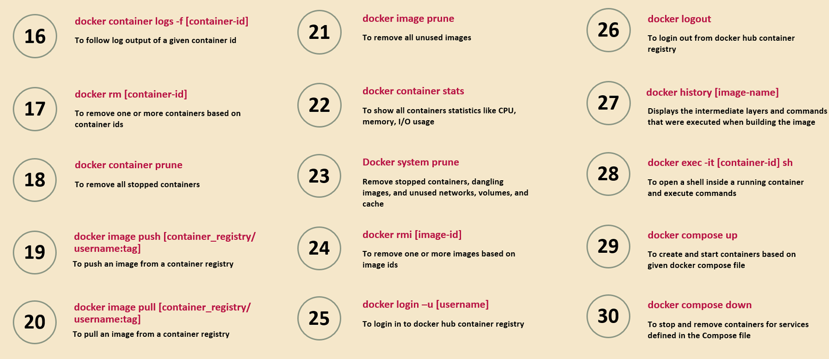

Run this 15th command, which is docker container logs <container-id>. And what is the container ID? This will fetch all the logs of a given container ID, but like I showed before, the more convenient way of checking the logs is with the help of Docker desktop. So inside your Docker desktop, go to containers and click on the container name and you will be able to see the logs of the container in live. Now moving on to the next important commands, sometimes you want to continuously follow the logs of a container like you want to see the logs in action what is happening. In such scenario, you can use this -f flag which tells to your Docker server that you want to follow the log output of a given container ID continuously inside your terminal and to remove your container

You can run the 17th command, which which is Docker rm and what is your container ID? If you want to remove multiple containers at the same time, you can provide all those container IDs separated by the space value

The 18th command, which which is docker container prune. This will help you to remove all the stopped containers with a single command. You don't even have to mention what are the stopped container IDs. So by default, this command is going to remove all the stopped containers.

And the docker image push and docker image pull commands we already discussed. Using these commands, we can push and pull the images from local system to remote repository and vice versa.

And just like Docker container prune, we also have Docker image prune like you can see in the 21st command. So this is going to remove all the unused images. So how your Docker server is going to identify all unused images. The answer is very simple. If there are no associated containers of an image is present either in start or stop mode, then that image will be considered as an unused image by your Docker server. From Docker Desktop, I showed you how to see the statistics of CPU usage or memory usage of your container.

If you want to see from your CLI as well, you can run this command which is docker container stats. So this will show all container statistics like CPU utilization, memory and IO usage. And just like how we have image prune and container prune, we also have Docker system prune. This will remove all the stopped containers, unused images, unused networks, volumes, cache inside your Docker server. And under that 24th command you can see I have mentioned one more approach on how to delete our image.

Docker rmi, I indicates image with this rmi we are telling to our Docker server to remove the image which is associated to an image ID that we have provided. Now coming to the next command, which is 25th command.

Whenever you want to log in into your remote Docker hub from your CLI, you need to use this docker login -u and followed by what is your username. Post that it will ask you the password. You can enter your password and with that from your CLI you are going to get logged in. But we don't have to follow this because inside Docker desktop there is a sign in option which will allow you to sign in with the help of browser as long as you logged in with the Docker desktop, your CLI also is automatically connected to your Docker hub account. But in the scenarios where you don't have Docker desktop installed, you have only Docker and Docker server. Then in such cases, these Docker login will help you to log in into your remote hub repository.

And similarly we also have Docker log out to log out from the Docker Hub Container Registry account.

Now moving on to that 27th command, which is Docker History Command with the help of Docker History Command and providing an image name, we can see all the intermediate layers and the commands that were executed while building an image. So this is going to help you to debug your image. If you are facing any issues behind the scenes, there will be lot of work that will be done by the Buildpacks or the Google jib or the Docker server while generating a Docker image. So to understand the intermediate layers and the commands that it has used to generate the Docker image, you can use this command.

Sometimes you may want to run some commands inside your running container, so the running container is present in its own network to run any CLI commands or any terminal commands from the Docker desktop, you always have an option to directly go to the terminal and run the commands. Whereas if you want the similar behavior with the help of Docker CLI, you can execute these 28th command which is docker execute -it and followed by what is your <containerId> followed by sh. So with that you are telling I want to open a shell inside a running container based upon the container id that you have passed and this will open a shell inside a running container from your CLI itself and you can execute the commands.

And at last we discussed that Docker compose related commands like like docker compose up, which will create and start the containers based upon the given Docker compose file.

And similarly we have docker compose down which will stop and remove the containers. And if you don't want to delete your containers, you can simply use docker compose stop command.

And similarly, if you simply want to start the containers and if you don't want to create the containers from scratch, then you can use the command docker compost start. So these are all the important commands that you can use on your day to day basis. And these commands will be also handy to you whenever you go for any interview. That's why I have mentioned all the important commands inside the slides that I'm going to provide, and at the same time I have also mentioned them inside the GitHub repo page, so please refer them whenever you have some questions.

### Docker Extensions and Logs Explorer

Let me introduce a Docker extension that may be useful for you on day to day basis. You can see inside your Docker desktop there is an option add extensions. There are thousands of Docker extensions available which you can use based upon your requirements on day to day basis.

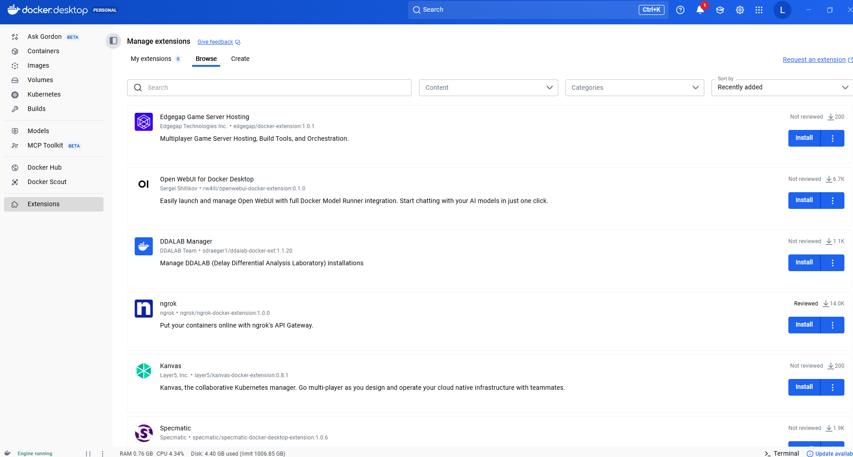

So whenever you are into a problem while using Docker containers, Docker images or Docker desktop, always search for if there is any extension that will solve your problem. By installing these extensions, you can make your life easy. One such extension is related to logs, so if you search for log, there is an extension with the name Logs Explorer. You can see if you can click on this.

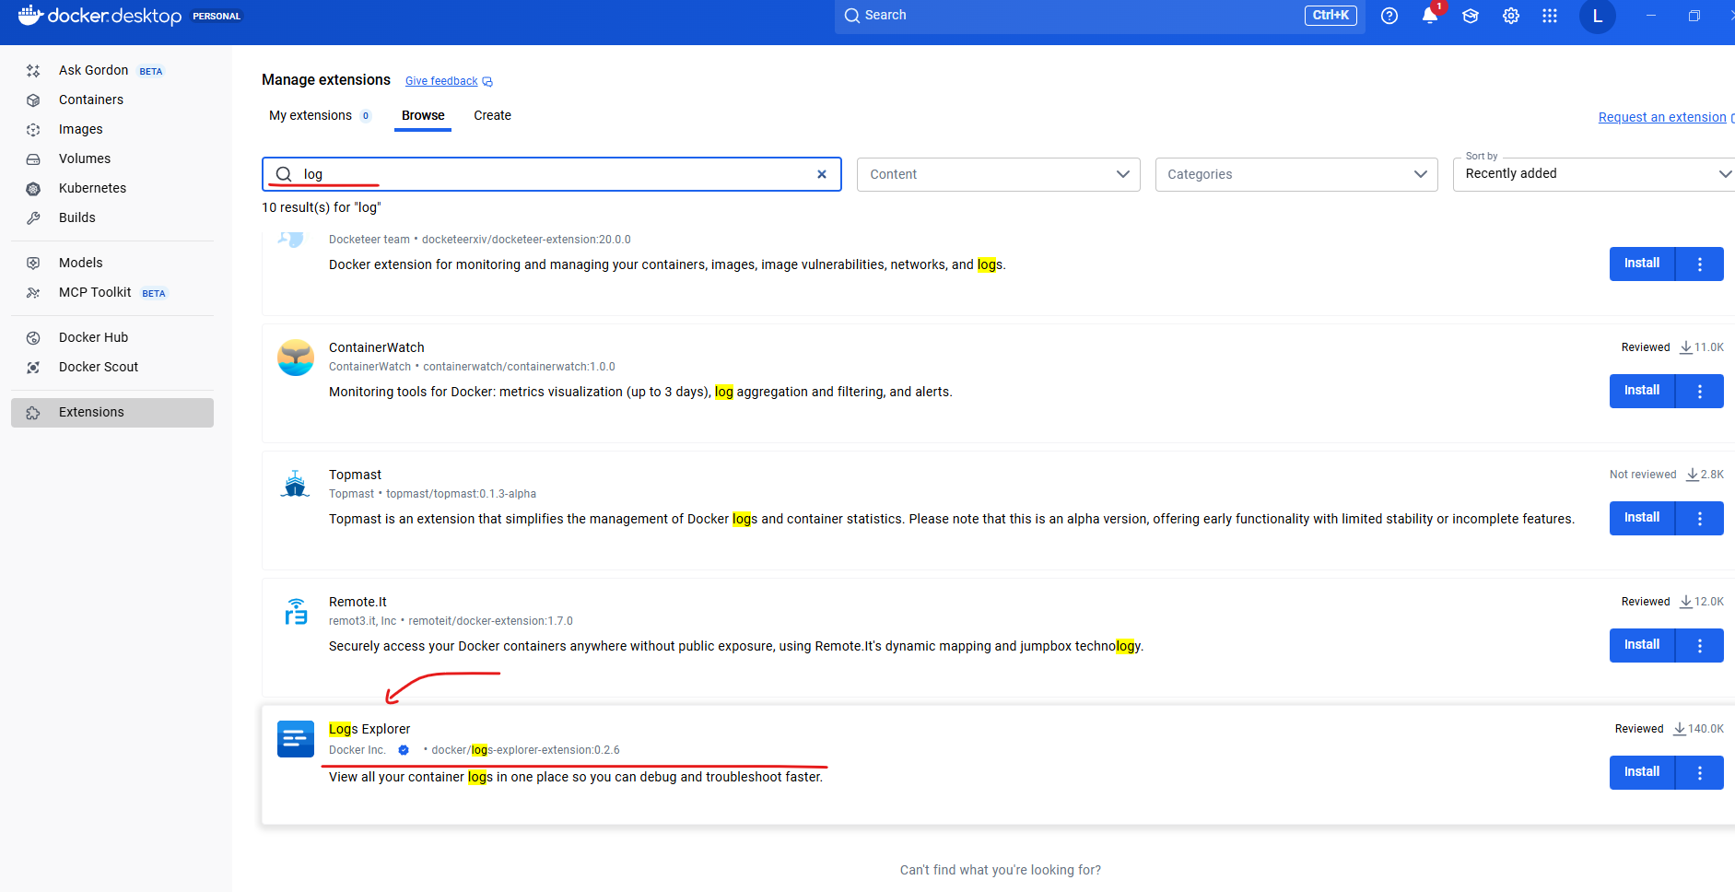

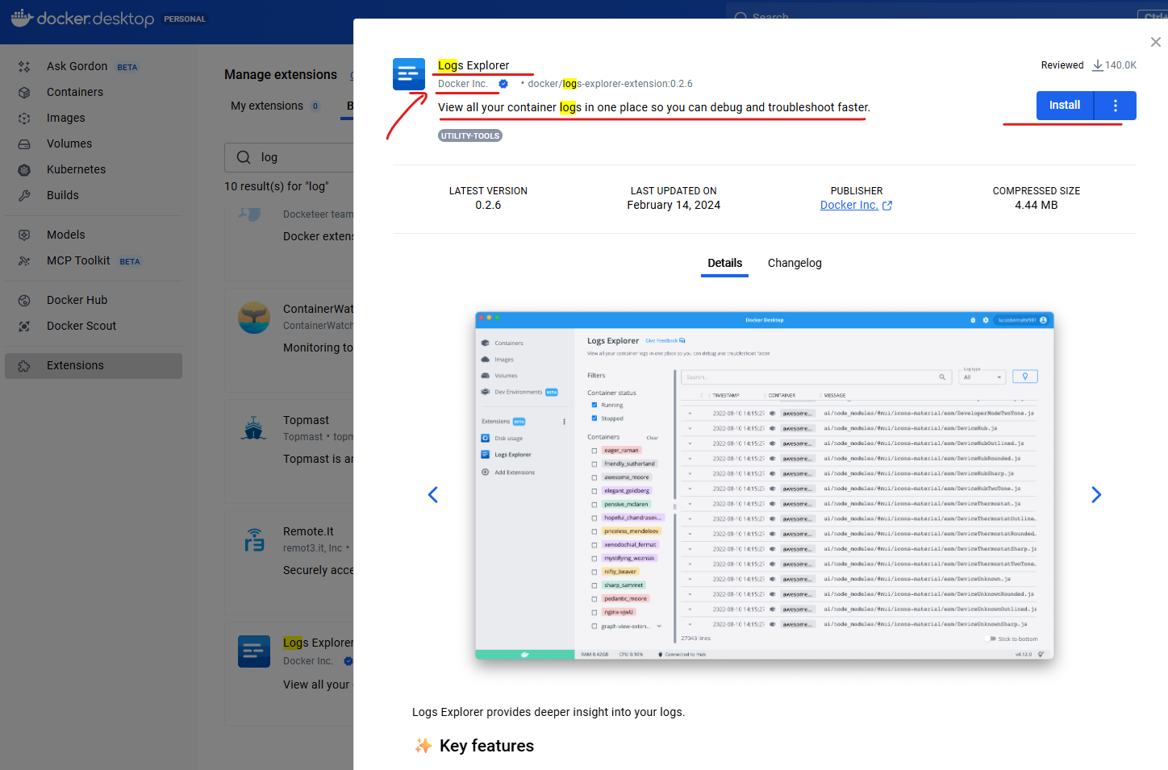

This is officially published by the Docker company itself. You can click on this install button as soon as you click on this install button, this extension will be installed inside your Docker desktop. So let me close this right now. You can see the installation is completed. With that, I have a logs explorer under my extensions, so let me click on that. You can see there is no logs information right now because I have installed this just now. So with the help of these Logs Explorer, we can see all the logs of our running containers or stopped containers. So let me show you a demo of this extension.

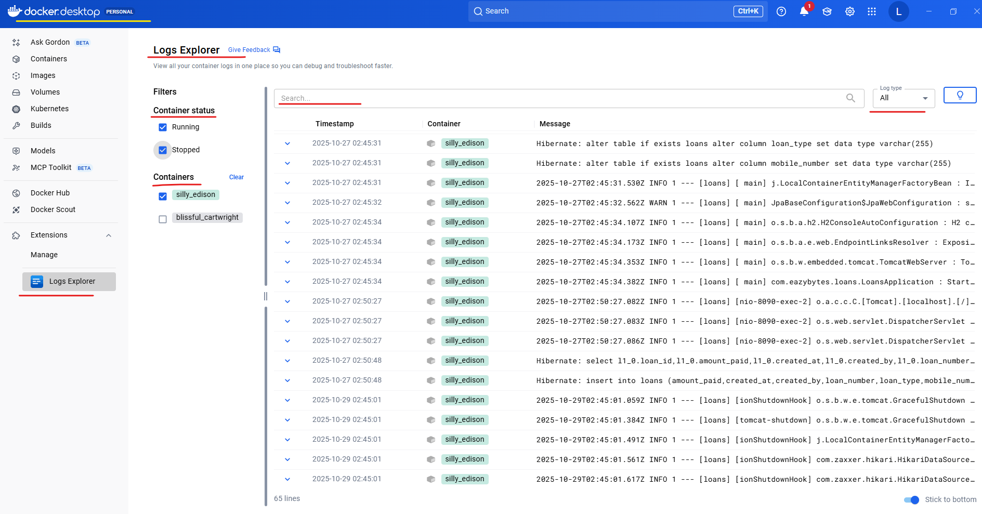

For the same, I'm going to run a command which is docker compose up, which will start all of my containers. Now I can go to my Docker desktop. Here you can see under accounts there are three different microservices are running like loans microservice, cards microservice and accounts microservice. And each microservice has its own color. Like all accounts microservice related logs are highlighted in a blue color. Similarly for loan, it is red color, and for cards it is green color.

For some reason I was not able to see the logs in Docker Desktop > Logs Explorer when service taken up via docker compose up

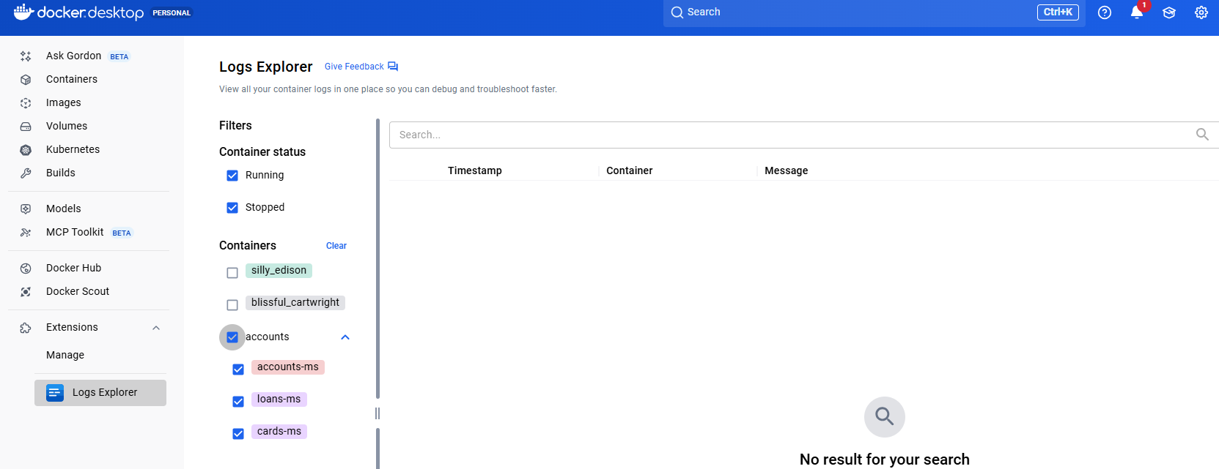

And can see for the ones that were created using docker earlier via jib/ buildpacks or dockerfile

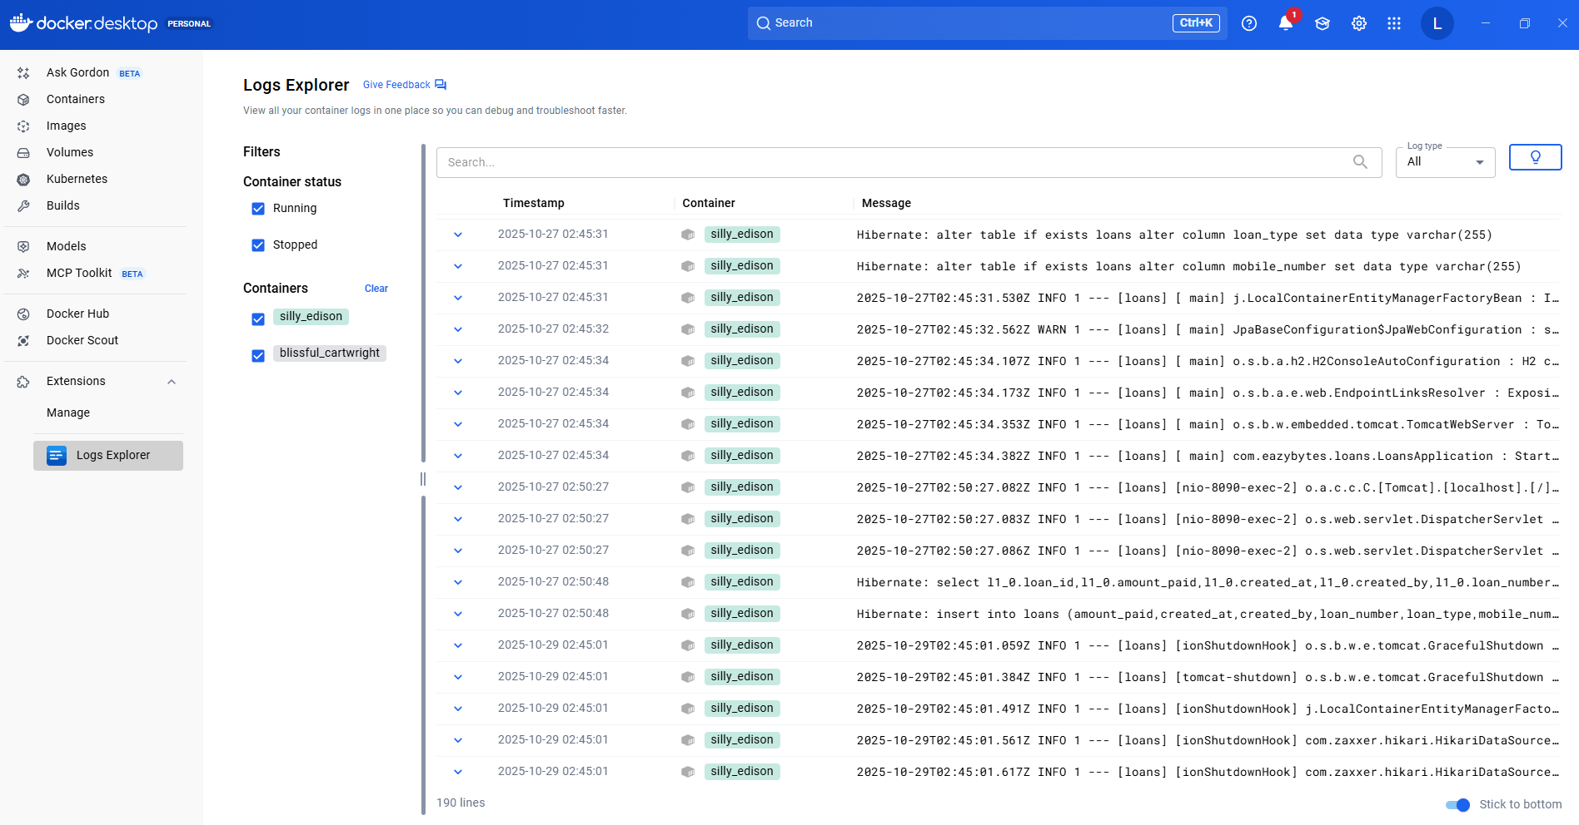

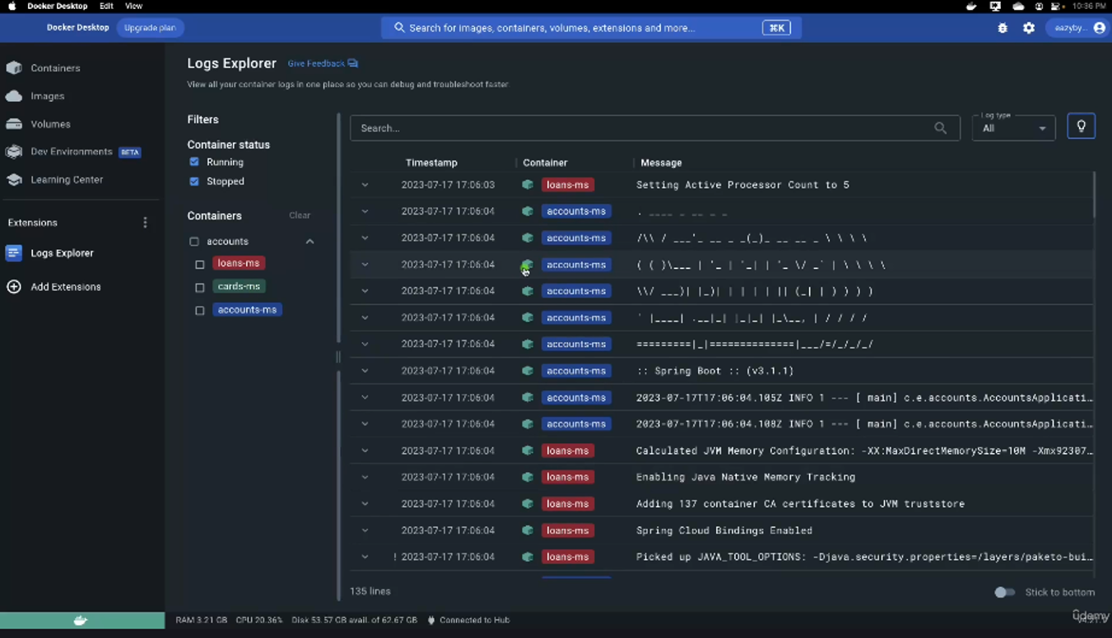

So you can look for all the logs from this Logs Explorer itself instead of navigating each of the container. If you are looking for the logs of a specific container, you can select here and that will do the filtration automatically and you will be able to see only the logs related to the loans microservice. And at the same time there is also a filter option to see the running containers logs or the stopped container logs. There is also a search button and if you want to see the logs based upon the specific log type like standard output or standard error, you can select the option accordingly.

This way, these Docker extensions are going to make our lives super, super easy and Logs Explorer is one such extension. I would strongly recommend you to install this extension inside your system as well. In future anytime like I said, if you face any problem with the Docker or if there is some task which is taking you a lot of time, then look for extensions because somebody might have faced the same issue and they might have built the extension, which which is right now available for others to use. So with the help of these extensions, make your life easy. That's what my recommendation here.

The docker logs command can be used to look at the logs of a container.

docker logs -f backend_api_1

Before I try to conclude this section, I just wanted to share a few important information. One such information is I have uploaded the section 4 related code inside the GitHub repo. Like you can see under this section 4 you should be able to see three different microservices with the name accounts, cards and loans. And inside the accounts you will be able to see the Docker file and Docker compose file that we have created along with the other Maven related configurations that we have done inside the pom.xml. So please refer to this GitHub repo for any questions. Since I also provided you the PDF content, please try to revise the same multiple times so that the concepts are going to be super, super clear for you. So we did a lot of hard work inside this section.

<https://github.com/eazybytes/microservices/tree/3.4.1/section4>

## Configuration Management in Microservices

The challenge 4 that we are going to face while building the microservice or cloud native applications is about configuration management inside the microservices. So to understand more about this challenge, let me try to pose some questions to you. The very first question that I have for you is, inside microservices, how we are going to separate the configurations or properties from your business logic, because without separating the configurations and properties from your microservices business logic, you cannot reuse the same Docker image across multiple environments. If you club all your business logic and configurations together, then for each environment you need to create a separate Docker image along with the relevant properties or configurations. Since it is not a recommended approach like generating the Docker image again and again for each environment, we need to make sure we are using the same Docker image for all type of environments, including the production. With such requirements, how are we going to separate the configurations from the business logic?

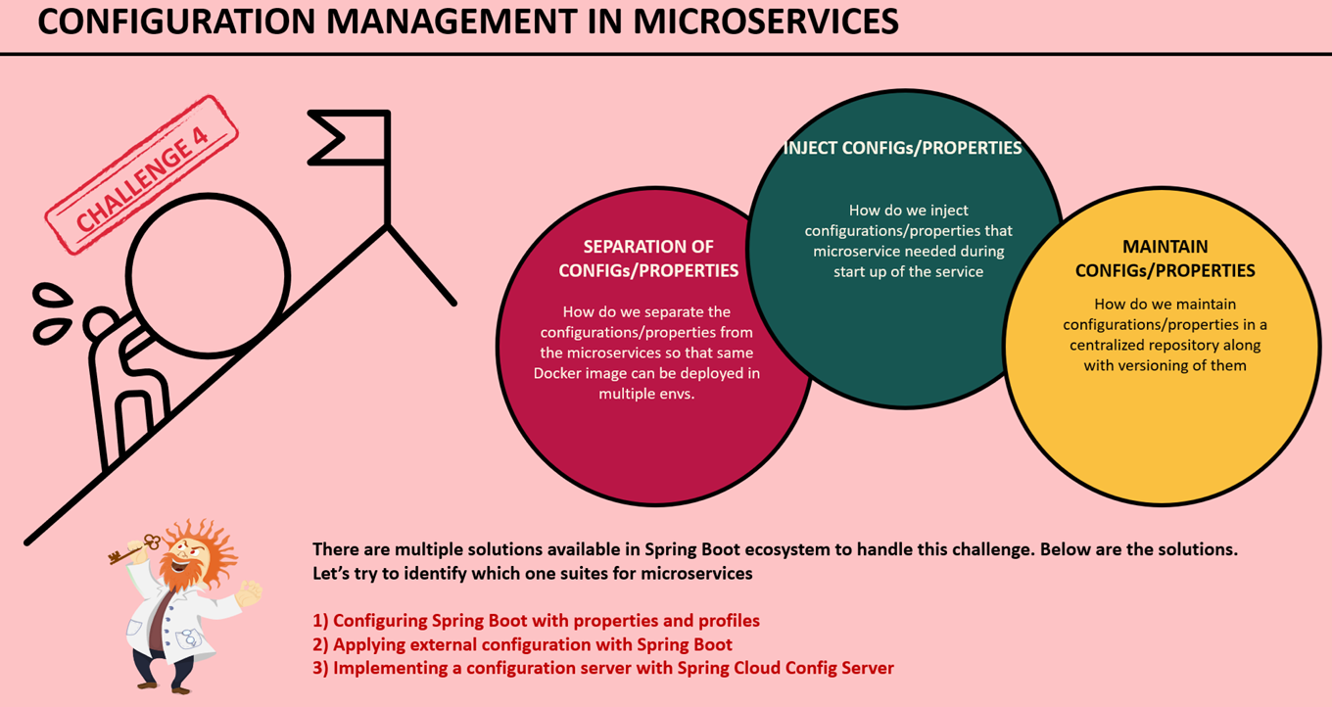

So this is the very first question that I have, in the similar lines how we are going to inject the configurations or properties at runtime that are needed by our microservices during the startup of the service, some of the sensitive properties like credentials, we can't mention them inside any configurations or inside any business logic, such sensitive properties or configurations. We need to make sure we are injecting them into microservices during the startup of the service. In the very similar lines, whenever we are dealing with the configurations or properties, we need to make sure we are maintaining all these configurations or properties in a centralized repository along with the versioning of them. Because inside monolithic applications you will be having only 1 or 2 applications and it is very easy to maintain all your configurations wherever you want, whereas with hundreds of microservices it is going to be super complex to maintain all the properties of all the microservices manually. That's why when we are trying to build microservices, we need to make sure we are maintaining all the properties in a centralized repository along with the versioning of them. So how we are going to achieve that? So we have all these challenges in terms of configuration management in microservices.

We have multiple solutions available inside the springboot ecosystem, and these solutions are like right from very basic solution, which is configuring Spring Boot itself with the relevant properties and the required profiles. And the second approach is applying external configuration with the spring boot. And the third approach is implementing a separate configuration server with the spring cloud config server project. So these are the options that we have. I'm going to show a demo of all these options and in the same process I will show what are the basic approaches and what are the disadvantages that we have with them and what is the best option that we have and why we should go with that. So all those discussions I'm going to do inside this section and inside this section, we are going to make lot of code changes inside our microservices. So it is going to be super, super engaging and fun throughout this section.

Now, before I try to close this lecture, let me try to give you how the configuration management happens inside a traditional application and microservices application. Back in the days when we were trying to build traditional applications or monolithic applications, all your source code along with the configurations files, they will be bundled together.



And with that, whenever there is a different configuration is needed for a different environment. We need to rebuild the application code again with the required configurations. So with this there is no guarantee that the application would behave consistently because the main business logic may differ from one environment to other environment when you are trying to build the application. This approach might have worked for monolithic application because there is only one application and they can do multiple builds based upon the environment. Whereas with microservice, since there will be hundreds of microservices doing multiple builds again and again for each environment with the required configuration data is going to be super, super complex.



That's why as per the 15 factor methodology. All the configurations which are going to change between deployments such as credentials, service URLs or resource handles. So all such configuration data we need to provide outside our build component. So all such configurations that are likely to change, we need to maintain outside our business logic. So that the application artifacts will be immutable across all environments. Once we do a build and generate a Docker image for your microservice, the same image you can use across environments and the configurations has to be injected from the external location. This way the application build will remains unchanged across all the environments. Like you can see here, first there will be an microservice or cloud native application codebase inside the GitHub repo.

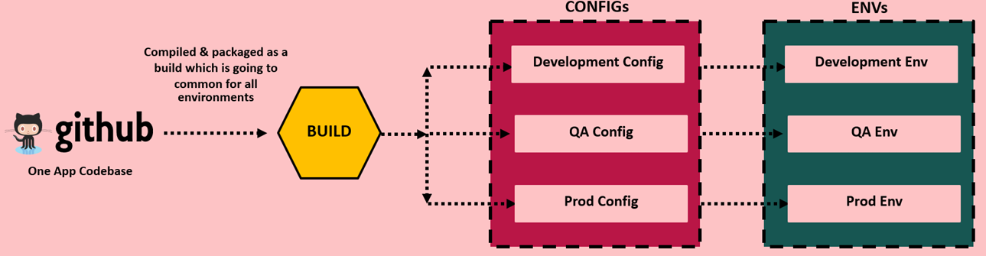

We will do compilation and package as a build, which is going to be common for all environments. So inside this build you may generate a Docker image for your microservice and to this build a component we are going to inject configurations based upon the target environment. If you are trying to do a deployment into a development environment, then we can inject the configurations related to that development environment at runtime during the startup of the microservice. And both your configurations and the source code will be clubbed and deployed into that target environment like development QA and production. So this is how it has to work inside microservices or inside the cloud native applications and we should not follow the traditional approaches.

### How Configurations work in Spring Boot

Once we discuss the basic approaches, then we'll go to the advanced approaches that we have with the help of spring cloud config server. The main problem that right now we have is, we want to externalize the properties for our microservices. So that the same immutable code artifact can be used across different, different environments. So to handle these kind of scenarios, we are trying to learn how to separate the configurations and codebase and also how to externalize the configurations from the codebase. So let's see if the Spring Boot is going to help us in externalizing our application properties.

Spring Boot lets you externalize your configuration so that you can work with the same application code in different, different environments. You can use a variety of external configuration sources, including java property files, yaml files, environment variables and command line arguments. You don't have to rebuild your application again and again.

There are different approaches in Spring Boot for externalize the configuration sources like use of property files & Yaml files where you can define all the required configurations and properties that your application or microservice need during the startup of the service. Apart from these property files and Yaml files, we can also inject the configurations or properties during the startup of the service with the help of environment variables and command line arguments. So there are many approaches, so let's try to understand in detail about them.

By default, your spring boot application is going to look for the configurations or the properties that you have mentioned inside the application.properties or inside the application.yaml file. We are already using these inside our accounts, loans and cards microservice where we have defined various properties inside the application.yml file and we place that inside the classpath location.

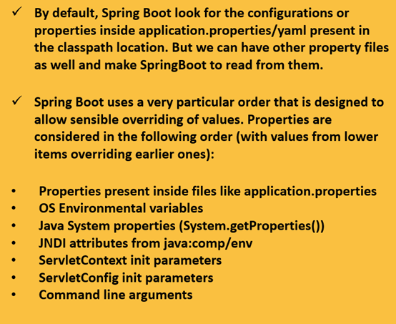

Apart from these default name, we can also have other property file names and we can make our spring boot to read from them during the startup of the application. But if you try to mention the properties or configurations inside your property file, you are clubbing everything along with the source code. So this approach may not work to a great extent, that's why Spring Boot also supports other ways to override the default values that you have defined inside the application.properties file. Maybe for development environment. You might have mentioned that default database credentials, but at runtime inside your QA deployment or production deployment, we want to override the default values like username, password, url details of database during the startup of the application. That's why to overcome this challenge we can always override the properties with the other approaches like command line arguments, environment variables. So here you may have a question like if I mention the same property in multiple locations, will there be any preference or the priority that Spring Boot follows?

You can see here these are all the most commonly used approaches to provide the configurations inside your spring boot applications. The very first one is you can mention your properties inside the files like application.properties or application.yml. So whatever you mentioned inside these files, they will have the lowest priority or the lowest preference if the same property is mentioned with the help of operating system environmental variables, then the previous value which is mentioned inside the application.properties will be overrided and whatever value you have mentioned inside the environmental variables will be considered by the spring boot framework. And very similarly, you can also mention the configurations or properties with the approaches like Java System Properties, Jndi attributes servlet config, init parameters and command line arguments.

The way the priority works is, the lower items will be overriding the earlier ones, which means command line arguments is going to have highest priority. Whereas the properties that you have mentioned inside the application.properties is going to have the lowest priority. So please remember these priority and the order followed by the spring boot framework and this is going to be helpful for you inside your real projects. Now we understand Spring Boot allows us to externalize our configurations by following all these approaches right from basic approach with the help of application.properties or Yaml file to command line arguments. The next question that you may have here is, the properties are defined in some location or with some approach how to read those properties inside my business logic. So let's try to understand the same here again in Spring Boot.

In order to read the properties, there are multiple approaches. I will try to present three commonly used approaches inside this course. The very first approach is with the help of @Value annotation. So whenever you want to read a particular property, you can define a Java field inside your business logic. On top of that Java field, you can mention an annotation @Value along with the what is a property key name. Once you mention what is a property key name with the format like you can see on the screen, during the startup of your application, Spring Boot is going to look for this property inside all the places like application.properties environmental variables and command line arguments. So if the same property is defined in multiple places, then definitely it will follow the order of priority and accordingly it will populate the property value inside this field. Once we have the property value populated inside this field, you can use that anywhere inside your methods or inside your business logic.

In Spring Boot, there are multiple approaches to reading properties. Below are the most commonly used approaches

Using @Value Annotation

You can use the @Value annotation to directly inject property values into your beans. This approach is suitable for injecting individual properties into specific fields.For example:

@Value("${property.name}") private String propertyValue;

The next approach that we have is with the help of environment interface. Many times in real projects, many properties like sensitive information or sensitive credentials, they will be configured with the help of environmental variables. So the server admins, they will create these operating system environmental variables during the creation of the server very first time. Or they might have created some scripts which will create the environmental variables during the creation of the server. So the same scripts they will follow for all the servers. This way any server that is coming inside your microservice network or the cloud native applications, they will make sure all of them they have the same set of environmental variables along with the required values. So to read such environmental variables inside spring boots, there is an interface which is environment interface. So inside this environment interface it provides many methods to access properties from the applications environment, where your application is running. So wherever your application is running inside that server, if there are any environment properties define those values you can access with the help of these environment interface. So wherever you want to read these environment properties inside your code, first you need to autowire this environment interface to your class. Post that inside any method where you want to read the property you can use getProperty() method available inside this interface and to this method you need to pass, what is the environment variable property name. I'll be showing all these in demo so don't worry. For now please note about all these approaches.

Using Environment

The Environment interface provides methods to access properties from the application's environment. You can autowire the Environment bean and use its methods to retrieve property values. This approach is more flexible and allows accessing properties

programmatically. For example:

@Autowired

private Environment environment;

public void getProperty() {

String propertyValue = environment.getProperty("property.name");

}

The next approach that we have is, with the help of @Configuration properties. So if you see the very first and second approach, there are two drawbacks. The very first one is you are going to hardcode your property key name inside your Value annotation or inside your Environment.getProperty() method and these methods there are only useful to read a single property at a time. If you have multiple properties, then you need to define multiple Java fields with the help @Value. And similarly you need to invoke this getProperty() methods inside environment interface multiple times. So these one and two approaches we should use only if we have very few properties that we want to use. But if you have many properties configured for your application, then using these third approach is the most recommended approaches. This way, using this approach, you can avoid hardcoding the property keys. So this approach is, with the help of the annotation at @Configuration properties. How this approach is going to work is you need to define all your properties inside your property file with a prefix value. So once we define all your properties with the same prefix value you need to use @Configuration properties annotation on top of a Java class along with the what is a prefix value. Once we mention this annotation on top of a class inside the class, you can create any number of fields along with the getters and setters, but please note that the field names and their return type has to be matched with what you have configured inside your application.property file or in any other location.

Using @Configuration Properties

** Recommended approach as it avoids hard coding the propery keys

The @Configuration Properties annotation enables binding of entire groups of properties to a bean. You define a configuration class with annotated fields matching the properties, and Spring Boot automatically maps the properties to the corresponding fields.

@ConfigurationProperties("prefix")

public class MyConfig {

}

private String property;

// getters and setters

In this case, properties with the prefix "prefix" will be mapped to the fields of the MyConfig class.

I know it may not be very clear right now, but when I show you the demo of this third approach, it is going to be super, super clear for you. So with this approach, by the time the server started successfully, all your property values will be binded to the fields presence inside the class my config and to access all these fields you just need to invoke the get method available for all these fields. I hope you are clear about all these three approaches. From the next lecture, let's try to implement all these approaches inside our microservice. In the same process, we can also try to understand what are the disadvantages that we have with these basic approaches provided by the Spring boot framework.

### @Value

Let's try to update our microservices by defining some properties inside the application.yml file and try to read them with the help of the approaches that we have discussed in the previous lecture. For the same, first, I'm going to create a new folder inside my workspace location and the folder name. I'm going to keep it as section 6 because we are right now inside a section six. So inside these Section 6, I'm going to create one more folder with the name v1-springboot. So V1 indicates version one and inside this version one of my microservices inside my section 6, I'm going to follow the basic approaches provided by the Spring Boot Framework. Once we discuss all the basic approaches provided by the Spring Boot framework, then we'll look for the advanced approaches inside the next version, which is V2. So inside this v1-springboot folder, I'm going to copy all the microservices that I have from the section four, so let me copy these three microservices and I'll paste them inside the v1-spring boot.

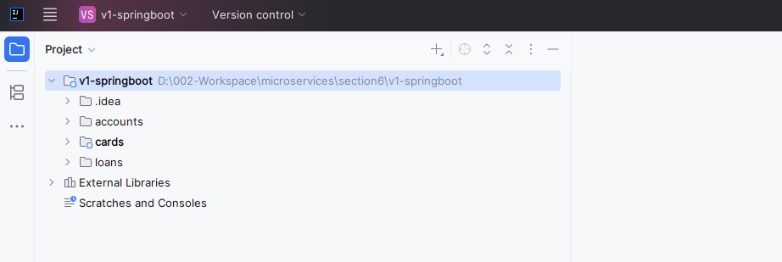

So I'll just select the parent folder which is v1-springboot and click on this open button in IntelliJ. And with that all the microservices projects will be loaded into my IntelliJ idea. We need to make sure we are clicking on this load button to detect all our microservices as maven projects. It will give a alert of maven projects found, click on LOAD

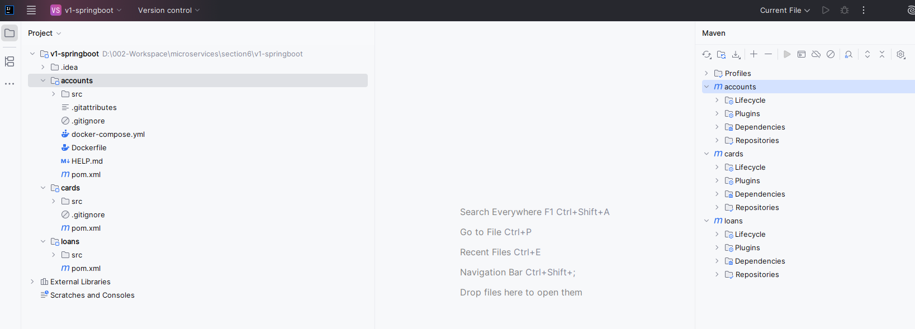

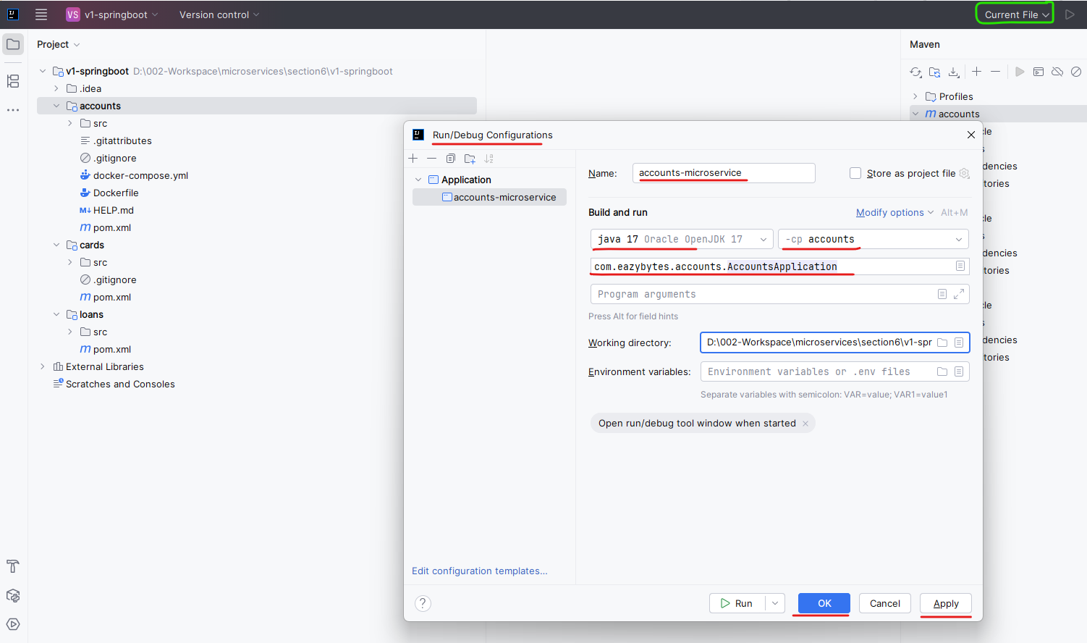

Copy the configuration to create one for cards

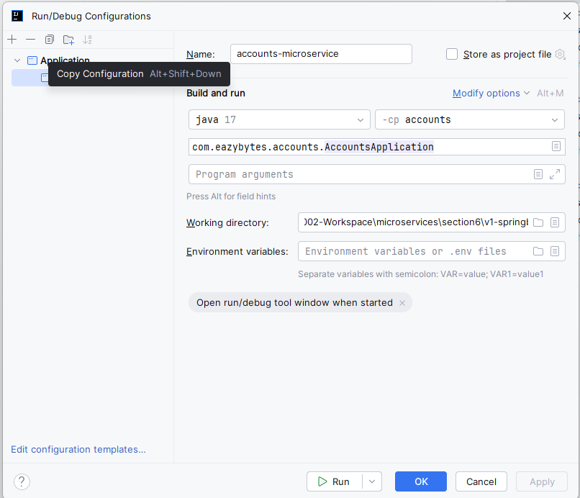

Copy the configuration and create one for loans

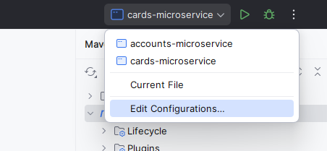

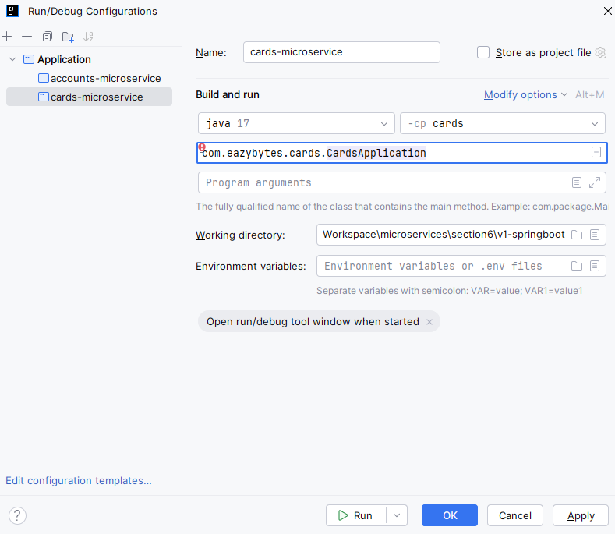 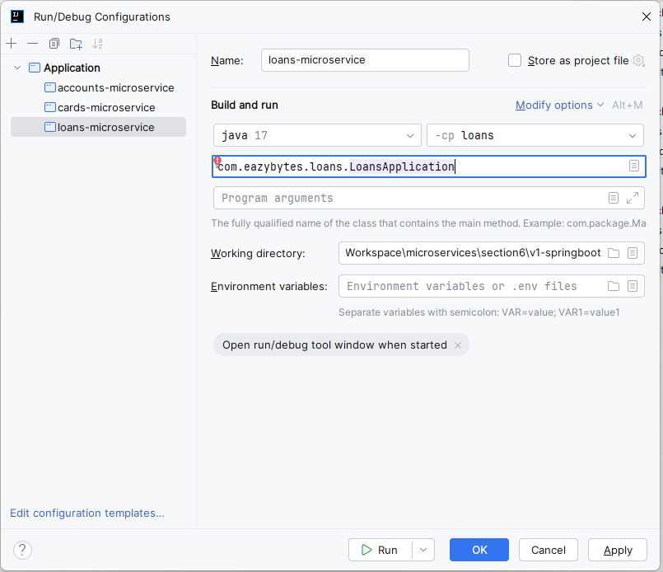

Post that you can open these v1-springboot project. And inside this you can see we have three different maven based microservices with the name accounts, cards and loans. If you recall inside the section 4, we discussed three different approaches to generate the Docker images from our microservices, and by the end of the same section, we also finalized to use the Google throughout the course. So for the same reason, I'm going to make some changes inside my accounts and loans microservice to use a Google jib approach instead of buildpacks and Docker file. So first I'll go to my cards microservice where I'm trying to use the Google jib approach. So here I'll open the pom.xml and we'll go to the down of my pom.xml where I have Google jib maven plugin details configure. So here first I'll try to change this image name to S6 because right now we are into a new section. Post that I'll try to load the maven changes, after this I will try to copy these plugin details.

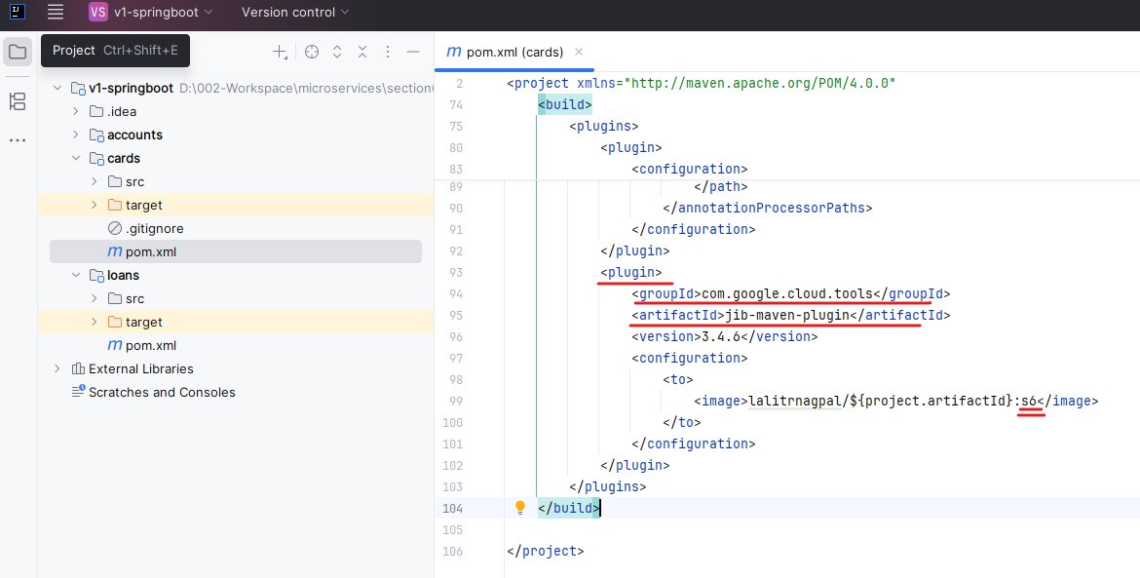

Once I copied these plugin details, I'll go to the accounts microservice. First I'll try to delete the docker file because we no more needed this file as we are not following the docker file approach. Once I deleted this Docker file, I'm going to open the pom.xml of accounts microservice, and here under the plugins configuration, I'm going to remove this Spring boot Maven plugin and replace it with the Google Jib Maven plugin.

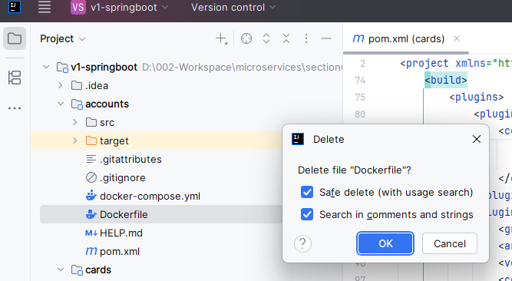

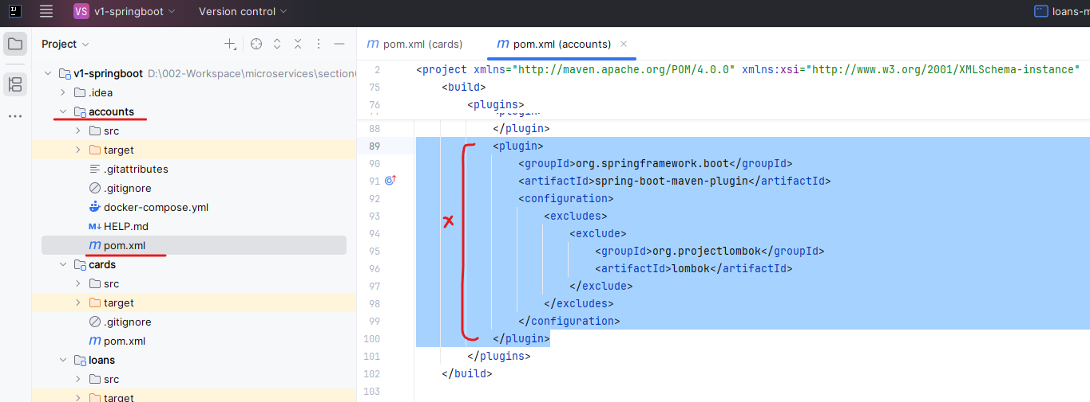

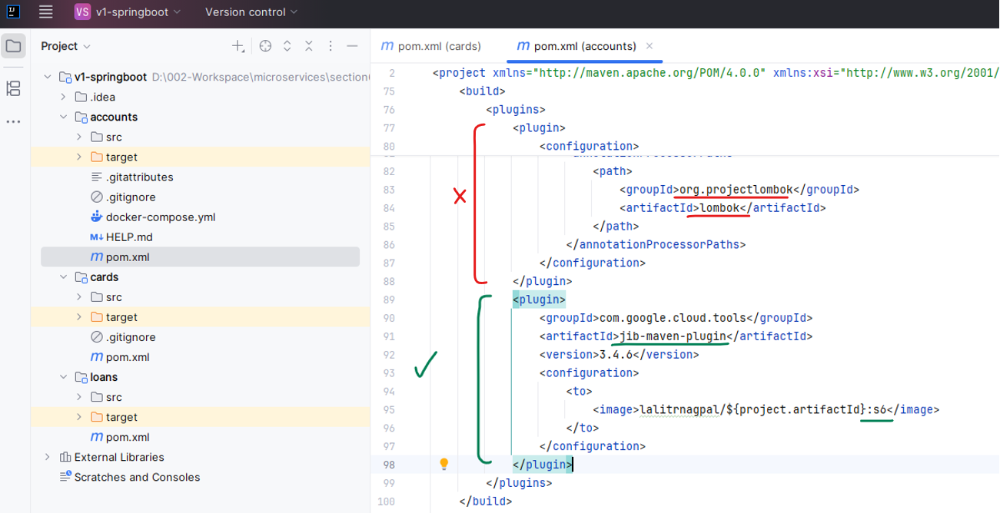

So once I make these changes I can load the maven changes. Now, similarly, let's go to the loans microservice. Under this loans microservice also I'm going to open the pom.xml and here also I'm going to look for the Spring Boot Maven plugin and I'm going to replace it with the Google Jib Maven plugin. So the image name, we don't have to change anything because the project.artifactId is going to be present inside the same pom.xml and accordingly my different microservices will have different Docker image name. So let me load these maven changes. So once we make all these changes now all our microservices are using same approach to generate the Docker image, which is Google Jib.

Note: we even removed the below plugin

<plugin>

<groupId>org.apache.maven.plugins</groupId>

<artifactId>maven-compiler-plugin</artifactId>

<configuration>

<annotationProcessorPaths>

<path>

<groupId>org.projectlombok</groupId>

<artifactId>lombok</artifactId>

</path>

</annotationProcessorPaths>

</configuration>

</plugin>

Our pom.xml looks like this now

<?xml version="1.0" encoding="UTF-8"?>

<project xmlns="http://maven.apache.org/POM/4.0.0" xmlns:xsi="http://www.w3.org/2001/XMLSchema-instance"

xsi:schemaLocation="http://maven.apache.org/POM/4.0.0 https://maven.apache.org/xsd/maven-4.0.0.xsd">

<modelVersion>4.0.0</modelVersion>

<parent>

<groupId>org.springframework.boot</groupId>

<artifactId>spring-boot-starter-parent</artifactId>

<version>3.5.6</version>

<relativePath/> <!-- lookup parent from repository -->

</parent>

<groupId>com.eazybytes</groupId>

<artifactId>accounts</artifactId>

<version>0.0.1-SNAPSHOT</version>

<packaging>jar</packaging>

<name>accounts</name>

<description>Accounts Microservice</description>

<url/>

<licenses>

<license/>

</licenses>

<developers>

<developer/>

</developers>

<scm>

<connection/>

<developerConnection/>

<tag/>

<url/>

</scm>

<properties>

<java.version>17</java.version>

</properties>

<dependencies>

<dependency>

<groupId>org.springframework.boot</groupId>

<artifactId>spring-boot-starter-data-jpa</artifactId>

</dependency>

<dependency>

<groupId>org.springframework.boot</groupId>

<artifactId>spring-boot-starter-validation</artifactId>

</dependency>

<dependency>

<groupId>org.springframework.boot</groupId>

<artifactId>spring-boot-starter-web</artifactId>

</dependency>

<dependency>

<groupId>org.springframework.boot</groupId>

<artifactId>spring-boot-devtools</artifactId>

<scope>runtime</scope>

<optional>true</optional>

</dependency>

<dependency>

<groupId>com.h2database</groupId>

<artifactId>h2</artifactId>

<scope>runtime</scope>

</dependency>

<dependency>

<groupId>org.projectlombok</groupId>

<artifactId>lombok</artifactId>

<optional>true</optional>

</dependency>

<dependency>

<groupId>org.springdoc</groupId>

<artifactId>springdoc-openapi-starter-webmvc-ui</artifactId>

<version>2.8.1</version>

</dependency>

<dependency>

<groupId>org.springframework.boot</groupId>

<artifactId>spring-boot-starter-test</artifactId>

<scope>test</scope>

</dependency>

</dependencies>

<build>

<plugins>

<plugin>

<groupId>com.google.cloud.tools</groupId>

<artifactId>jib-maven-plugin</artifactId>

<version>3.4.6</version>

<configuration>

<to>

<image>lalitrnagpal/${project.artifactId}:s6</image>

</to>

</configuration>

</plugin>

</plugins>

</build>

</project>

As a next step, first, I'll try to make all the required changes inside the accounts microservice. Post that, I'll give an activity for you to make similar set of changes inside the cards and loans microservice. Here under the accounts microservice you can look for the file which is application.yml. Inside this application.yml we can define any properties along with their values which we can read inside our Java code. First, let's try to start with a simple property name. So the property that I want to create here is build and I'll go to the next line and mention the tab space and here I'm going to mention version. So I'm trying to define a property with the key build.version and inside the yaml this is how we need to mention the same. And for this property I'm going to mention the value as 1.0. So this is the simple property I'm trying to define inside my application.yaml, now using this property only I'm going to read the value inside my Java code and I'll also build a small REST API, which my client applications can invoke to understand what is the build version right now my microservice is using.

server:

port: 8080

spring:

datasource:

url: jdbc:h2:mem:testdb

driverClassName: org.h2.Driver

username: sa

password: ''

h2:

console:

enabled: true

jpa:

database-platform: org.hibernate.dialect.H2Dialect

hibernate:

ddl-auto: update

show-sql: true

build:

version: "1.0"

As a next step, we need to go to the controller class inside AccountsMicroservice. The controller class that we have here is AccountsController. So here first I need to read the property defined inside my application.yml file. For the same, I'm going to create a new Java field inside my controller class which is of data type string and the field name I can keep it as buildVersion. Again, this name can be anything, but it will be a wise decision to follow the same name inside your Java field so that you can easily identify from your Java fields itself. So now this field will not have any value. This will have only null value right now to inject the property value during the startup of the spring boot application into this Java field, we need to mention an annotation which is @Value. To this annotation, we need to pass the property key name by following the spring expression language. So the syntax that we need to follow here is, first we need to mention that double quotes post that we need to mention dollar followed by curly braces. And inside these curly braces we need to mention the key value of our property. So the key value will be build.version. So let me try to mention the same build.version. So with these changes, the build version Java field will have the value that we have defined inside the Yaml file.

@Tag(

name = "CRUD REST APIs for Accounts in EazyBank",

description = "CRUD REST APIs in EazyBank to CREATE, UPDATE, FETCH AND DELETE account details"

)

@RestController

@Validated

@RequestMapping(path="/api", produces = {MediaType.APPLICATION_JSON_VALUE})

@AllArgsConstructor

public class AccountsController {

private IAccountsService iAccountsService;

@Value("${build.version}")

private String buildVersion;

@Operation(

summary = "Create Account REST API",

description = "REST API to create new Customer & Account inside EazyBank"

)

@ApiResponses({

@ApiResponse(

responseCode = "201",

description = "HTTP Status CREATED"

),

@ApiResponse(

responseCode = "500",

description = "HTTP Status Internal Server Error",

content = @Content(

schema = @Schema(implementation = ErrorResponseDto.class)

)

)

}

)

. . .

}

Like I said before, I'm going to build a small REST API service to send these build version information to my client. For the same, let me go to the end of this controller class. So first I'll create a Java method with the name public return type as response entity of String and the method name is going to be getBuildInfo() and it is not going to accept any input parameters. Post that inside the body of this method I can directly write return statement and inside this return statement I'm going to use the ResponseEntity using this ResponseEntity class. First, I'm going to send the status to this status(). I'm going to send HttpStatus.Ok, which conveys the overall operation is successful. And post this, I'm going to invoke the body(). So inside this body() only I'm going to pass the field name which holds the build version information. Like we know we have a Java field name with the name build version, so I'm going to pass the same. So let me try to format this code. Now this looks good. The next step that we need to follow is we need to mention @GetMapping on top of this method post that the path that it is going to support is build-info along with the forward slash in the starting of the path. So with this we have defined the REST API, but we should also make sure we are documenting this REST API properly. For the same, let me copy some spring doc related information from the get API. So on the top we have a get api. So here I'm going to take this entire operation along with the API responses and the same I'm going to copy on top of this method. Off course here we need to change the summary and description, so let me try to change that quickly. So the summary is going to be get build information. So that's a summary. Similarly, I'm going to replace the description with a value saying that get the build information that is deployed into accounts microservice. Post that this response description should be fine. Like in the case of successful, the response code is going to be 200 along with the description as HttpStatus.OK . And very similarly, in the case of RuntimeException, we are going to return the response code 500 along with this description. And the schema that we are going to send is, by following this ErrorResponseDto. So this you already familiar with. So with this, our new REST API is ready.

@Tag(

name = "CRUD REST APIs for Accounts in EazyBank",

description = "CRUD REST APIs to CREATE, UPDATE, FETCH & DELETE account details"

)

@RestController

@Validated

@RequestMapping(path="/api", produces = {MediaType.APPLICATION_JSON_VALUE})

@AllArgsConstructor

public class AccountsController {

private IAccountsService iAccountsService;

@Value("${build.version}")

private String buildVersion;

. . .

@Operation(

summary = "Get Build Information",

description = "Get Build Information from deployed Accounts Microservice"

)

@ApiResponses({

@ApiResponse(

responseCode = "200",

description = "HTTP Status OK"

),

@ApiResponse(

responseCode = "500",

description = "HTTP Status Internal Server Error",

content = @Content(

schema = @Schema(implementation = ErrorResponseDto.class)

)

)

}

)

@GetMapping("/build-info")

public ResponseEntity<String> getBuildInfo() {

return ResponseEntity.status(HttpStatus.OK).body(buildVersion);

}

}

Now let me try to start my accounts microservice. When you try to build very first time inside your workspace, this annotation will appear related to Lombok. Please make sure you are enabling this annotation processing. So once we enable this and the build is completed, I can go to the accounts application and here I'll try to start my application in the debug mode.

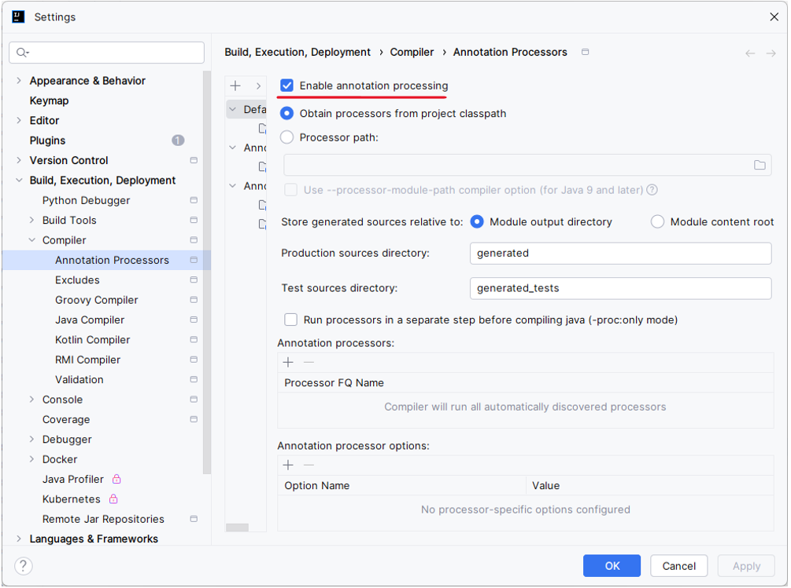

This will start my accounts microservice at the port 8080, but seems we are getting an errors. Let's try to understand what is this error? It is saying accounts controller is missing a bean of type String. I know why this is happening. Let's go to our accounts controller by default since we are using AllArgsConstructor here, my lombok is going to generate a constructor with all the fields that I have defined inside my AccountsController. So the fields right now I have is, accountService and buildVersion. So since it is trying to look for a bean of data type String which is nowhere exist inside my application, it is failing.

Action:

Consider defining a bean of type 'java.lang.String' in your configuration.

2025-11-01T09:22:42.658+05:30 WARN 32852 --- [ main] o.s.test.context.TestContextManager : Caught exception while allowing TestExecutionListener [org.springframework.test.context.web.ServletTestExecutionListener] to prepare test instance [com.eazybytes.accounts.AccountsApplicationTests@738ae785]

java.lang.IllegalStateException: Failed to load ApplicationContext for [WebMergedContextConfiguration@dffcf1 testClass = com.eazybytes.accounts.AccountsApplicationTests, locations = [], classes = [com.eazybytes.accounts.AccountsApplication], contextInitializerClasses = [], activeProfiles = [], propertySourceDescriptors = [], propertySourceProperties = ["org.springframework.boot.test.context.SpringBootTestContextBootstrapper=true"], contextCustomizers =

. . .

Caused by: org.springframework.beans.factory.UnsatisfiedDependencyException: Error creating bean with name 'accountsController' defined in file [D:\002-Workspace\microservices\section6\v1-springboot\accounts\target\classes\com\eazybytes\accounts\controller\AccountsController.class]: Unsatisfied dependency expressed through constructor parameter 1: No qualifying bean of type 'java.lang.String' available: expected at least 1 bean which qualifies as autowire candidate. Dependency annotations: {}

at org.springframework.beans.factory.support.ConstructorResolver.createArgumentArray(ConstructorResolver.java:804)

at org.springframework.beans.factory.support.ConstructorResolver.autowireConstructor(ConstructorResolver.java:240)

at org.springframework.beans.factory.support.AbstractAutowireCapableBeanFactory.autowireConstructor(AbstractAutowireCapableBeanFactory.java:1395)

at

. . .

So that's why to fix this first we need to make sure we are removing these AllArgsConstructor post that I'm going to create a new constructor manually. So the constructor is going to be public and I'm going to mention the class name and to this constructor I'm going to pass the parameter of type IAccountService and inside this constructor I'm going to invoke the logic, which is this. IAccountService =IAccountService. This way, with the help of this constructor, we are trying to autowire only one dependency been which is of type IAccountService. It is also a recommended approach to mention final before your field name of IAccountService. So this is the most recommended approach while following the constructor autowiring. This will make your application more secure. And if needed, you can also mention @Autowired annotation here. But like I said, this is completely optional when we have single constructor inside our class. So let me remove these optional Autowired annotation. Now I'll do the build post that I'll go to my accounts application and try to start the microservice in the debug mode.

@Tag(

name = "CRUD REST APIs for Accounts in EazyBank",

description = "CRUD REST APIs to CREATE, UPDATE, FETCH AND DELETE account details"

)

@RestController

@Validated

@RequestMapping(path="/api", produces = {MediaType.APPLICATION_JSON_VALUE})

~~@AllArgsConstructor~~ # 🡨 removed

public class AccountsController {

private IAccountsService iAccountsService;

@Value("${build.version}")

private String buildVersion;

@Autowired # 🡨 added

public AccountsController(IAccountsService iAccountsService) {

this.iAccountsService = iAccountsService;

}

OR as suggested here we can use the final keyword before the service

@Tag(

name = "CRUD REST APIs for Accounts in EazyBank",

description = "CRUD REST APIs to CREATE, UPDATE, FETCH AND DELETE account details"

)

@RestController

@Validated

@RequestMapping(path="/api", produces = {MediaType.APPLICATION_JSON_VALUE})

~~@AllArgsConstructor~~ # 🡨 removed

public class AccountsController {

private final IAccountsService iAccountsService; # 🡨 added

@Value("${build.version}")

private String buildVersion;

@Autowired # 🡨 Optional to specify

public AccountsController(IAccountsService iAccountsService) {

this.iAccountsService = iAccountsService;

}

So this time you can see my application started at the port 8080. Now I'll go to my postman. Here inside my postman you can see under accounts I have a new API with the name build-info. So this is going to accept http get method and the path is localhost://8080/api/build-info. If I click on the send button you can see I'm getting a response 1.0, which is the value that we have mentioned inside the application.yml file.

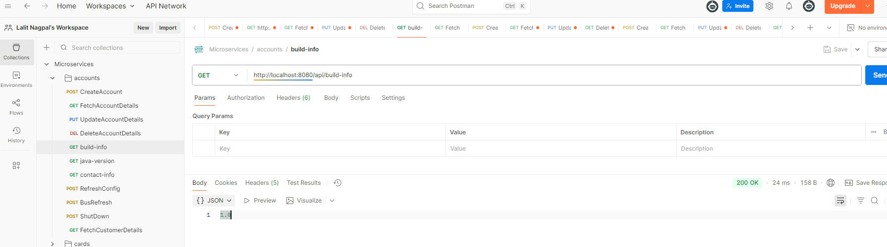

This way we can read the properties inside the application.properties file or application.yml file or inside any other file with the help of other @Value annotation.



And this allows to read all your properties from your Java code itself. Just a reminder I have uploaded these microservices related postman collection inside the GitHub repo. You can simply import these inside your postman and with that you will be able to see all these APIs that I'm showing here and you don't have to create these requests manually Inside the postman collection that I have provided all these APIs information and the sample requests, everything is already present. I hope now you are clear with the approach one on how to read the properties with the help of @Value annotation.

Do you think this approach is sufficient for microservice? Off course this is not going to work if you have hundreds of microservices and if they have 100 different properties, are we going to create 100 different fields inside your microservices? That's not a viable solution. And at the same time, inside this approach, if you see inside the AccountsController while injecting this Java field, we are hardcoding the property name like build.version. So creating a Java field and mentioning the hardcoded property value for every microservice is not going to be feasible option. That's why this approach is only recommended if you have only 1 or 2 properties. If you have many other properties, this approach is not going to work. So let's try to continue with the second approach that we have in the next lecture.

### Environment Interface

Let me show you the second approach that we have to read the properties, and this second approach will help you to read the environment properties defined inside the environment where you have deployed your microservices. And here you may have a question like, "Why do we need to define some properties as environment variables? Why can't we directly define them inside the application.yaml file?" That's a very valid question. Like I said before, some sensitive informations, like passwords or any other information, we can't define them inside the application.yaml file or inside any other place where it will expose my sensitive information. With that reason, it is always advisable to define the sensitive configuration details as the environment variables only so that no one can see those values because they'll not have access to your production server. Only the server admins, they'll have access. This way you're trying to secure your application whenever they're dealing with the sensitive configurations. Like we discussed before, this approach involves an interface with the name environment. So first, let's try to autowire the environment interface to this AccountsController. So here I'm going to mention private, post that, Environment interface and the variable name is going to be environment. On top of this field, I'm going to mention Autowired annotation. With this, now all the environment details that I have defined inside my local system can be accessed with the help of these environment variable.

import org.springframework.core.env.Environment;

@Tag(

name = "CRUD REST APIs for Accounts in EazyBank",

description = "CRUD REST APIs to CREATE, UPDATE, FETCH AND DELETE account details"

)

@RestController

@Validated

@RequestMapping(path="/api", produces = {MediaType.APPLICATION_JSON_VALUE})

public class AccountsController {

private final IAccountsService iAccountsService;

public AccountsController(IAccountsService iAccountsService){

this.iAccountsService = iAccountsService;

}

@Value("${build.version}")

private String buildVersion;

@Autowired

private Environment environment;

. . .

@Operation(

summary = "Get Java Version",

description = "Get Java Version used by Accounts Microservice"

)

@ApiResponses({

@ApiResponse(

responseCode = "200",

description = "HTTP Status OK"

),

@ApiResponse(

responseCode = "500",

description = "HTTP Status Internal Server Error",

content = @Content(

schema = @Schema(implementation = ErrorResponseDto.class)

)

)

}

)

@GetMapping("/java-version")

public ResponseEntity<String> getJavaVersion() {

return ResponseEntity.status(HttpStatus.OK)

.body(environment.getProperty("java.version"));

}

}

To demo the same, I'm going to create a small REST API. Let me go to the end of this file. Here, first, I'll try to copy the entire REST API related to the build-info. Post that, I'm going to paste the same here inside this class. Now I'm going to create a new REST API that will return the what is a Java version that my microservice right now is using. So inside my local system or in any Java developer system, we'll always install a Java, and we'll set a environment variable with the name JAVA_HOME. With the help of these environment interface, I'll try to read that environment property related to Java version. And the same I'll return to the client applications where it's trying to invoke my REST API. So first, I'll try to change the method name to getJavaVersion and similarly, I'm going to change the REST API path to java-version. So with this, I'm good from REST API perspective, but here, after making these REST API changes inside the body, as of now, I'm sending the buildVersion field information. Instead, I'm going to use the environment variable that we have. Against this environment variable, I'm going to invoke the method getProperty since we have injected a wrong environment interface.

So let me go to the import statements. Here, under the import statements, if you see, the environment, right now, we are importing is from the hibernate but we don't want that hibernate-related environment. We want the environment present inside the Spring Core Framework. So let me try to press Control + space here. So you can see we have the interface with the package org.springframework.core.env. So please make sure you are injecting the same into this controller class. So once I define this and imported this into this class, I can go to the Java method, and here now I should be able to invoke the method, which is getProperty. And to this getProperty method, I'm going to pass the environment variable name regarding the Java version. So these details we store inside a environment variable with the name JAVA_HOME. So now my REST API is capable to read the JAVA_HOME environment variable inside my local system, and send the same as a response to the client applications. As a next step, I should also update the summary here. Like first, I'll change this to get Java version. Post this, I'll also change the description details to get Java version details that is installed into accounts microservice. With this, we should be good. There is no need to change anything inside the API responses.

Let me do a build. Once the build is completed, if needed, please restart your application. I'm also restarting my application to be on safe side. So let me restart in debug mode, and I'll go to the Postman. Here inside the Postman, I'm going to click on this java-version API. You can see here, this is the complete path, /api/java-version, and this is going to support HTTP GET method. As soon as I click on the Send button, I'm getting a response where my JAVA_HOME is installed. So inside the response, since I have used the SD command to install the Java, it is simply giving the JAVA_HOME folder location.

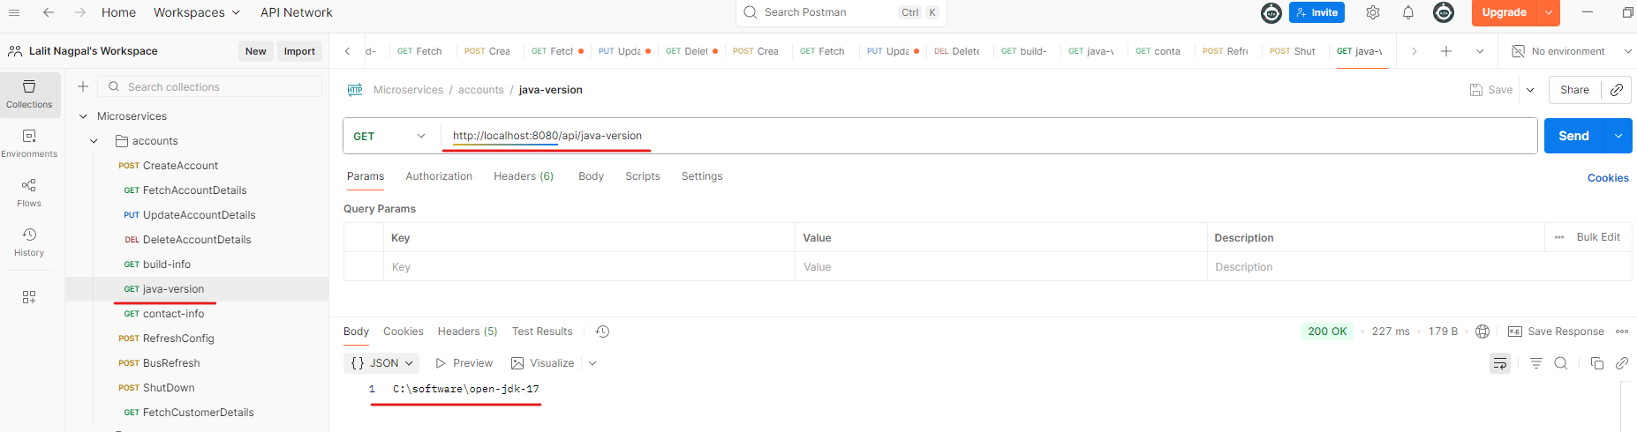

But ideally inside the production servers, we'll directly install the JDK by downloading from the official website. And in such scenarios, it is going to give you the complete folder location, along with the Java version name. So this output should be fine for me since I just want to show you the demo of how to use the environment interface to read the properties of environment details. I can also show you one more environment property demo. Inside my local system, I also have Maven installed. So whenever we have the Maven installed, we are going to have the environment property set with the name MAVEN_HOME. So after adding these property details, I'm trying to save the changes and do your build. Once the build is completed, I go to my Postman. Here I am trying to click on the Send button. You can see it is giving me a location where my Apache Maven is installed. So from this folder location, I can easily understand. The version right now we have installed is 3.8.6.

This way, we can read any type of environment property inside your Java code with the help of environment interface. So let me rework these changes back to JAVA_HOME and do your build. Once the build is completed, I'm going to test again. And here, it is showing me the Java installation folder location. So this should be fine for me, though it is not showing my Java version install. Like I said, in production environment, it is going to work. With this, I'm assuming you're super clear about the second approach that we have used to read the properties, which is with the help of Environment interface. So this approach also has disadvantages, like you can only read one property at a time and at the same time, you need to hard code the property key name inside your Java code. And this approach is also going to work only if you have one or two properties. If you have higher number of environment properties that you want to read, then definitely this approach is not recommended. We'll see some advanced options that we have in the coming lectures, but now we should be good with this approach two. Inside the next lecture, let's try to discuss the approach three that we have.

### @ConfigurationProperties

Using this third approach, we can read multiple properties at a time with a single pojo class. All the limitations that we have with the previous two approaches will be handled with this third approach. Limitations are like where we are hardcoding the property key names inside the Java code. And at the same time we can only read one property at a time with the two approaches that we have discussed. So to demo you, the third approach, I'm going to create a set of properties that are required for my Accounts Microservice. Whenever we are trying to use @ConfigurationProperties approach, first, we need to make sure all our properties have a common prefix name. For the same, I'm going to create a prefix name with the name accounts. Since I'm trying to create various properties for my accounts microservice, I thought mentioning a prefix as accounts would make more sense here. After this, inside this property we can define any number of other properties. Here just to save some time, I'm going to paste a few properties. You can get these properties from the GitHub location as well. These properties are like message, contactDetails and onCallSupport So I'm going to use these properties to send to my client applications whenever they're trying to invoke one new REST API that I'm going to build. So with the new Rest API that I'm going to build, since I'm sending this information, my client applications, they know to whom they need to contact in case of any issues like what is the developer name, what is the email of the developer, what is the on call support details? So you can see under the same accounts prefix property. I have three different properties, message, contact details and on call support and you can see these contact details again has internally other properties like name and email and similarly on call support property has multiple values. Like we are providing two different phone numbers that someone can call in case of any issues when they're trying to invoke our accounts microservice. Now we have different set of properties with the same prefix name accounts. If you are following the first approach, which is with the help of @Value annotation, if you want to read all these properties, you need to define all these fields along with the hardcoded property key names inside your controller class. Similarly, if you have any other controller class where you have to use the same properties, then in that controller class also you need to create multiple Java fields with the help of @Value annotation along with the hardcoded property key names. So that is going to be super, super inconvenience.

**application.yml**

server:

port: 8080

spring:

datasource:

url: jdbc:h2:mem:testdb

driverClassName: org.h2.Driver

username: sa

password: ''

h2:

console:

enabled: true

jpa:

database-platform: org.hibernate.dialect.H2Dialect

hibernate:

ddl-auto: update

show-sql: true

build:

version: "1.0"

accounts:

message: "Welcome to EazyBank accounts related local APIs"

contactDetails:

name: "John Doe - Developer"

email: "john@eazybank.com"

onCallSupport:

- (555) 555-1234

- (555) 555-1235

So to overcome this challenge we can use the third approach. In order to use the third approach, first, we need to have a pojo class which represents all of the properties that we have defined here. In order to create a pojo class, let me go to the dto package that we have. Inside this DTO package, I'm going to create a new DTO class and this class name is going to be AccountsContactInfoDto So here I'm not going to create a Java class. Instead, I'll go with the Java record. Record is a new type of Java classes introduced in Java 17. Let me try to talk few minutes about what is this record class and why Java people introduce this. Sometimes we want our Pojo class or DTO classes to simply act as a data carriers, which means first I'll create an object of this DTO class and someone can read the data from the object of this DTO class, but they should not be able to change. So whatever fields data that you pass during the object creation, the same values are going to be final. And anyone can read using the getter methods and there won't be any setter methods. So this is the most common scenario and common requirement. So instead of writing all the getter methods and creating a constructor that is going to accept the final Java fields, you can simply use this record class. So to this record class, you can pass all the Java fields inside these brackets. So in order to define the Java fields, first I need to know what is the property name that we have defined inside the application.yml.

import org.springframework.boot.context.properties.ConfigurationProperties;

import java.util.List;

import java.util.Map;

@ConfigurationProperties(prefix = "accounts")

public record AccountsContacInfoDto( String message, Map<String, String> contactDetails,

List<String> onCallSupport) {

}

So inside my application.yml you can see the very first property name is message and it is holding a value of type String. And very similarly the second property name is contact details, but here it has a list of properties with the key and value. So inside Java the key and values can be represented with the help of HashMap or Map. And the third property we have here is on call support and this property has list of phone numbers in a alphanumeric format. You can see message is a simple String. Contact details supports storing of map data and on call support is going to support to store the list of elements. By following the same data types, we need to define the fields inside our pojo class. So here our pojo class is a record class. That's why we need to define all the fields inside this bracket itself. So first property is of type String and please make sure the field name is same as the message because we have defined the same inside the application.yml and the second field data type is going to be map and it is going to have key and values of type String. That's why I'm mentioning the String, String inside this map and the field name has to be same as contact details. Since we have defined the contact details here and inside this we have key and value which can be stored inside the map with the name, contact details. And very similarly, you need to create a list of string with the name on call support. So let me go to my controller class and here I'm going to mention the data type as list of String and the field name is going to be on call support. So with this I should be good.

Now behind the scenes, the Java is going to make these fields as final and at the same time it is going to generate a getter method and a constructor behind the scenes. So there won't be any setter methods, which means whenever you are using record type classes, you can only initialize the data only once and you cannot change that and whatever you have provided during the object creation, it is going to be final. Since we also have a requirement to not change these values at runtime again and again, we can use record class here now to map all these properties to Java fields. We need to mention this prefix with the help of @Configuration properties. So to this annotation we need to mention a parameter which is prefix. And to this prefix we need to pass a prefix which is accounts. So please make sure you are mentioning the same prefix both in application.yml and inside this record class. So once we make these changes we need to go to our spring boot main class and on top of this class we need to make sure we are mentioning an annotation which is @EnableConfigurationProperties. Against to this annotation, we need to invoke a parameter value and inside this value we need to pass the Pojo class details. The class name that we have here is, AccountsContactInfoDto.class

@OpenAPIDefinition(

info = @Info(

title = "Accounts microservice REST API Documentation",

description = "EazyBank Accounts microservice REST API Documentation",

version = "v1",

contact = @Contact(

name = "Madan Reddy",

email = "tutor@eazybytes.com",

url = "https://www.eazybytes.com"

),

license = @License(

name = "Apache 2.0",

url = "https://www.eazybytes.com"

)

),

externalDocs = @ExternalDocumentation(

description = "EazyBank Accounts microservice REST API Documentation",

url = "https://www.eazybytes.com/swagger-ui.html"

)

)

@SpringBootApplication

/* @ComponentScans({ @ComponentScan("com.eazybytes.accounts.controller") })

@EnableJpaRepositories("com.eazybytes.accounts.repository")

@EntityScan("com.eazybytes.accounts.model") */

@EnableJpaAuditing(auditorAwareRef = "auditAwareImpl")

@EnableConfigurationProperties(value = { AccountsContacInfoDto.class })

public class AccountsApplication {

public static void main(String[] args) {

SpringApplication.run(AccountsApplication.class, args);

}

}

So this is the class name where we try to map all our properties from application.yml to the Pojo class. So now we have the Pojo class ready and during the startup my spring boot will try to read all the properties with the prefix value as accounts and it will try to map those property values to the fields present inside this class with the name. AccountsContactInfoDto. As a next step, I can use this Pojo class anywhere inside my business logic and I don't have to depend on the @Value annotation, so let me go to the AccountsController. I'm going to create a new REST API by copying the existing REST API related to Java version. And first, I'll change this Java method name to getContactInfo() since any client they can get these contact details by invoking this REST API, I want to make the method name as getContactInfo(). Post that I'll change the API path to contact-info Once we change this API path, we need to make sure we are changing the operation summary and description. So let me change the summary and description. So the summary is going to be Get Contact info. Once I mention the summary details as a next step, I'm going to change the description which is Contact info details that can be reached out in case of any issues.

@Tag(

name = "CRUD REST APIs for Accounts in EazyBank",

description = "CRUD REST APIs to CREATE, UPDATE, FETCH AND DELETE account details"

)

@RestController

@Validated

@RequestMapping(path="/api", produces = {MediaType.APPLICATION_JSON_VALUE})

public class AccountsController {

private final IAccountsService iAccountsService;

public AccountsController(IAccountsService iAccountsService){

this.iAccountsService = iAccountsService;

}

@Value("${build.version}")

private String buildVersion;

@Autowired

private Environment environment;

@Autowired

private AccountsContactInfoDto accountsContactInfoDto;

@Operation(

summary = "Get Contact Info",

description = "Get Contact Info for Accounts Microservice"

)

@ApiResponses({

@ApiResponse(

responseCode = "200",

description = "HTTP Status OK"

),

@ApiResponse(

responseCode = "500",

description = "HTTP Status Internal Server Error",

content = @Content(

schema = @Schema(implementation = ErrorResponseDto.class)

)

)

}

)

@GetMapping("/contact-info")

public ResponseEntity<AccountsContactInfoDto> getContactInfo() {

return ResponseEntity.status(HttpStatus.OK).body(accountsContactInfoDto);

}}

So the API responses are going to be the same. Now in order to write the business logic inside this method, first we need to make sure we are injecting the bean of AccountsContactInfoDto Since we have mentioned this @ConfigurationProperties on top of this class, behind the scenes, my spring framework is going to create a bean, so that's why we can directly inject that with the help of @Autowired annotation inside my controller class, I'll try to copy these environment related autowiring information and instead of environment, I'm going to mention the class name of AccountsContactInfoDto. The variable name also I'm going to change it to accountsContactInfoDto. So now I have these AccountsContactInfoDto. I'll simply go to my REST API that I have created here inside this body, I'm going to send the entire object of AccountsInfoDto and with that inside the return statement I need to remove the String and mention AccountsContactInfoDto. So with these changes now anyone can invoke my contact-info API and they are going to get all the properties that we have defined inside my application.yml.

This way you can create hundreds of properties inside your application.yml and for all of them you can define Java fields inside your Dto class. Whether you are following a record class or a normal pojo class, it's up to you. But please make sure this field names and the return data types are matching with the property names and the data types that we have inside this application.yml. So now I have made all the required changes. So let me save these changes and do a build. Once the build is completed we can restart the server just to make sure our new REST API method is going to work properly. So now my Accounts Microservice started successfully. Let me go to the postman. Inside my postman there is an API with the name contact-info. You can click on that. You can see this is an API that supports GET method and the URL is localhost:8080/api/contact-info . I'm clicking on this send button.

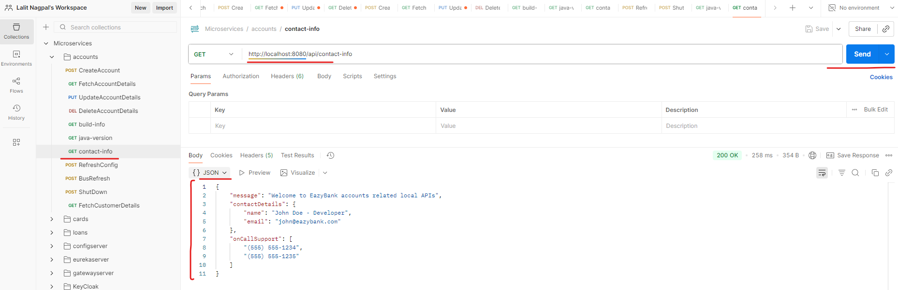

You can see I got a successful response with all the property details. Like what is the message? What is the contact details? What is the on call support? So this information can be used by my client applications. Here we are just passing these DTO object directly in the client response, but in real projects it's up to you on how to read the data and utilize the data present inside this object. I'm just trying to show you a demo of how to map multiple properties into a single pojo class, and that's why I have used this third approach, which is with the help of @ConfigurationProperties.

This is more matured approach, Spring team also recommend to use this approach compared to @Value annotation. Off course, we need to use environment interface to read the environment variables that approach you can use. But in real applications we will not be having multiple environment properties. There will be 2 or 3. Normal properties and configurations there can be multiple properties that you may need to create. That's why using this third approach, which is ConfigurationProperties approach, is going to make more sense to you.

So as of now, we have explored all the three approaches. But here I have a question for you. You can see as of now we have created an application.yml and we have defined all the properties. But what if I want to have different values for different environment? Maybe I want to follow these values inside my dev environment? How about inside the QA and production environment? If my requirement is to maintain different values for different environments, then definitely all these three approaches are not going to be helpful. We need something more advanced that is supported by the spring boot framework.